Vendor Sourcing Wireframes – Step by Step
Nov 4, 2026 · @Ravindra

Step 1 – Create vendor on one page
The Vendor Sourcing Manager fills vendor details, products with variants, quantity slabs, discount and warehouse-wise shipping in accordion sections on one page, including courier rates (FedEx, DHL) for 1 to 100 packets from the vendor address in Hyderabad to each US warehouse, then sends to the Admin.
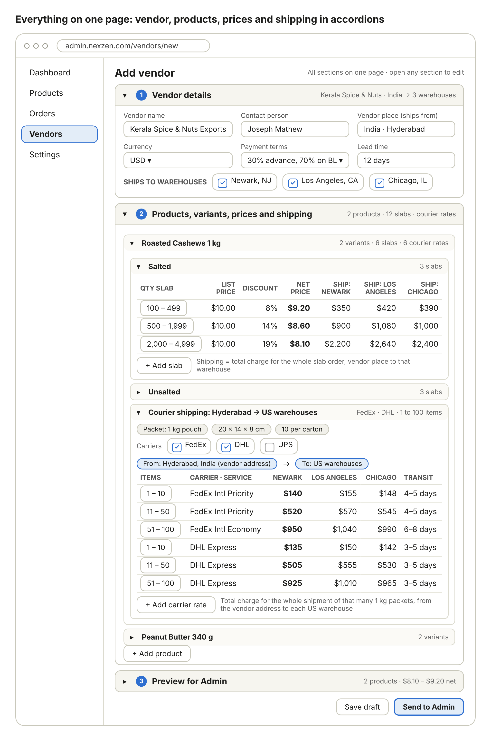

Step 2 – Admin is notified
The Admin gets an in-app alert and an email with a Review button.
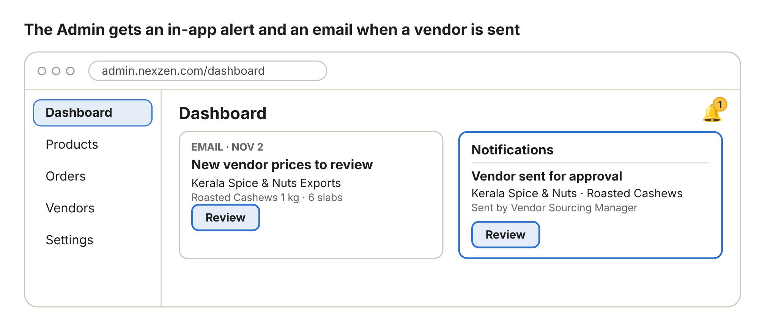

Step 3 – Admin sees what is in the system
When no other vendor quoted the same product, the Admin sees this quote next to what is already in the system.
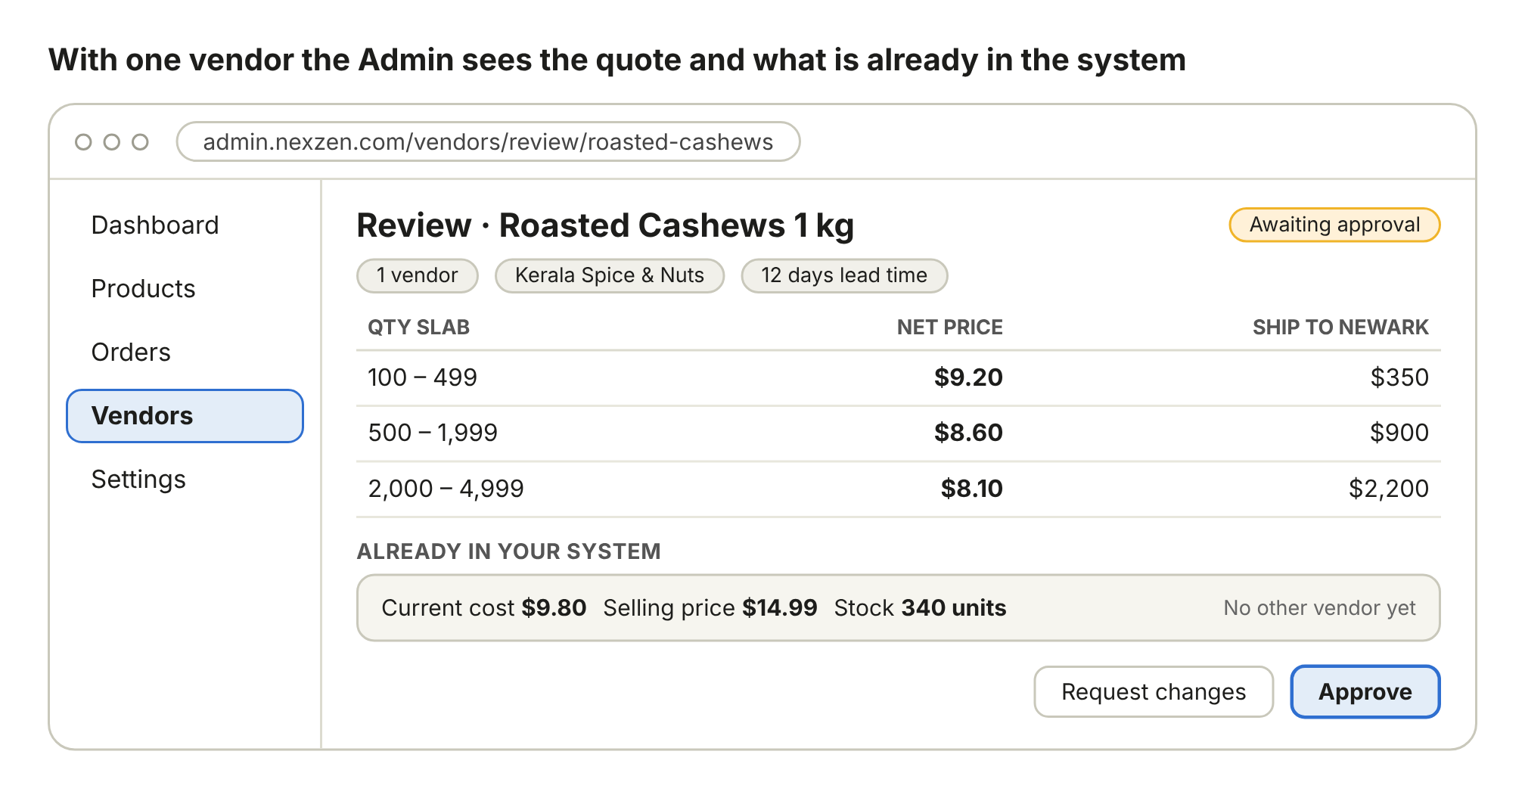

Step 4 – Vendor comparison with AI analysis
When other vendors quoted the same product, the Admin sees the comparison and the AI recommendation.
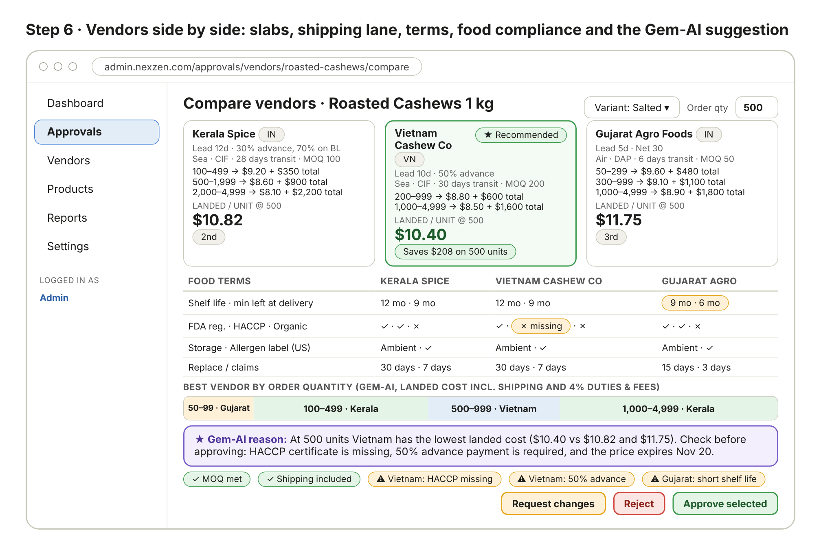

Step 5 – Admin approves or requests changes
The Admin approves the chosen vendors or sends a vendor back with a comment.
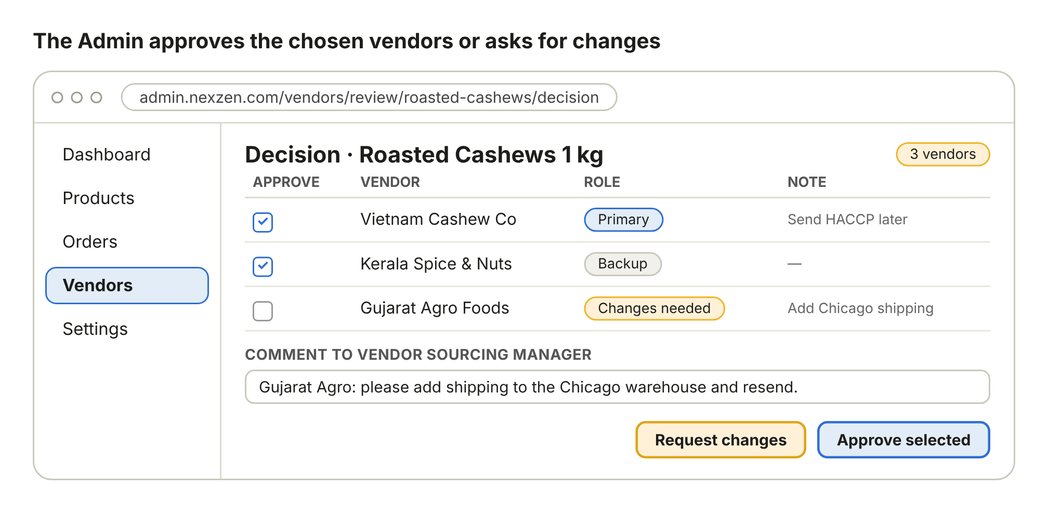

Step 6 – Manager is notified and resends
The manager is notified, corrects the vendor and sends it back to the Admin if needed.
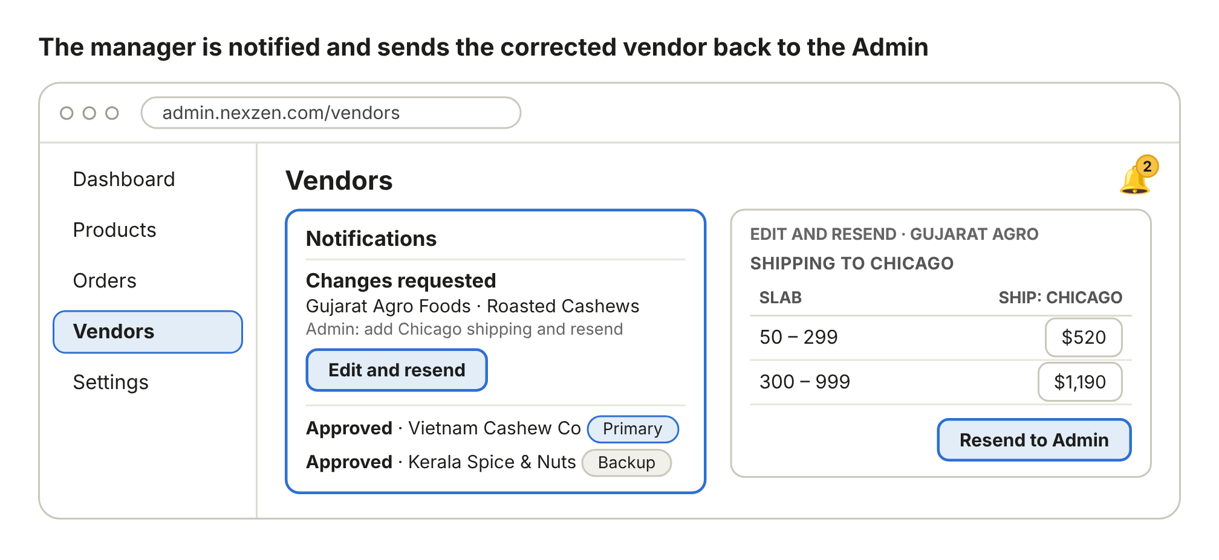

Step 7 – Vendor list with status
The vendor list shows every vendor with its final status.
