Vendor Sourcing and Approval Flow
NexZen EGFPOS | Product variant-wise inputs, wireframes and step-by-step explanation

1. Purpose
This document explains how a Vendor Sourcing Manager adds a vendor with product variant-wise quantity slabs, discounts and shipping charges, how the Admin compares vendors with help from Gem-AI, and how approved vendors are onboarded automatically. The wireframes come from the Vendor Sourcing Wireframes document and every step below explains what each part of the screen means.
Principles: one page for the manager, every variant priced on its own, quantity slabs that the vendor decides, simple labels with no SKU or internal codes, and the Admin always makes the final decision.

2. Roles
Role | What this role does
Vendor Sourcing Manager | Adds vendors and selects the products they supply.  Enters variant-wise slabs, discounts, shipping and courier rates.  Sends to the Admin, and edits and resends when changes are requested.  Cannot approve or reject, not even their own request.
Admin | Gets an alert and email for every new vendor.  Sees one vendor with what is already in the system, or all vendors side by side.  Reads the Gem-AI suggestion, then approves selected vendors as Primary or Backup, requests changes or rejects.
System (automatic) | Notifies people, locks a request while it waits, onboards approved vendors and writes everything to action history.
Gem-AI (automatic) | Calculates landed cost per unit including shipping and duties, ranks vendors, shows the best vendor for each order quantity and lists warnings. It only suggests and never approves.

3. Flow at a glance
Step | Who | What
1 | Sourcing Manager | Opens Vendors and clicks + Add vendor
2 | Sourcing Manager | Fills vendor details (section 1)
3 | Sourcing Manager | Selects products; variants appear (section 2)
4 | Sourcing Manager | Enters slabs, discount and shipping for each variant
5 | Sourcing Manager | Enters courier rates for small quantities (FedEx, DHL)
6 | Sourcing Manager | Checks the Admin preview and sends (section 3)
7 | System | Alerts the Admin by app and email
8 | Admin | Reviews one vendor next to what is already in the system
9 | Admin and Gem-AI | Compares vendors side by side with the Gem-AI suggestion
10 | Admin | Approves selected vendors as Primary or Backup, or requests changes
11 | System | Onboards approved vendors automatically
12 | Sourcing Manager | Gets the notification, edits and resends
13 | Everyone | Vendor list shows every vendor with its status

4. Step by step

Step 1: Open Vendors and click + Add vendor
Who | Vendor Sourcing Manager
Screen | Vendors list (see Step 13 wireframe)
What happens | - Log in and open Vendors from the left menu.  - See every vendor with ships-from country, product and status.  - Click + Add vendor. To finish a saved draft, click Continue on that row.
Result | The Add vendor page opens with three sections on one page.

Add vendor page: one page, three sections (used in Steps 2 to 6)
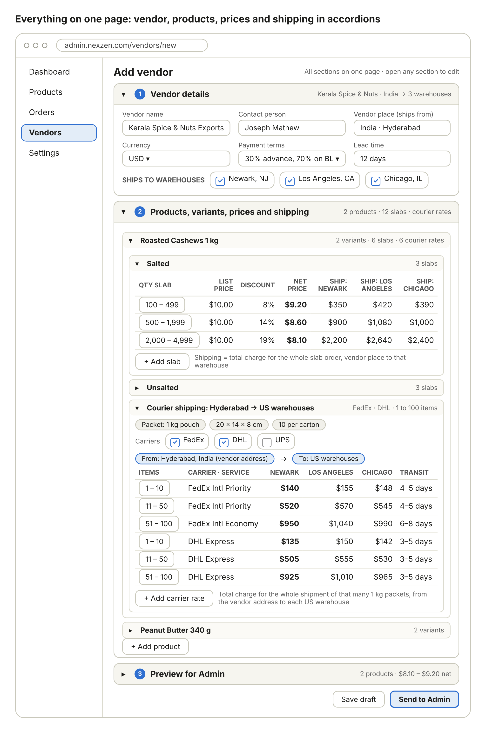
Wireframe: everything on one page in accordions. Vendor, products, variants, prices and shipping.
Each section is an accordion. The manager can open any section at any time and edit it, so there is no forced order and no page to go back to. Section 1 is Vendor details, section 2 is Products, variants, prices and shipping, and section 3 is Preview for Admin.

Step 2: Fill vendor details (section 1)
Who | Vendor Sourcing Manager
Screen | Add vendor, section 1: Vendor details
What happens | - Type the vendor name and contact person.  - Choose Vendor place (ships from). All shipping charges in this quote are measured from this place.  - Choose currency, payment terms and lead time.  - Tick every US warehouse this vendor will ship to.
Result | Vendor basics are set. Each ticked warehouse becomes a shipping column in Steps 4 and 5.

Field | Example | Why it matters
Vendor name | Kerala Spice & Nuts Exports | Required. Shown everywhere the vendor appears.
Contact person | Joseph Mathew | Who the Admin or buyer speaks to.
Vendor place (ships from) | India, Hyderabad | Start point for all shipping and courier charges.
Currency | USD | All prices of this vendor are in this currency.
Payment terms | 30% advance, 70% on BL (bill of lading) | Shown on the compare screen. Gem-AI warns about a large advance.
Lead time | 12 days | Days from order until the goods are ready to ship.
Ships to warehouses | Newark NJ, Los Angeles CA, Chicago IL | Creates one shipping column per warehouse.

Step 3: Select products and see their variants (section 2)
Who | Vendor Sourcing Manager
Screen | Add vendor, section 2: Products, variants, prices and shipping
What happens | - Click + Add product and pick each product this vendor supplies, for example Roasted Cashews 1 kg and Peanut Butter 340 g.  - Each product opens as its own accordion with the count of variants, slabs and courier rates.  - The variants load automatically from the product: Roasted Cashews 1 kg shows Salted and Unsalted. Variants show their options only, never codes.  - Prices are entered for each variant separately because a Salted pack and an Unsalted pack can cost differently. A variant the vendor does not supply is left empty.
Result | Every variant of every chosen product has its own place to enter slabs and shipping.

Step 4: Enter variant-wise slabs, discount and shipping
Who | Vendor Sourcing Manager
Screen | Section 2, inside a variant (example: Roasted Cashews 1 kg, Salted)
What happens | - Add a slab row: Qty slab from and to, for example 100 to 499.  - Type the List price and the Discount %. Net price is calculated automatically.  - Type the shipping charge for each ticked warehouse. It is the total charge for the whole slab order from the vendor place to that warehouse.  - Click + Add slab for as many slabs as the vendor gives. Slabs are free-form and not fixed by us.  - Repeat for the next variant (Unsalted).
Result | Each variant has its own slab table with net prices and warehouse-wise shipping.

Qty slab | List price | Discount | Net price | Ship: Newark | Ship: Los Angeles | Ship: Chicago
100 to 499 | $10.00 | 8% | $9.20 | $350 | $420 | $390
500 to 1,999 | $10.00 | 14% | $8.60 | $900 | $1,080 | $1,000
2,000 to 4,999 | $10.00 | 19% | $8.10 | $2,200 | $2,640 | $2,400
Net price = List price x (1 - Discount). Example: $10.00 with 8% discount gives $9.20. Shipping is the total for the whole order, so 100 to 499 units to Newark costs $350 in total, not $350 per unit.

Step 5: Enter courier shipping for small quantities
Who | Vendor Sourcing Manager
Screen | Section 2, inside a product: Courier shipping, Hyderabad to US warehouses
What happens | - Enter the packet: 1 kg pouch, size 20 x 14 x 8 cm, 10 per carton.  - Tick the carriers used: FedEx, DHL, UPS.  - Add a rate row for each item band and service: for example 1 to 10, 11 to 50 and 51 to 100 packets.  - Type the charge for each warehouse and the transit days.  - Click + Add carrier rate to add more.
Result | Courier rates are saved for small orders of 1 to 100 packets, next to the slab shipping used for bulk orders.

Items | Carrier and service | Newark | Los Angeles | Chicago | Transit
1 to 10 | FedEx Intl Priority | $140 | $155 | $148 | 4 to 5 days
11 to 50 | FedEx Intl Priority | $520 | $570 | $545 | 4 to 5 days
51 to 100 | FedEx Intl Economy | $950 | $1,040 | $990 | 6 to 8 days
1 to 10 | DHL Express | $135 | $150 | $142 | 3 to 5 days
11 to 50 | DHL Express | $505 | $555 | $530 | 3 to 5 days
51 to 100 | DHL Express | $925 | $1,010 | $965 | 3 to 5 days
Each charge is the total for the whole shipment of that many 1 kg packets, from the vendor address to that warehouse. Proposed rule: Gem-AI uses courier rates when the order is 100 packets or fewer, and slab shipping above that.

Step 6: Preview for Admin and send (section 3)
Who | Vendor Sourcing Manager
Screen | Add vendor, section 3: Preview for Admin
What happens | - Open Preview for Admin to see exactly what the Admin will see, for example: 2 products, $8.10 to $9.20 net.  - Click Save draft to continue later, or Send to Admin.  - The system checks that every supplied variant has at least one slab, slabs do not overlap, prices are above zero and every ticked warehouse has shipping.
Result | Status becomes Awaiting approval. The request is locked until the Admin responds.

Step 7: Admin is notified
Who | System
Screen | In-app alert and email
What happens | - The Admin gets an alert in the app and an email with a Review button.  - Clicking Review opens the vendor review page directly.  - The action is written to action history.
Result | The Admin knows a new vendor is waiting.

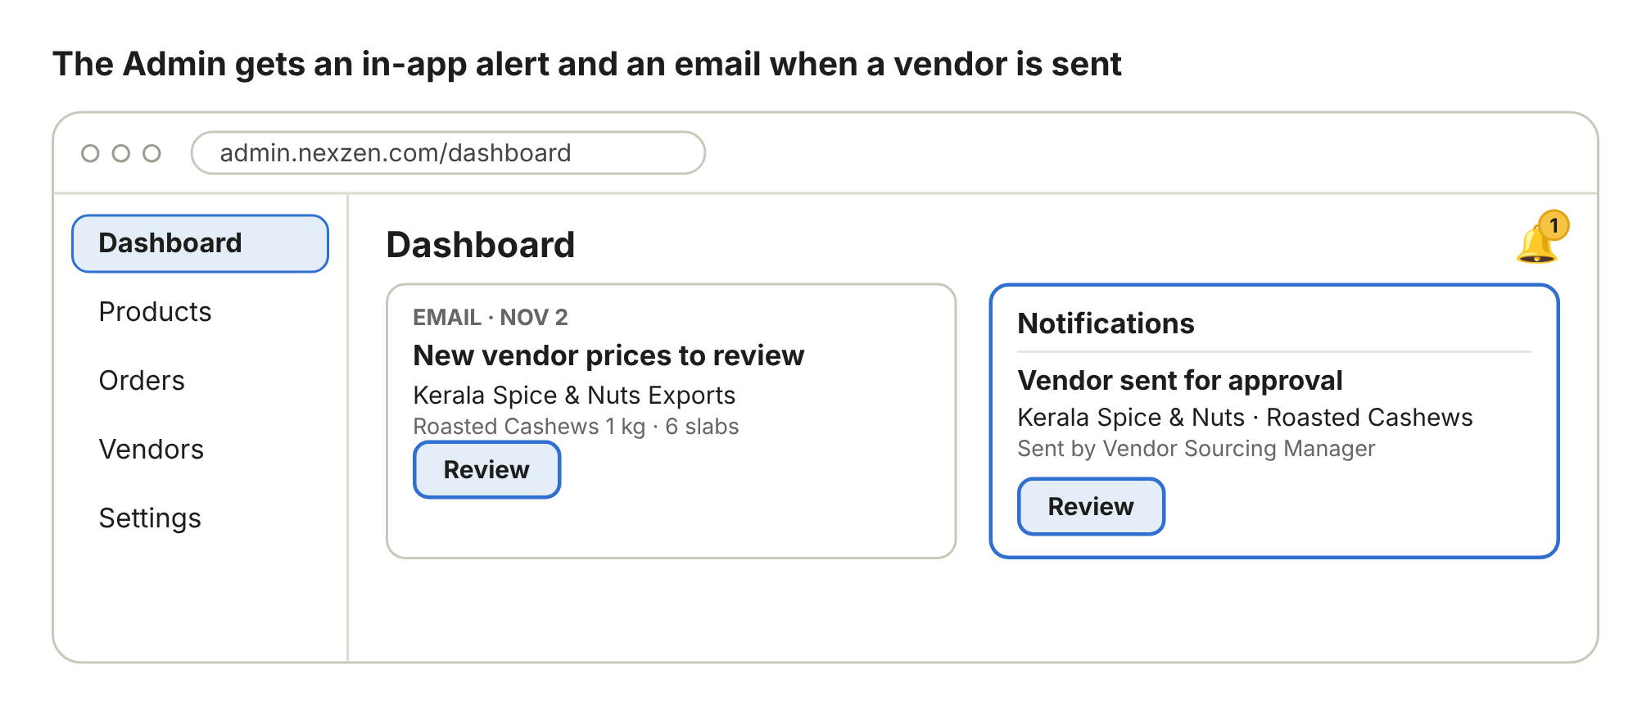
Wireframe: the Admin is notified in the app and by email.

Step 8: Admin reviews one vendor next to what is already in the system
Who | Admin
Screen | Review page, first vendor for the product
What happens | - Sees the vendor, lead time and slab table: Qty slab, Net price and Ship to warehouse.  - Sees Already in your system: current cost $9.80, selling price $14.99 and stock 340 units, with the note No other vendor yet.  - This shows at once whether the new net price ($9.20 to $8.10) beats the current cost, and how much stock is on hand.  - Chooses Approve or Request changes. Reject is also available. Leaving it open keeps it waiting for more vendors.
Result | The Admin decides, or waits until more vendors quote the same product.

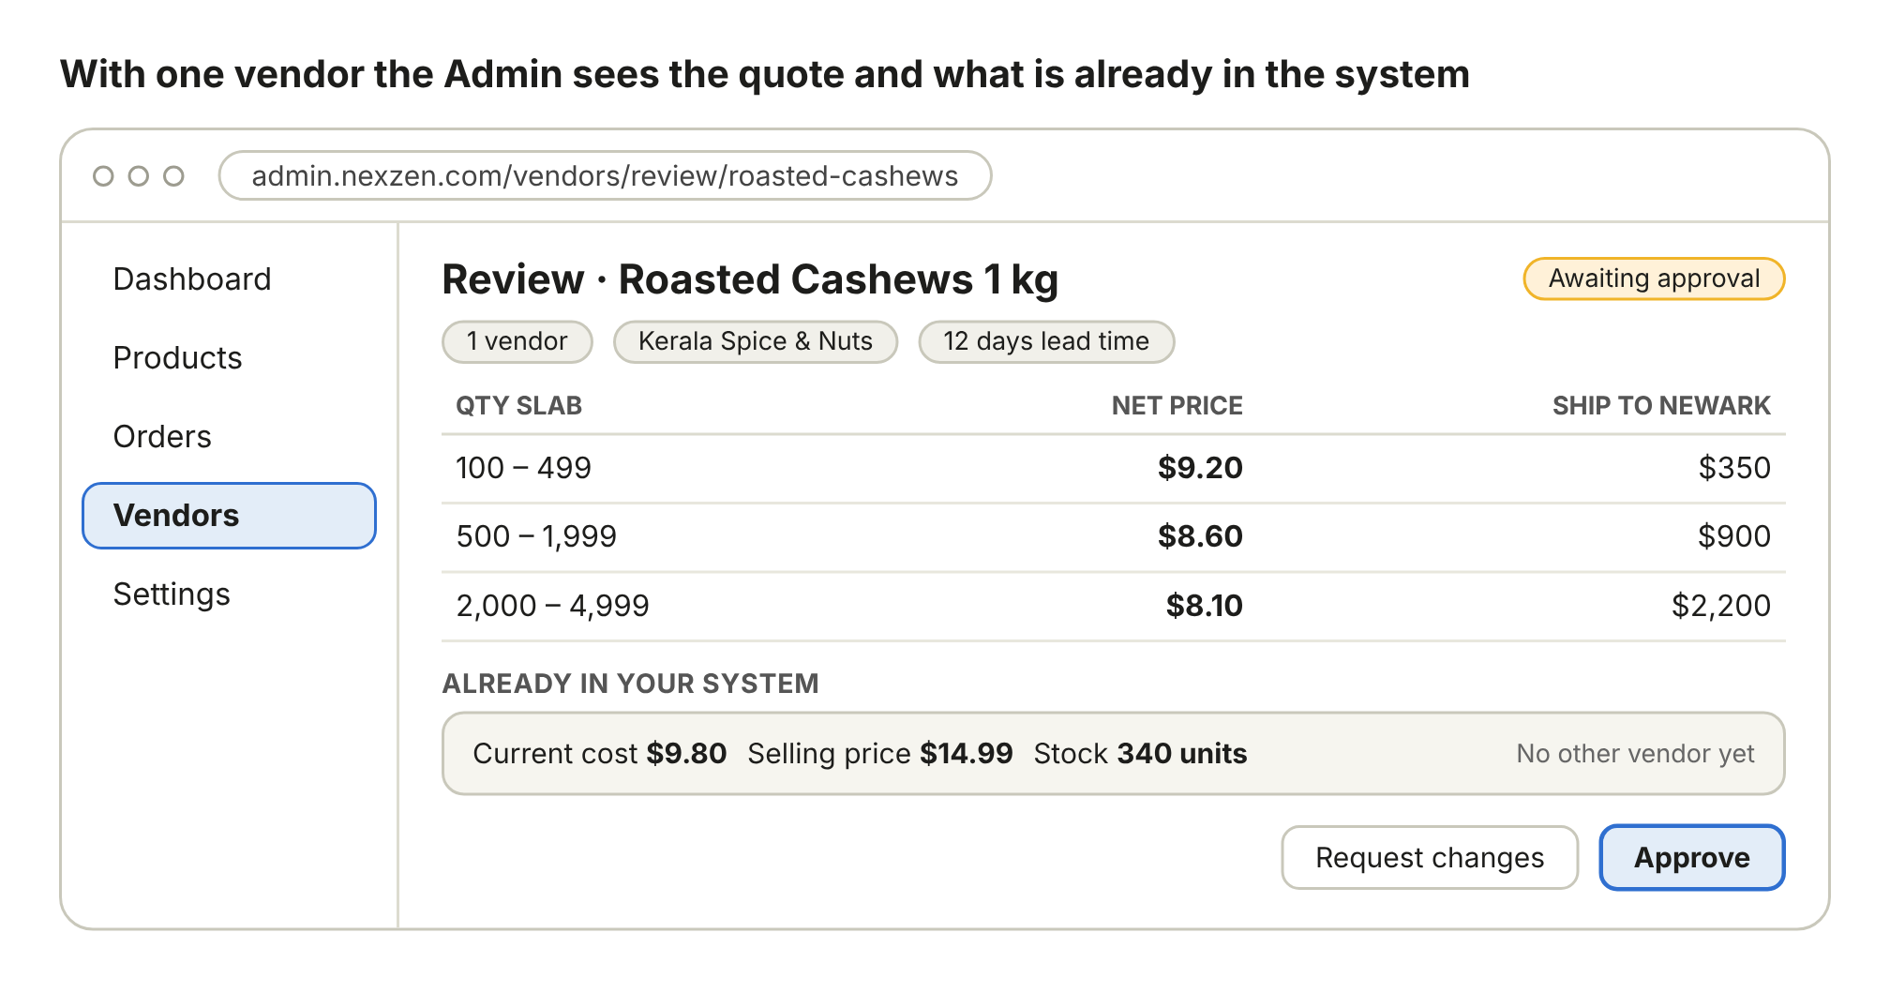
Wireframe: with one vendor the Admin sees the quote and what is already in the system.

Step 9: Admin compares vendors side by side with Gem-AI
Who | Admin and Gem-AI
Screen | Compare vendors page (opens when 2 or more vendors quoted the same product)
What happens | - Choose the Variant (for example Salted) and type the Order qty (for example 500). Everything recalculates.  - Each vendor card shows country, lead time, payment terms, shipping mode and terms (Sea CIF, Air DAP), transit days, MOQ (minimum order quantity) and its slabs with shipping totals.  - Each card shows Landed per unit at the chosen quantity, its rank and how much it saves.  - The Food terms table compares shelf life, certificates, storage, allergen label and replacement or claim days.  - The bar Best vendor by order quantity shows which vendor wins in each quantity band.  - The Gem-AI reason explains the choice and lists warnings to check before approving.
Result | The Admin sees the best vendor, why it is best, and what to check.

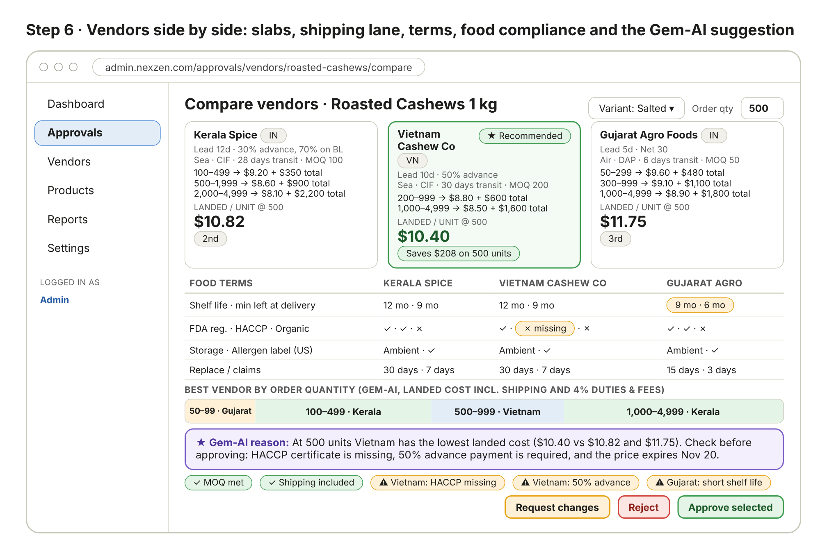
Wireframe: vendors side by side with slabs, shipping, terms, food compliance and the Gem-AI suggestion.
How Gem-AI works out the landed cost per unit
Landed cost per unit = (Net price of the slab for the order quantity + Shipping total of that slab / order quantity) x (1 + duties and fees %). In the wireframe duties and fees are 4%. Example for 500 units of Roasted Cashews 1 kg, Salted, delivered to Newark:
Vendor | Net price | Shipping total | Shipping per unit | Subtotal | With 4% duties and fees | Rank
Vietnam Cashew Co (200 to 999 slab) | $8.80 | $600 | $1.20 | $10.00 | $10.40 | 1st
Kerala Spice (500 to 1,999 slab) | $8.60 | $900 | $1.80 | $10.40 | $10.82 | 2nd
Gujarat Agro (300 to 999 slab) | $9.10 | $1,100 | $2.20 | $11.30 | $11.75 | 3rd
Savings for Vietnam over Kerala at 500 units = ($10.82 - $10.40) x 500 = $208. Kerala has the lowest net price but loses at 500 because its shipping is higher. This is why the shipping total must be entered for every slab.
Part of the screen | What the Admin reads
Best vendor by order quantity | Gujarat wins 50 to 99, Kerala wins 100 to 499, Vietnam wins 500 to 999, Kerala wins 1,000 to 4,999. The best vendor changes with quantity.
Gem-AI reason | At 500 units Vietnam has the lowest landed cost ($10.40 vs $10.82 and $11.75). Check before approving: HACCP certificate missing, 50% advance payment required, price expires Nov 20.
Warning tags | MOQ met, Shipping included, Vietnam: HACCP missing, Vietnam: 50% advance, Gujarat: short shelf life.

Step 10: Admin approves selected vendors or requests changes
Who | Admin
Screen | Decision page
What happens | - Tick Approve for each vendor to accept. More than one vendor can be approved for the same product.  - Give each approved vendor a Role: Primary (default supplier) or Backup (alternate supplier).  - Add a Note per vendor, for example Send HACCP later, or Add Chicago shipping.  - Write a Comment to Vendor Sourcing Manager for any vendor that needs changes.  - Click Approve selected, or Request changes. The Admin may choose a vendor other than the Gem-AI suggestion.
Result | Selected vendors are approved. Others are sent back with the comment, or rejected.

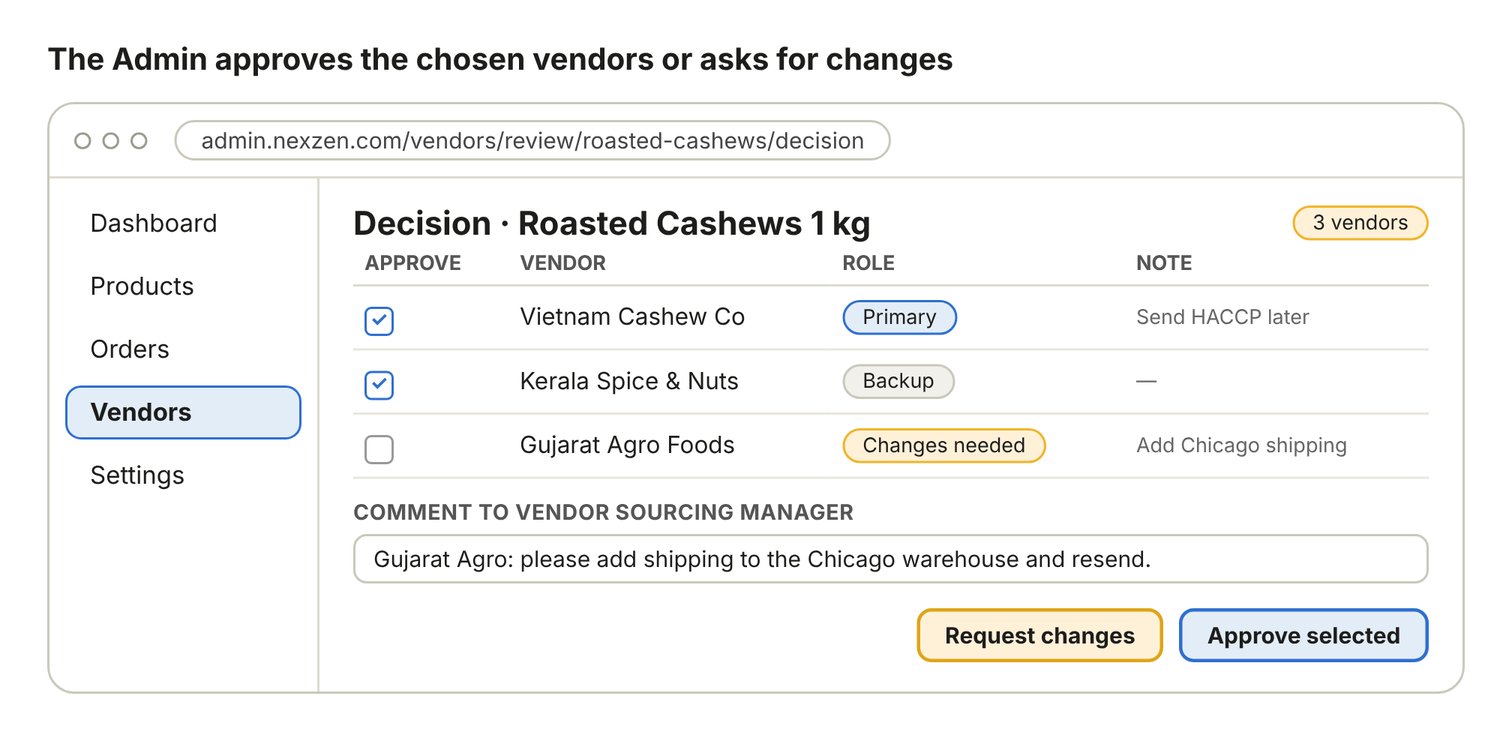
Wireframe: the Admin approves chosen vendors or asks for changes.

Step 11: Automatic onboarding after approval
Who | System
Screen | No screen (automatic)
What happens | - Each approved vendor becomes Active with its role: Primary or Backup.  - The vendor is linked to the product and each variant.  - Variant-wise slabs, discounts, net prices, warehouse shipping and courier rates are saved as the vendor cost.  - The Primary vendor becomes the default for purchasing that product. Backup stays ready as the alternate.  - Notes and comments are saved on the vendor. Manager and Admin are notified and action history is updated.
Result | Approved vendors are onboarded with no extra manual step. Stock is added later through the purchase invoice.

Step 12: Manager is notified, edits and resends
Who | Vendor Sourcing Manager
Screen | Notifications on the Vendors page, then Edit and resend
What happens | - The bell shows the count. The notification lists Changes requested with the Admin comment, and Approved vendors with their role.  - Click Edit and resend on the vendor that needs changes.  - Fix only what was asked, for example shipping to Chicago for each slab (50 to 299 and 300 to 999).  - Click Resend to Admin.
Result | The vendor returns to the Admin as Resent, Awaiting approval. Approved vendors are not affected.

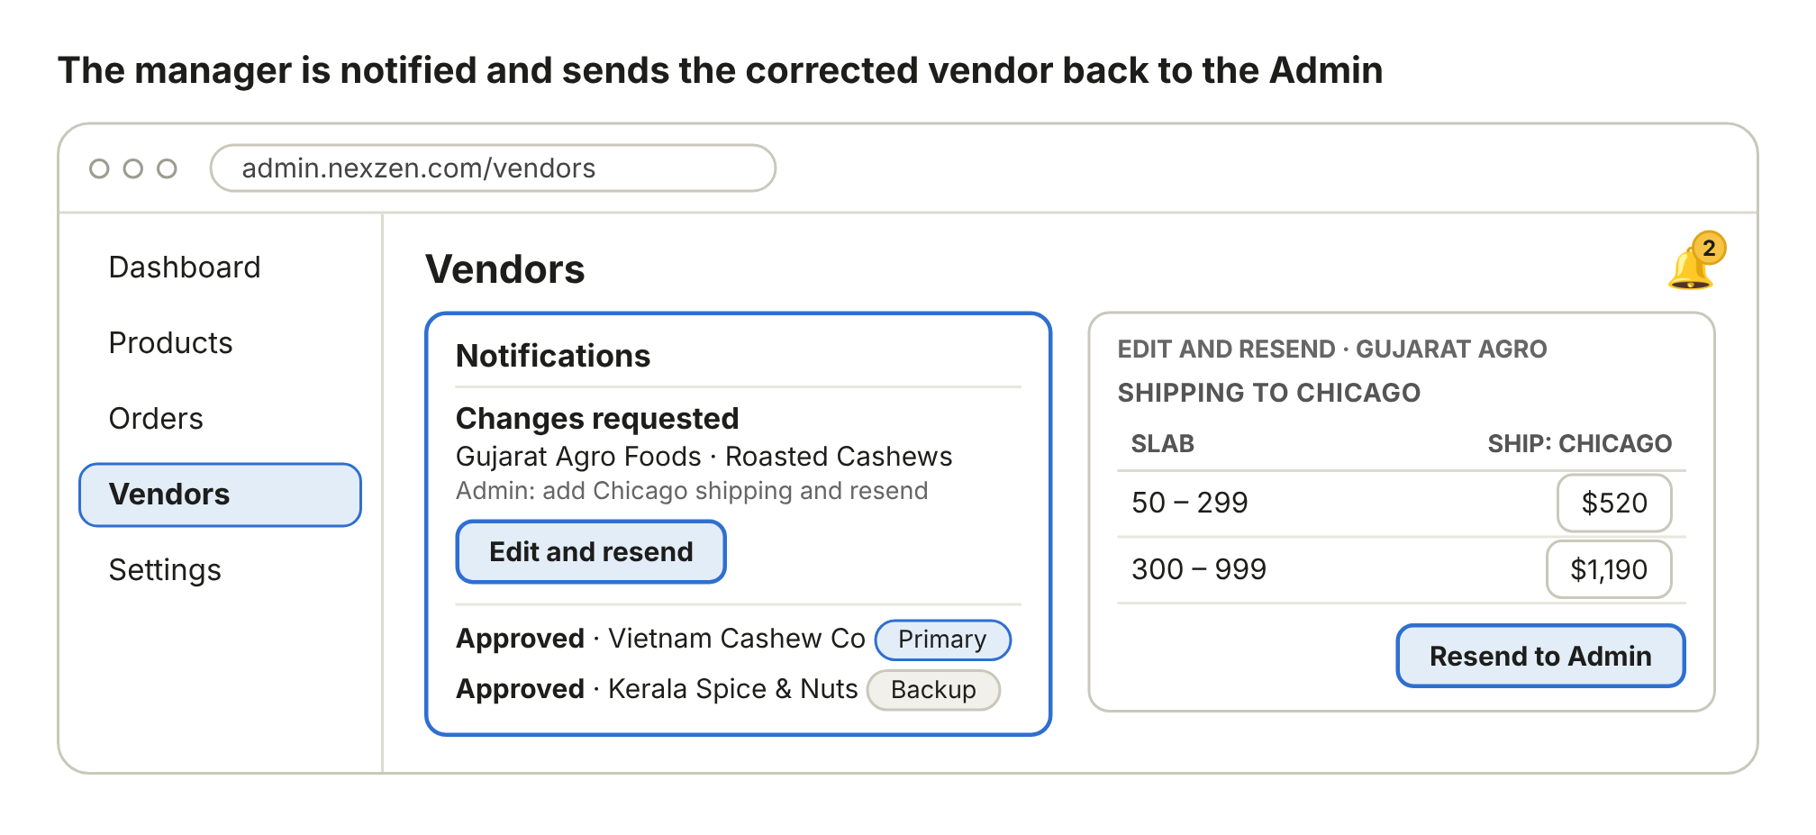
Wireframe: the manager is notified and sends the corrected vendor back to the Admin.

Step 13: Vendor list shows every vendor with its status
Who | Vendor Sourcing Manager and Admin
Screen | Vendors list
What happens | - Filter by status.  - Read each vendor: ships-from country, product and status.  - Click View to read a vendor, or Continue to finish a draft.
Result | Everyone sees the same current status for every vendor.

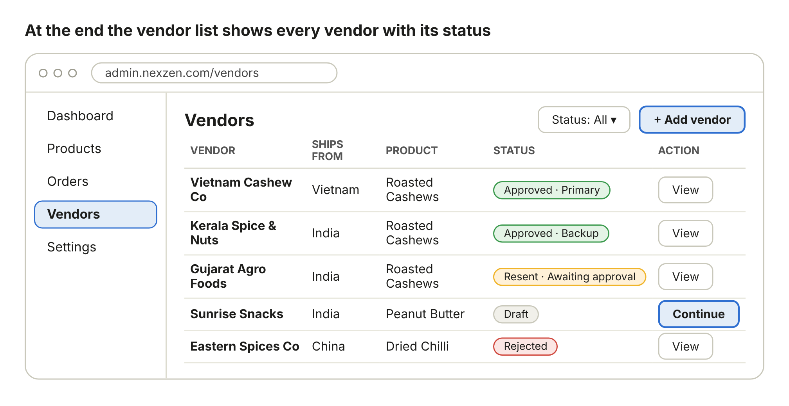
Wireframe: the vendor list shows every vendor with its status.

5. Screens and who uses them
Screen | Used by | Actions
Vendors list | Sourcing Manager, Admin | Filter, View, Continue a draft, + Add vendor (Sourcing Manager)
Add vendor (3 sections) | Sourcing Manager | Fill details, add products, enter variant slabs and courier rates, preview, Save draft, Send to Admin
Notification and email | Admin, Sourcing Manager | Review (Admin), Edit and resend (Sourcing Manager)
Review one vendor | Admin | Compare with current cost, price and stock, Approve, Request changes, Reject
Compare vendors | Admin | Pick variant and quantity, read Gem-AI, move to the decision
Decision | Admin | Approve selected as Primary or Backup, notes, comment, Request changes
Edit and resend | Sourcing Manager | Correct requested items, Resend to Admin

6. Status
Status | Set by | Meaning
Draft | Sourcing Manager | Saved, not sent. Continue to edit.
Awaiting approval | System | Sent to Admin. Locked for editing.
Changes requested | Admin | Needs correction. Shown in notifications.
Resent, Awaiting approval | System | Corrected and sent again.
Approved, Primary | Admin | Active vendor and default supplier.
Approved, Backup | Admin | Active vendor kept as alternate.
Rejected | Admin | Closed. A reason is saved.

7. Rules
- Quantity slabs are free-form and cannot overlap. Net price is always calculated from list price and discount.
- Shipping is always the total charge for the whole slab or shipment, from the vendor place to that warehouse.
- Every variant is priced separately. A variant the vendor does not supply is left empty and is not compared.
- If a vendor has no slab that covers the order quantity, Gem-AI marks it Not covered instead of guessing.
- Only the Admin approves. Gem-AI only suggests. A reason is saved when the Admin picks a vendor that Gem-AI did not suggest.
- SKU and internal codes are never shown. Variants appear by their options.
- Resending changes only the vendor that was sent back. Approved vendors stay approved.
- Every create, edit, approval, change request and resend is written to action history.

8. Gaps found in the wireframes (recommended additions)
The compare screen shows some data that the Add vendor wireframe has no field for. These need to be added so Gem-AI has the data it displays.
Shown on compare screen | Add this to the Add vendor page
MOQ, shipping mode, delivery terms (Sea CIF, Air DAP), transit days | Per product in section 2: Minimum order quantity, Shipping mode, Delivery terms, Transit days for bulk shipping
Price expires Nov 20 | Price valid until date in section 1
Shelf life, min left at delivery, FDA registration, HACCP, Organic, Storage, Allergen label, Replace and claim days | A Food and compliance block per product with certificate upload. Missing certificates then show as warnings.
Duties and fees 4% | An Admin setting, by country and product type, not typed per vendor
Courier rates from Hyderabad | The courier block uses the vendor place from section 1, so it works for any country
Also, the picture titles in the uploaded document say Step 4 to Step 9, while the headings say Step 2 to Step 7. This document uses one numbering, Step 1 to Step 13.

9. Using the existing code base
Reuse | Vendor list and add form, Sourcing Manager role, admin approval, notifications and email, action history, products and variants, warehouses, stock and cost shown on the product, purchase invoices
New | Vendor quote per product with status, variant slab rows (from, to, list price, discount, net price), shipping per slab and warehouse, courier rate rows, food and compliance fields, compare and Gem-AI service, Decision with Primary and Backup roles, onboarding action
Build split | One Backend subtask and one Frontend subtask, each covering all functionality
This mapping is based on what has been shared about the app. Exact files can be listed once the repo folders are shared.

10. Questions to confirm
- Should duties and fees default to 4% for every country, or differ by country and product?
- Which food compliance fields are mandatory before a vendor can be sent to the Admin?
- Should Gem-AI use courier rates for orders up to 100 packets and slab shipping above that?
- When the Primary vendor cannot supply, should the Backup be used automatically or only suggested?

