NexZen EGFPOS
E-commerce Module
End-to-End Flow, Roles and Flow Charts
A simple guide to how an order travels from company setup to delivery and return, and what each role does at each step.
Product | NexZen EGFPOS, e-commerce module (MERN stack)
Roles covered | Super Admin, Admin, Manager, Warehouse Manager, Picker, Packer, Vendor Sourcing Manager, Dropper, Customer
Carrier | FedEx (shipping rates, labels, tracking, returns)
Warehouses | Current US store / default warehouse, and other warehouses (for example India)
Version | Draft 5, 1 October 2026

How to read this document
- Every step shows who does it, what happens in simple words, a real-world example and what the system does.
- Orange rows are missing points in the current flow. Blue rows list what is required to implement the step.
- Example people: Alex (Admin), Nina (Manager), David (Vendor Sourcing Manager), Sarah (Warehouse Manager, Chicago Hub, US), Ravi (Warehouse Manager, Hyderabad Hub, India), John (Picker), Maria (Packer), Tom (Dropper), Emily (Customer). Company: FreshNest Organics.

Contents
1. The big picture
2. Roles and page access
3. Phase A: Setup, catalog and stock (steps 1 to 10)
4. Phase B: Storefront and checkout (steps 11 to 14)
5. Phase C: Order fulfilment (steps 15 to 19)
6. Phase D: Returns and refunds (steps 20 to 23)
7. Missing points in the current flow, with solutions
8. Supporting flows missing from the 23 steps
9. Status lifecycles and data to store
10. Test scenarios before launch
11. Suggested order of building
12. A day in the life of each role
Glossary

1. The big picture
An order moves through six stages and may end in a seventh (return). Each stage has one main owner.
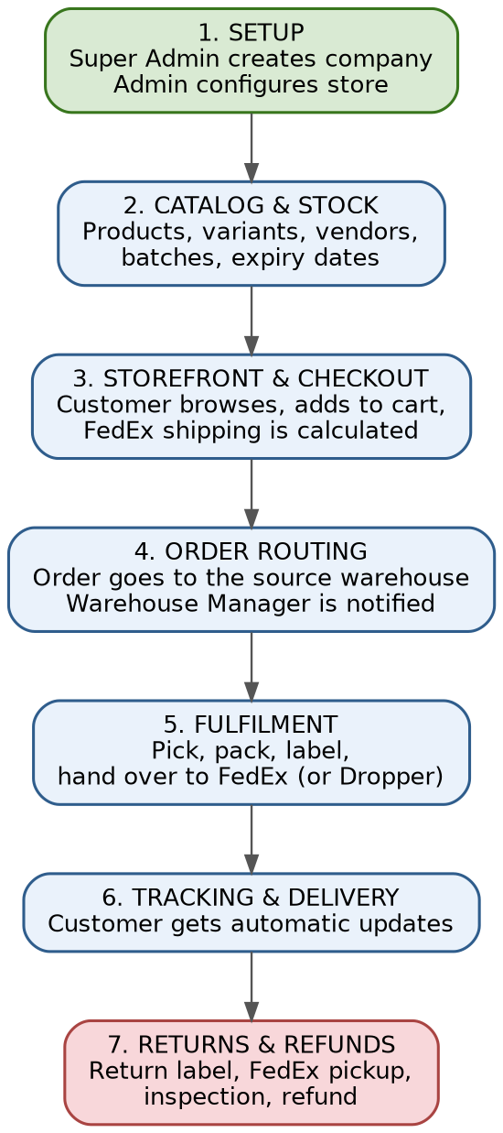
Order status seen by staff and customer:
Main modules of an enterprise e-commerce system:
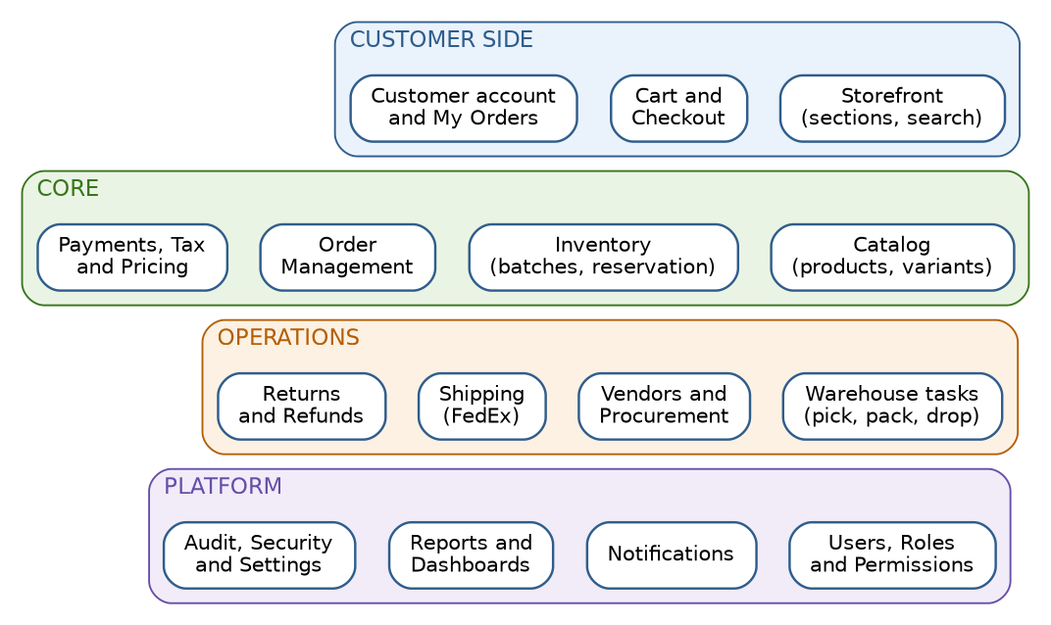

2. Roles and page access
These are the e-commerce roles, plus the Super Admin and the Customer.
Role | What they do in simple words | Like this in a real business
Super Admin | Works in the Nexzentek panel. Creates companies and their first Admin. | Company that sells the software
Admin | Owner of the store. Sets everything up and sees everything. | Store owner
Manager | Runs daily business. Sees all pages, like the Admin. | Operations manager
Vendor Sourcing Manager | Finds vendors, adds products, updates stock and purchases. | Buyer / procurement officer
Warehouse Manager | Runs a warehouse. Accepts orders, checks stock, assigns tasks, receives goods and returns. | Warehouse supervisor
Picker | Travels to vendor places, picks items from the vendor and hands them over at the warehouse. Can do Packer duties when staff are short. | Purchase runner
Packer | Picks in-house products from the warehouse, packs, prints label and hands the parcel to FedEx. Can do Picker duties when staff are short. | Packing station worker
Dropper | Hands parcels to FedEx when the pickup is missed. | Delivery runner
Customer | Buys on the storefront, tracks the order, requests returns. | Online shopper

Pages by role
Page | Admin | Manager | Warehouse Manager | Vendor Sourcing | Picker / Packer / Dropper
Dashboard | Yes | Yes | Yes | - | -
Products | Yes | Yes | Yes | Yes | -
Users | Yes | Yes | Yes | - | -
Warehouses | Yes | Yes | Yes | - | -
Purchases | Yes | Yes | Yes | Yes | -
Expenses | Yes | Yes | - | - | -
Customers | Yes | Yes | - | - | -
Settings | Yes | Yes | - | - | -
Admin | Yes | Yes | - | - | -
Orders | Yes | Yes | Yes | - | -
Returns | Yes | Yes | Yes | - | -
To-do task list | - | - | - | - | Yes (own tasks only)
Admin and Manager see all pages. The Vendor Sourcing Manager sees Products and Purchases. Picker, Packer and Dropper see only their To-do task list. Warehouse Manager access is limited to the user's own warehouse.

Recommended action permissions
Pages show where a role can go. This table shows what a role can do. It is a recommendation for an enterprise set-up. Please compare it with your application. 'Own WH' means only the user's mapped warehouses. A star (*) means only if you allow it.
Action | Admin | Manager | WH Mgr | Sourcing | Picker | Packer | Dropper
Create and edit users | Yes | Yes | Own WH* | - | - | - | -
Create and edit warehouses | Yes | Yes | - | - | - | - | -
Map users and products to warehouses | Yes | Yes | Own WH | - | - | - | -
Create and edit categories and products | Yes | Yes | - | Yes | - | - | -
Enable products for the store | Yes | Yes | - | Yes | - | - | -
Create and edit vendors | Yes | Yes | - | Yes | - | - | -
Add stock (goods receipt) | Yes | Yes | Own WH | Yes | - | - | -
Adjust stock (needs reason) | Yes | Yes | Own WH | Approval | - | - | -
View orders | All | All | Own WH | - | - | - | -
Accept or reject an order | Yes | Yes | Own WH | - | - | - | -
Assign tasks to staff | Yes | Yes | Own WH | - | - | - | -
Do vendor pickup tasks | - | - | Own WH | - | Yes | - | -
Do pick and pack tasks | - | - | Own WH | - | - | Yes | -
Create FedEx label and request pickup | Yes | Yes | Own WH | - | - | Yes | -
Do drop-off tasks | - | - | Own WH | - | - | - | Yes
Cancel or transfer an order | Yes | Yes | Own WH | - | - | - | -
Receive and inspect returns | Yes | Yes | Own WH | - | - | - | -
Approve returns and refunds | Yes | Yes | Suggest | - | - | - | -
Change settings and company profile | Yes | Yes | - | - | - | - | -
View reports | All | All | Own WH | Sourcing | - | - | -
View activity log | Yes | View | - | - | - | - | -

3. Phase A: Setup, catalog and stock (steps 1 to 10)
This phase is done first, then updated when new products or warehouses are added. It is mainly done by Admin, Manager and Vendor Sourcing Manager.
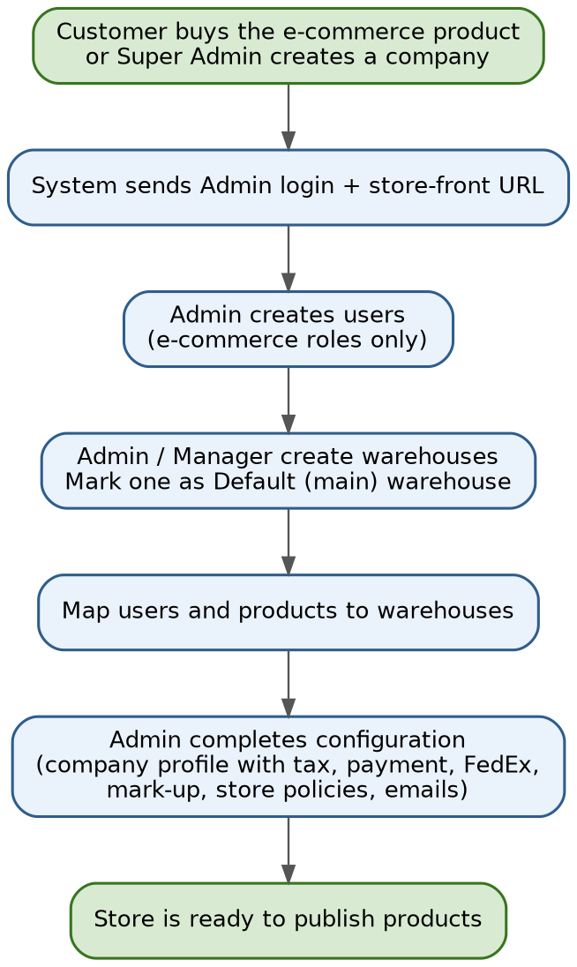
Step 1 Company is created and the Admin receives login details
Who | Super Admin (Nexzentek panel), then the company Admin
What happens | When a customer buys the e-commerce product (or the Super Admin creates the company), the system creates the company, its admin panel, its storefront and one Admin user. The Admin receives the admin panel link, the storefront URL and the login details.
Real-world example | FreshNest Organics buys the e-commerce product. Alex (the owner) receives an email with the admin panel link, the storefront link and his login details.
What the system does | Creates the company, adds only the e-commerce roles and the e-commerce side menu, creates the first Admin user and sends the login email.
Required to implement | - Tenant set-up job: company record with a company ID, company profile, default settings, the 7 e-commerce roles, the first Admin, store address (sub-domain) and security certificate.  - Welcome email with a one-time set-password link that expires (24 to 72 hours); force password change and verify email.  - Plan limits per company (users, warehouses, products, orders per month) and a product flag so only e-commerce menus show.  - Super Admin page: company list, status (Active / Suspended), resend invite, reset Admin password, activity log.  - Company separation: every query and every API call must filter by company ID.

Step 2 Admin creates users
Who | Admin
What happens | Admin creates people and gives each one a role. The role list shows only e-commerce roles: Admin, Manager, Warehouse Manager, Picker, Packer, Vendor Sourcing Manager and Dropper.
Real-world example | Alex creates Nina (Manager), David (Vendor Sourcing Manager), Sarah (Warehouse Manager, US), Ravi (Warehouse Manager, India), John (Picker), Maria (Packer) and Tom (Dropper).
What the system does | Saves the user, sends the login details and shows only the pages allowed for that role.
Required to implement | - Users page: create, edit, deactivate, reset password. Fields: name, email, phone, role, mapped warehouses, status, last login.  - Rules: email unique per company; the company must always keep one active Admin; role changes are logged; a deactivated user is logged out at once and open tasks are handed to the Warehouse Manager.  - Optional: two-step login for Admin and Manager.

Step 3 Create products and vendors
Who | Admin, Manager, Vendor Sourcing Manager
What happens | These three roles add vendors (suppliers) and products with complete details.
Real-world example | David adds a new supplier, EcoFoods Corp, with contact details and address, and adds their product Organic Almond Milk.
What the system does | Saves the vendor and the product. The vendor page lists all products supplied by that vendor.
Required to implement | - Vendor form: name, contact person, phone, email, address, country, tax ID, payment terms, usual lead time (days), currency, status (Active / Blocked), rating, receiving warehouse, documents (licence, certificates), notes.  - Vendor to product link: vendor SKU, cost price, minimum quantity, lead time, preferred vendor. One product can have several vendors.  - Product basics: name, brand, category, description, images, status (Draft / Active / Archived).  - Checks: duplicate vendor (same name or tax ID) and duplicate SKU.  - Setting: optional approval (Draft to Approved by Admin or Manager).

Step 4 Each role sees only its own pages
Who | All roles
What happens | Admin and Manager see all pages. Vendor Sourcing Manager sees Products and Purchases. Orders and Returns are separate pages in the Admin side menu. Picker, Packer and Dropper do not use the Admin side menu. They get a separate To-do task list page with their own tasks only.
Real-world example | David logs in and sees only Products and Purchases. Maria (Packer) logs in and sees only her packing to-do list.
What the system does | Builds the pages and menu from the role, and shows only the data of the user's own warehouse.
Required to implement | - Permission table stored per company: page and action (view, create, edit, delete, approve) with warehouse scope (all or own).  - Frontend: menu built from permissions.  - Backend (most important): every API checks login, company, permission and warehouse scope. Hiding a menu is not enough.  - Task pages for Picker, Packer and Dropper: only tasks assigned to them (or the unassigned tasks of their warehouse), mobile-friendly, big buttons.  - Tests: try every role on every API and confirm the blocks.

Catalog and stock flow (steps 3, 5, 6 and 7):
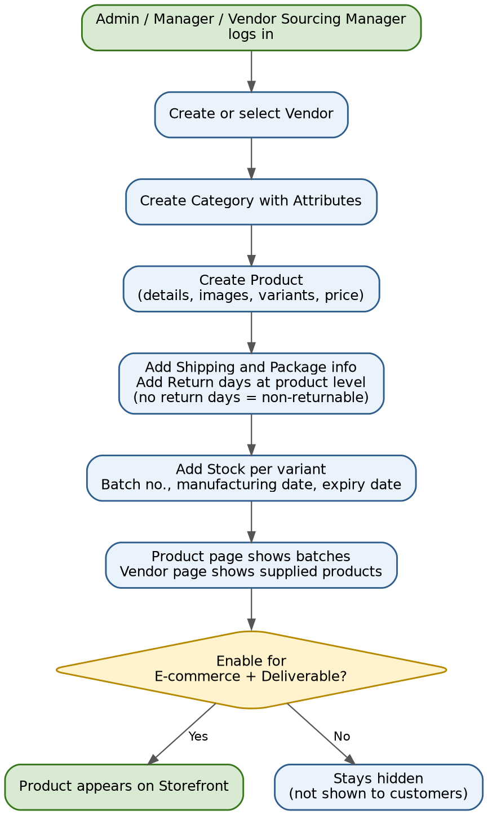
Step 5 Categories, attributes, products with variants, shipping, package and return information
Who | Admin, Manager, Vendor Sourcing Manager
What happens | First a category (for example Beverages) with attributes (size, flavour). Then products with variants. Every product gets shipping and package information. Return days and return rules are set at product level (not per variant). A product with no return days added is shown as non-returnable by default.
Real-world example | Category Beverages with attributes Size and Flavour. Product Organic Almond Milk with variants 1 L and 500 ml. Package: 4x4x8 in, 2.2 lb. Return days: 7 (returnable).
What the system does | Saves variants, shipping and package details (used later for FedEx rates and labels) and the return settings (used later when the customer asks for a return).
Missing point | Add customs and compliance data per product (HS code, country of origin, customs description, food fields, restricted countries), shelf-life rules, maximum order quantity and vendor-sourcing settings. See 7.1, 7.2, 7.7 and 7.8.
Required to implement | - Category tree (parent and child). Attributes: name, type (text, number, list), required, used for variants, shown as storefront filter.  - Variant (from attribute combinations): SKU (unique), barcode, price, compare-at price, cost price, tax class, images, status.  - Shipping and package per variant: weight, length, width, height, units, fragile, liquid, perishable, hazard, ship-alone, handling days.  - Return settings per product: return days, return handling (Return required / Refund without return allowed / Decide by rule). No return days means non-returnable.  - Compliance per product: HS code, country of origin, customs description, default customs value, food fields (see 7.2).  - Expiry and ordering per product: has expiry, minimum shelf life for customer, minimum and maximum order quantity, sell when out of stock, vendor lead time.  - Checks: weight and size are mandatory before a product can be Deliverable.

Step 6 Enable products for e-commerce and delivery
Who | Admin, Manager, Vendor Sourcing Manager
What happens | A product is shown in the store only when it is switched on as E-commerce enabled and Deliverable.
Real-world example | Nina switches on Organic Almond Milk. A product still being tested is left off.
What the system does | Shows enabled products and variants on the storefront and hides the others.
Missing point | A product cannot be enabled for a destination country until its compliance data is complete. See 7.1.
Required to implement | - Flags: E-commerce enabled and Deliverable, and the list of countries it can be delivered to.  - Publish checklist enforced by the system: image, price above 0, package info, at least one active variant, compliance data for cross-border, and either stock in a warehouse or sourcing allowed.  - Published date is saved (used by the Just Launched section); optional scheduled publish.  - Bulk enable and disable with an activity log.

Step 7 Update stock by variant with manufacturing date, expiry date and batch
Who | Vendor Sourcing Manager, Admin, Manager
What happens | Stock is updated per variant. Each batch saves its manufacturing date, expiry date and quantity. The product details page shows the batch information and the vendor details page shows what that vendor supplied.
Real-world example | Batch AM-2026-09: 500 cartons of Almond Milk 1 L, made on 1 Sep 2026, expiring on 1 Dec 2026, from EcoFoods Corp.
What the system does | Creates the batch record, adds the quantity to the variant stock and links the batch to the vendor and the warehouse.
Missing point | Add the minimum shelf-life rule and a Near expiry / Not for sale batch status. See 7.7.
Required to implement | - Stock screen per variant and per warehouse showing on-hand, reserved, available, incoming from vendors, quarantine and damaged.  - Stock entry fields: warehouse, variant, quantity, batch number, manufacturing date, expiry date, vendor, cost per unit, received date, reference (pickup record, purchase or manual) and a reason for manual changes.  - Stock ledger: every change is a line (type, quantity, before, after, user, time, reference). Lines are never edited.  - Checks: expiry after manufacturing, batch number unique per variant and warehouse, stock cannot go below zero.  - Alerts: low-stock level and reorder point per variant.

Step 8 Create warehouses and set the default (main) warehouse
Who | Admin, Manager
What happens | Warehouses are created with their address and configuration. One warehouse is the default (main) warehouse, which is also the company store address. A warehouse can act as a store.
Real-world example | Sarah's Chicago Hub (US) is the default warehouse and company store. Ravi's Hyderabad Hub (India) is another warehouse.
What the system does | Saves the address and configuration. The default warehouse is the first place checked for stock when a customer orders.
Required to implement | - Warehouse form: name, code, type (Warehouse / Store / Both), full address, country, time zone, currency, contact, working days and hours, daily cut-off time, handling days, return address, countries it serves, status, FedEx account and pickup settings, tax and customs registrations.  - Rules: exactly one default warehouse; an address is converted to map position (for distance); a warehouse with open orders or stock cannot be switched off before transfer.

Step 9 Map users and products to warehouses
Who | Admin, Warehouse Manager
What happens | Users and products are linked to warehouses. Only then do those users see the work of that warehouse.
Real-world example | John and Maria are mapped to Chicago Hub. Almond Milk is mapped to both hubs, each hub with its own stock.
What the system does | Filters orders, stock and tasks by the warehouse of the user.
Required to implement | - Mappings: user to warehouse (many to many), variant to warehouse (through stock), vendor to receiving warehouse.  - Rules: a variant with no warehouse and no sourcing is not sellable; every list a user opens is filtered by their warehouses.  - Bulk mapping and an activity log.

Step 10 Remaining admin configuration
Who | Admin
What happens | Admin completes the other configuration before the store goes live. Tax is configured in the company profile. The company profile also holds the mark-up used on FedEx shipping prices. The Admin also sets up the payment method for the store and the store policy pages (for example Terms, Privacy, Shipping and Return policy). Delivery configuration, email notifications and the storefront details are also set here.
Real-world example | Alex opens the company profile and sets the tax, the shipping mark-up (10%) and the support email. He connects the store payment method and adds the policy pages.
What the system does | Saves the configuration and uses it in checkout, invoices and emails.
Required to implement | - Company profile: legal name, address, tax IDs, logo, support email and phone, currency, time zone, tax settings (US sales tax, India GST), shipping mark-up rule, default return limits, order number format, invoice template.  - Payment: gateway connection with test and live keys and the webhook address.  - FedEx: credentials, account number per warehouse, allowed services, mark-up (percent or fixed per service), free-shipping limit, backup flat rates.  - Store policy pages (Terms, Privacy, Shipping, Returns), email templates and sender address, domain and certificate.  - Setup progress list on the Admin dashboard.

4. Phase B: Storefront and checkout (steps 11 to 14)
This is what the customer sees. The customer is Emily, shopping from Chicago.
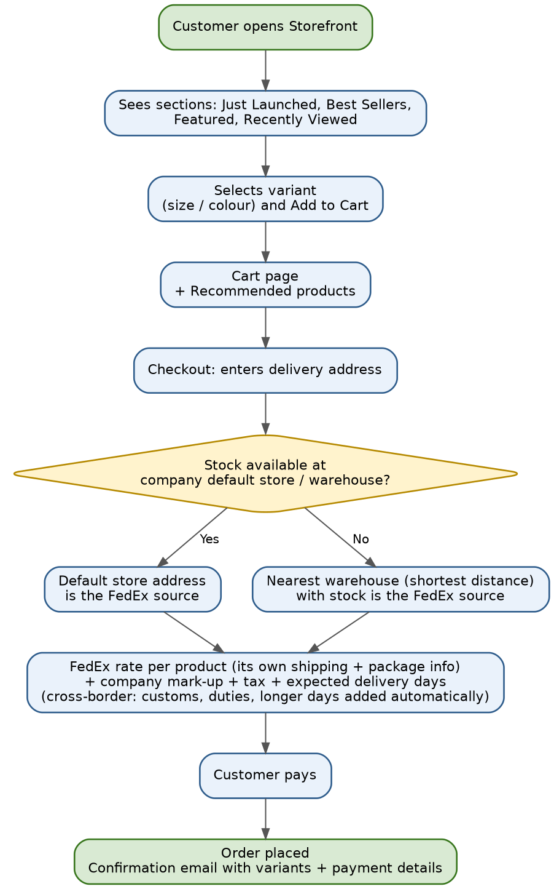
Step 11 Storefront shows products, variants and sections
Who | Customer
What happens | The store shows products with their variants and sections such as Just Launched, Best Sellers, Featured Products and Recently Viewed.
Real-world example | Emily opens the store and sees Organic Almond Milk under Just Launched. Recently Viewed shows what she looked at yesterday.
What the system does | Builds each section and shows only products that are e-commerce enabled and deliverable.
Missing point | Show Available-to-sell stock, an Only N left message and a maximum order quantity. Vendor-sourced products show Ships in X days. See 7.8.
Required to implement | - Section rules saved in settings: Just Launched (published in the last N days), Best Seller (units sold in the last N days), Featured (chosen by Admin or Manager, with order), Recently Viewed (cookie for guests, saved for logged-in customers).  - Catalog API with filters (category, attributes, price, availability), search, sorting and paging; variant selector shows its own price, image and stock status.  - Visibility rule: enabled, deliverable to the customer's country, and sellable stock or sourcing allowed.  - Extras: Notify me for out-of-stock, fast images from a CDN, cached section queries.

Step 12 Select variant, add to cart, recommended products
Who | Customer
What happens | The customer selects a variant and clicks Add to Cart. The cart page also shows recommended products.
Real-world example | Emily selects 1 L, quantity 2, and adds it to the cart. Below the cart she sees Oat Milk 1 L as a recommendation.
What the system does | Saves the item with its variant in the cart and suggests related products.
Required to implement | - Cart: guest cart (cookie) and customer cart, merged at login. Each line stores variant, quantity and the price seen. Minimum and maximum quantity checks.  - Re-check price, stock and shelf life on every cart change and again at checkout.  - Recommendations: rule-based (same category, bought together, best sellers) and never out-of-stock items.  - Optional: coupon code, cart expiry (for example 30 days).

Step 13 Checkout: shipping source, FedEx shipping price, mark-up and delivery days
Who | Customer, system
What happens | After the delivery address is entered, the system first decides the source address for FedEx. It checks stock in the company default store / warehouse. If stock is available there, the default store address is the source. Otherwise it checks the other warehouses and uses the nearest warehouse (shortest distance) that has stock. The system detects this automatically from stock and distance. Then FedEx gives the shipping price using each product's own shipping and package settings. The company mark-up from the company profile is added. The customer sees the delivery options allowed by the product's shipping and delivery settings (for example Standard or Express), each with its price and expected delivery days, and picks one. Tax from the company profile is added to the total. When the source warehouse is in another country (for example India to US), the system automatically adds the customs and duty details and the longer delivery time.
Real-world example | Emily (Chicago) enters her address. Chicago Hub has stock, so it is the FedEx source. FedEx rate $6.00 + 10% mark-up = $6.60. Expected delivery: 3 to 4 days.
What the system does | Checks stock in the default warehouse, then in nearest warehouses, asks FedEx for rates, adds mark-up and tax, and shows total and delivery days.
Missing point | Check shipping rules per product and destination, prefer one warehouse that holds all items, and show separate packages when a split is needed. See 7.1, 7.6 and 7.8.
Required to implement | - Address form with country and state lists, phone and email; address validation through the FedEx Address Validation API; saved addresses for customers.  - Allocation service: input cart and address, output a plan. Order of checks: shipping rules, shelf life, default warehouse with all items, nearest single warehouse with all items, split with fewest packages. The reason for the choice is saved.  - Packing logic: build boxes from item size and weight (or one box per item) and call the FedEx Rates and Transit Times API for each package; filter service options by the product's shipping settings.  - Price build-up: FedEx rate + mark-up + tax by ship-to address + duties for cross-border. Delivery days = handling days + FedEx transit days + vendor lead time (if sourced).  - Quote: saved with an expiry (for example 30 minutes) and recalculated on the server at payment. If FedEx does not answer, show the backup flat rates.

Step 14 Order placed email
Who | Customer, system
What happens | After payment, the customer receives an email with the ordered products, their variant details and the payment details.
Real-world example | Emily receives an email: 2 x Organic Almond Milk 1 L, shipping $6.60, paid by card.
What the system does | Creates the order, saves the payment and sends the email.
Required to implement | - Order creation in one transaction: order header (order number from a sequence, customer, addresses, currency, totals), lines (variant, quantity, price, tax), planned packages, payment record, and stock reservation by batch, earliest expiry first.  - Idempotency key so a double click never creates two orders.  - Payment: the order is confirmed only after the gateway confirms payment (see 8.3). Failed or abandoned payment releases the reservation after a time limit.  - Emails: customer confirmation (items, variants, shipping option, estimated delivery, payment summary, invoice link); Admin and Manager new-order summary.  - Customer pages: My Orders and a tracking link for guests.

5. Phase C: Order fulfilment (steps 15 to 19)
Now the order becomes work for the warehouse team. Decisions are shown as yellow diamonds.
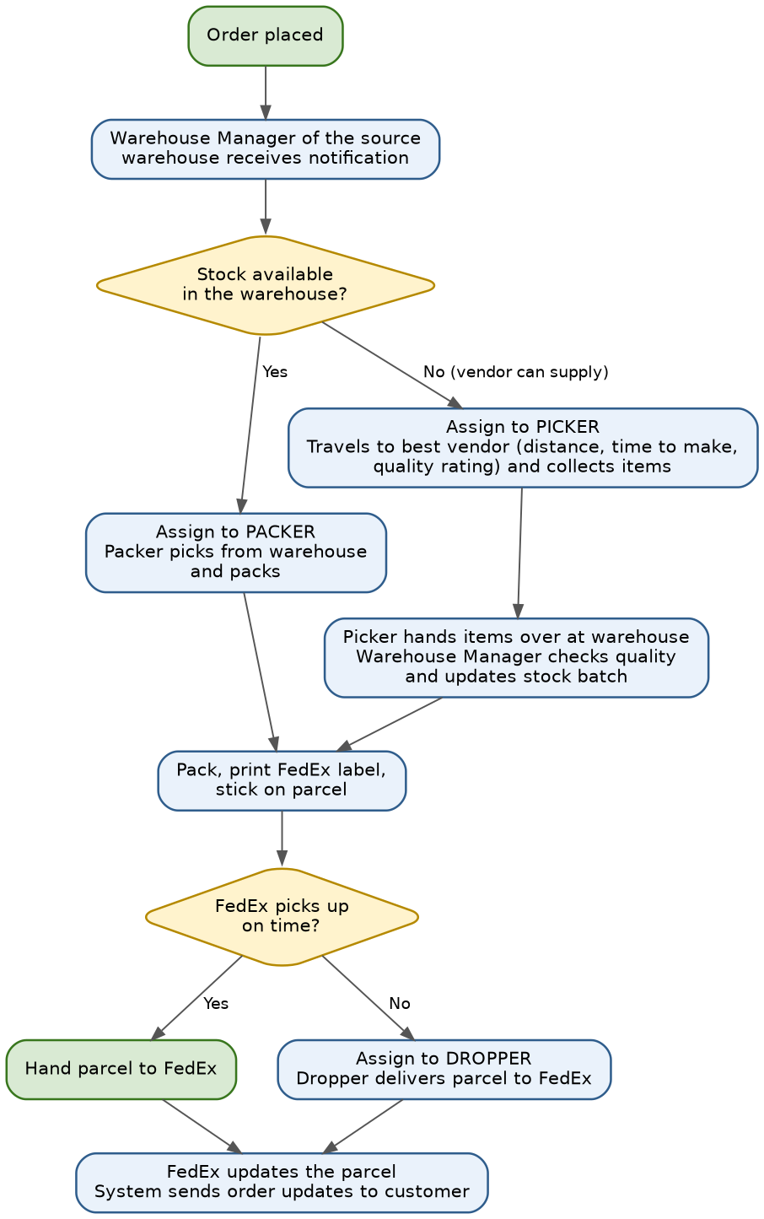
Step 15 Order goes to the source warehouse; Warehouse Manager is notified
Who | System, Warehouse Manager
What happens | The order goes to the same source warehouse that was used for the FedEx price: the current store (within US) or another warehouse (for example in India). That Warehouse Manager is notified. The stock for the order is already reserved.
Real-world example | Emily's order goes to Chicago Hub. Sarah receives a notification on her dashboard.
What the system does | Creates the order in the Orders page of that warehouse and sends the notification.
Missing point | The Warehouse Manager needs an order queue with batching and a daily cut-off, not one alert per order. See 7.4.
Required to implement | - Routing service re-checks stock at order time, creates one fulfilment order per warehouse and sets timers (accept within X hours, ship within Y hours).  - Orders page filters: status, warehouse, age, cross-border flag, priority.  - Warehouse Manager actions: Accept, or Reject with a reason (this starts transfer or cancel, see 7.5).  - Escalation: not accepted in time, alert Admin and Manager; if there is no Warehouse Manager, Admin can act.

Step 16 Warehouse Manager checks stock and assigns the work
Who | Warehouse Manager, Packer, Picker
What happens | The Warehouse Manager checks the stock. If stock is available, the order is assigned to a Packer, who picks the products from the warehouse (in-house staff) and packs them. If stock is not available and a vendor can supply, the order is assigned to a Picker, who travels to the vendor's place, picks the items and hands them over at the warehouse. The best vendor is chosen using distance, time to make the products and quality or ranking. When staff are not enough, a Picker can do the Packer's duties and a Packer can do the Picker's duties. If a task is not picked up in time, the Warehouse Manager and the Admin are notified. If no staff are available, the Warehouse Manager can do the task.
Real-world example | Sarah sees 450 cartons on the shelf, so she assigns Emily's order to Maria (Packer). For another product with no stock, she picks a nearby vendor and assigns John (Picker) to go and collect it.
What the system does | Shows the stock, shows vendors with distance, time and rating, and puts the task on the To-do list of the assigned person.
Missing point | Add the actions Transfer to another warehouse, Wait for vendor and Cancel, each with a reason, an audit log, Admin alerts and a vendor delay register. See 7.5.
Required to implement | - Stock check screen per order line: sellable batches (earliest expiry first), reserved quantity, shelf place.  - Task creation: Pack task for a Packer; Vendor pickup task for a Picker with vendor, items, quantity, agreed price (optional), contact, promised date and address.  - Vendor suggestion list with distance, lead time, rating, on-time percent, price and last supplied date.  - Task states: Unassigned, Assigned, Accepted, In progress, Done, Failed (with reason). Tasks can be picked from a pool or assigned by name.  - Timers and escalation: not accepted in X minutes, alert the Warehouse Manager and Admin; the Warehouse Manager can take the task.  - To-do list page for staff: task card, items, quantity, deadline, buttons Start, Done and Report a problem.

Step 17 Goods reach the warehouse, batch updated, pack, label, hand over to FedEx
Who | Picker, Warehouse Manager, Packer
What happens | Items collected from a vendor are handed over at the warehouse. The Warehouse Manager checks them and updates the stock batch. Some vendors do not use a purchase order (the order is agreed by phone call or email). In that case the goods are still received and entered with the vendor, products, quantity, batch, manufacturing and expiry dates. The Packer then packs, prints the label, sticks it on the parcel and hands the parcel to FedEx.
Real-world example | John returns from the vendor with 20 cartons. Sarah checks them and adds a batch with expiry date. Maria packs the order, prints the FedEx label and gives the parcel to the FedEx driver.
What the system does | Updates stock and batch, creates the FedEx label with tracking number and marks the order as packed and shipped.
Missing point | Cross-border parcels need customs documents, and food needs the FDA Prior Notice confirmation, before the label is printed. See 7.1.
Required to implement | - Goods receipt screen (Warehouse Manager): receive against a pickup record, a purchase, or nothing; per item variant, quantity received, quantity rejected with reason, batch number, manufacturing and expiry dates, cost and photos. It creates stock and ledger lines and can reserve the goods for the waiting order.  - Quality check: pass, or fail to quarantine and alert (see 7.5).  - Packing screen (Packer): confirm each item (barcode if available), choose the box, weigh and measure, compare with the plan, then create the shipment through the FedEx Ship API to get the label and tracking number. Print the packing slip and customs papers when needed.  - Handover: request a FedEx pickup through the Pickup Request API, or record the handover scan (who, when, how many parcels).  - Printing: support for 4x6 label printers.  - Status and email: Packed, then Shipped with tracking link.

Step 18 If FedEx pickup is missed, Dropper takes the parcel
Who | Warehouse Manager, Dropper
What happens | If the FedEx carrier misses the pickup, the package is assigned to a Dropper, who hands the package over to FedEx.
Real-world example | FedEx missed the pickup. Tom takes the parcel to the FedEx location and hands it over.
What the system does | Puts the task on Tom's To-do list and marks it done when he completes it.
Required to implement | - Dropper task: parcels and tracking numbers, drop-off location (FedEx Locations Search API), deadline before the location closes.  - Proof: photo of the drop receipt or a scan, with time.  - Status rule: Handed to FedEx only after proof or the first FedEx scan.  - Problems: location closed or parcel refused, then reschedule the pickup or reassign; alert the Warehouse Manager.  - Optional: record travel cost in Expenses.

Step 19 FedEx updates reach the customer automatically
Who | System, customer
What happens | Once FedEx updates the package, the system automatically sends order updates to the customer.
Real-world example | Emily receives emails: Shipped, Out for delivery and Delivered.
What the system does | Reads the FedEx updates, saves them on the order and sends messages to the customer.
Required to implement | - Tracking sync: the FedEx Shipment Visibility Webhook (a paid FedEx service, billed per tracking number) or the Track API checked every few hours as backup.  - Status mapping: FedEx events to our statuses (Label created, Picked up, In transit, Out for delivery, Delivered, Exception, Delayed, Returned to sender). Handle the same event arriving twice.  - Customer emails at each milestone and a tracking page on the order.  - Delivered date is saved and starts the return window.  - Problems: delay, failed delivery or address issue alert the customer and the Warehouse Manager; keep the delivery proof; record a FedEx claim for lost or damaged parcels.

6. Phase D: Returns and refunds (steps 20 to 23)
The return rules come from the product settings. The return parcel goes back to the original warehouse.
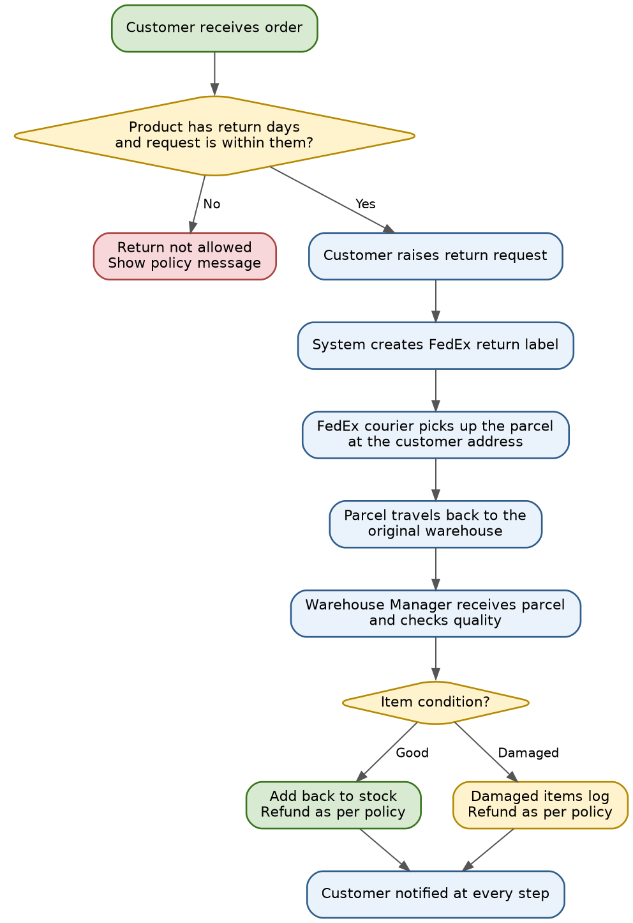
Step 20 Customer raises a return request within return days
Who | Customer
What happens | After delivery, within the return days of the item, the customer can raise a return request. Return days and return rules are read from the product settings.
Real-world example | Emily received a damaged carton on day 2. The product allows returns for 7 days, so she raises a return request.
What the system does | Checks the delivery date and the product return settings, then creates the return request. A product with no return days is non-returnable, and no return request can be raised for it.
Missing point | Add a rule for refund without return (low value, cross-border, damaged with photos). See 7.3.
Required to implement | - Return request form (My Orders or a guest link with order number and email): items and quantity, reason list, comment, photos, wanted result (refund, replacement, store credit) as allowed.  - Eligibility check: delivered date plus product return days, product return handling, quantity already returned, customer limits. Show a clear message when not eligible.  - Return record (RMA): number, status flow and notification to the Warehouse Manager and Manager.  - Setting: approve automatically by rule, or send to a Manager approval list.  - Returns page for Admin, Manager and Warehouse Manager with filters.

Steps 21 and 22 Return label and FedEx pickup from the customer
Who | System, FedEx, Warehouse Manager
What happens | The system creates a return label and sends it to FedEx. The FedEx courier goes to the customer's address, picks up the parcel and returns it to our original warehouse address. For cross-border orders the system adds the required return details automatically.
Real-world example | Emily receives the return label by email. A FedEx courier picks up the parcel from her house and delivers it to Chicago Hub.
What the system does | Creates the return label and tracking, informs the Warehouse Manager and sends return updates to the customer.
Missing point | Decide per request: return required, or refund without return. See 7.3.
Required to implement | - Return shipment through the FedEx Ship API (return label) and, if wanted, the Pickup Request API for pickup at the customer's address. Please confirm in your FedEx account which return and pickup services are enabled in each country.  - Label is emailed to the customer; the return tracking number is saved; the return address is the original warehouse.  - Cost rule: who pays; amount deducted from the refund when the customer pays; carrier cost saved in Expenses.  - Tracking uses the same sync as outgoing parcels. The Warehouse Manager sees Return in transit.  - Missed pickup: reschedule, or close the return after X days.  - Cross-border returns: customs papers added by the algorithm (see 7.3).

Step 23 Quality check and refund by policy
Who | Warehouse Manager, Manager / Admin
What happens | The warehouse checks the quality of the returned product. The refund amount is decided by the return policy.
Real-world example | Sarah finds the carton damaged and records it in the damaged items log. Emily receives the refund as per the policy.
What the system does | Saves the inspection result, updates the stock (good items back to stock) and processes the refund.
Required to implement | - Returns receiving screen: scan the RMA; for each item condition (Good, Opened, Damaged, Expired, Wrong item), quantity, photos, notes and decision (Restock, Quarantine, Write off, Return to vendor).  - Refund calculation: item price x quantity, minus restocking fee and return shipping (if the customer pays), with tax adjusted. Refunds above a limit need Manager or Admin approval.  - Payment refund to the original method through the gateway (full or partial), with status and failure handling; credit note and customer email.  - Stock effect: good items go back to the same batch if shelf life is still valid; damaged items go to damaged stock; ledger lines are written.  - Reports and accounting: refunds appear in Sales and Expenses; return rate by product and vendor claims.

7. Missing points in the current flow, with solutions
Everything in orange and yellow in this document is missing in the current flow. Each item shows what real e-commerce stores do and what to add in our system. Small orange notes inside the steps point to these items.
Important about rules and laws
- Customs, FDA and tax rules change often. The points below are the common industry approach. Please confirm the exact rules for your products with a customs broker and a food-compliance adviser before launch.
- As of 1 October 2026 the US has suspended duty-free entry for low-value shipments from all countries, so every parcel coming from India needs a customs entry and pays the applicable duties. Food shipped by couriers such as FedEx also needs an FDA Prior Notice.

7.1 Restricted products and cross-border check (for example food from India to US)
MISSING IN CURRENT FLOW
Missing | The flow does not check whether a product may be shipped from a warehouse country to the customer's country. Almond milk or any food from the India warehouse to a US customer has extra rules.
What real stores do | - Keep a rules table per product category and destination country: allowed, allowed with documents, or not allowed.  - For food, drinks and supplements entering the US: the making facility has an FDA food facility registration, a Prior Notice is filed for every shipment before it ships (courier shipments are not exempt), labels follow US rules, and a US importer takes responsibility for the shipment.  - Many food sellers import in bulk to a US warehouse and sell from there, and use the India warehouse only for items that are allowed or for Indian customers.
Solution for our system | - Product form: add compliance fields (see 7.2) and a product category.  - Settings: add a Shipping rules table with origin country, destination country, product category and result (Allowed / Allowed with documents / Not allowed).  - Checkout (step 13): for each cart item and each candidate warehouse, run the check. If a warehouse is not allowed, try the next nearest one. If none is allowed, show 'Not available to your address' for that item.  - Enable products (step 6): block enabling a product for a country when its compliance data is incomplete.  - Order routing (step 15) and packing (step 17): for cross-border orders create a compliance checklist on the order (customs invoice, duty payment method, Prior Notice confirmation number for food). The label can be printed only when the checklist is complete.
Where to add | Product form, Settings, Checkout, Orders page of the Warehouse Manager. Roles: Admin and Manager set rules; Vendor Sourcing Manager fills product data; Warehouse Manager completes the checklist.

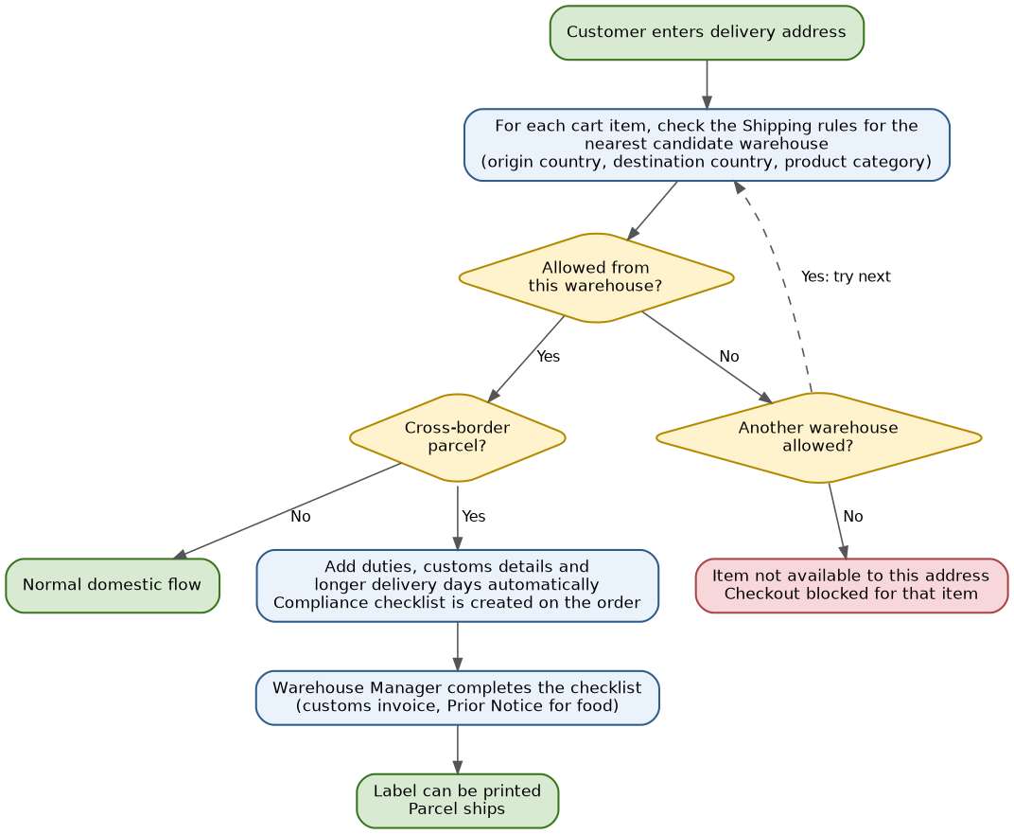
7.2 Customs and compliance data to maintain (answer to: other values and declared value)
MISSING IN CURRENT FLOW
Missing | Only HS code and country of origin are kept. Cross-border parcels need more.
Product data | - HS code (6 digits worldwide; the US uses a 10-digit tariff code, so keep the full code) and country of origin.  - Customs description in plain English (for example 'Almond drink, unsweetened, 1 litre carton').  - Net weight, gross weight, unit of measure and quantity per pack.  - Declared value (explained below) and brand.  - Ingredients and allergens, shelf life and storage type (food).  - Manufacturer name and address; for food into the US also the FDA facility registration number, FDA product code and FDA country of production.  - Hazard flags: liquid, aerosol, battery, flammable.  - Certificates and licences (for example organic certificate, food licence of the Indian maker, exporter code).
What is declared value | The value of the goods written on the customs invoice. It is normally the price the customer actually paid for the item (after discounts) multiplied by quantity. Shipping, insurance and taxes are shown on separate lines. It is not the cost price and must not be set artificially low. Keep a default customs value on the product, but use the real sold price on each order. Confirm with your customs broker how value is counted in your case.
Warehouse and company data | - Warehouse: country, address, customs and tax registration, FedEx account.  - Company profile: exporter details (India), US importer details and tax ID, customs broker, who pays duty (customer at checkout or company), currency.

7.3 Refund without return and cross-border returns (which is best)
MISSING IN CURRENT FLOW
Missing | Every return is assumed to come back to the warehouse. For cross-border and low-value items the return can cost more than the item.
What real stores do | Amazon, Flipkart and Shopify stores use rules, not one setting for everything. They refund without asking for the item back when the item is cheap, when return shipping costs more than the item, when it is food or hazardous, or when the customer has a good history. They always ask for the item back for high-value items or customers with many returns.
Best option for you | A hybrid rule set in the company profile, with an override on each product:
Rules | - Damaged, wrong or expired item with photos: refund or replacement without return for low value; return needed for high value.  - Low value: refund without return when the item value is below a limit set by you (for example $15 to $25) or when return cost is more than about half the item value.  - Cross-border order: refund without return up to the limit. Above the limit, the return goes to the US warehouse, not India.  - Food and opened items: not returned. Refund or credit only for damaged, wrong or expired items with photo proof.  - Customer with many returns or a fraud flag: return always required.  - Change of mind: return required and return shipping is deducted from the refund.  - Abuse control: maximum number of refund-without-return cases per customer in 90 days.
Where to add | Product form: field 'Return handling' with values Return required / Refund without return allowed / Decide by rule. Settings: limits and percentages. Returns page: shows which rule was used and who approved.

7.4 Many orders at one warehouse: queue, batching and one daily shipment
MISSING IN CURRENT FLOW
Missing | The flow notifies the Warehouse Manager for each order. At high volume this becomes too many alerts and many small FedEx pickups.
What real stores do | Warehouses work from an order queue and a dashboard, not one alert per order. Orders are grouped into batches (wave picking) before a daily cut-off time, packed together and handed over in one carrier pickup with one manifest. Instant alerts are kept for urgent cases only.
Solution for our system | - Orders page: a New orders queue sorted by promised delivery date, with counters on the dashboard.  - Notifications: an instant alert for the first order, then a summary every 30 or 60 minutes (time is configurable). Instant alerts always for urgent cases: compliance checklist pending, vendor delay, order near its time limit.  - Batches: the Warehouse Manager selects many orders and creates a batch with one combined pick list (item totals and shelf places) and assigns it to staff.  - Daily cut-off and one FedEx pickup: each warehouse has a cut-off time. One pickup request and one manifest are created for all parcels of the day.  - Same customer: if one customer places several orders to the same address within a short window (for example 2 hours), offer to combine them into one parcel and refund the extra shipping.  - Different customers: always separate parcels with their own labels. For large India to US volume, send bulk stock by freight to a US warehouse and deliver from there.
Where to add | Orders page, Settings (notification and cut-off times), Warehouse configuration.

7.5 Cancellation, transfer to another warehouse and vendor delay (with audit)
MISSING IN CURRENT FLOW
Missing | There is no cancel, transfer or vendor-delay handling, and no record of why an action was taken.
What real stores do | Customers can cancel until packing starts; after that it becomes a return. If a seller cannot fulfil, the order is moved to another location when possible, otherwise the customer is told and offered a new date or a refund. Every action is logged with a reason.
Solution for our system | - Customer cancel: allowed automatically while picking has not started. After that the Warehouse Manager approves or rejects. Once FedEx has the parcel, use the return flow.  - Warehouse cannot fulfil: the Warehouse Manager chooses one action: (1) Transfer to another warehouse that has stock, (2) Wait for vendor with a new date, or (3) Cancel the order or one item.  - Transfer: the system lists warehouses with stock, shows distance, new shipping price and new delivery days. Stock reservation moves to the new warehouse and its manager is notified. Limit the number of transfers per order (for example 2). By default the company absorbs any extra shipping cost.  - Cancel: a reason code and a note are mandatory, the refund starts automatically and the customer gets an email.  - Reason codes: Out of stock, Vendor cannot supply, Vendor delay too long, Damaged, Quality failed, Address problem, Customer request, Compliance restriction.  - Audit log on every order: who, when, old and new status, reason, note, and old and new warehouse.  - Admin and Manager are notified of every warehouse cancel, every transfer and every vendor delay past the limit, in the app and by email, with a daily summary.
Vendor delay list | - For vendors that work by phone or email, create a Vendor pickup record instead of a purchase order: vendor, items, quantity, agreed price, how it was agreed (call or email), contact person, promised date, assigned Picker.  - Vendor delay register (a page for Admin and Manager): vendor, product, related order, promised date, expected date, actual date, delay days, reason, Picker and status.  - Vendor summary: on-time percentage, average delay and cancellations caused. This score is shown to the Warehouse Manager when choosing a vendor in step 16.
Where to add | Orders page (actions and audit log), Purchases / vendor page (pickup record and delay register), notification settings.

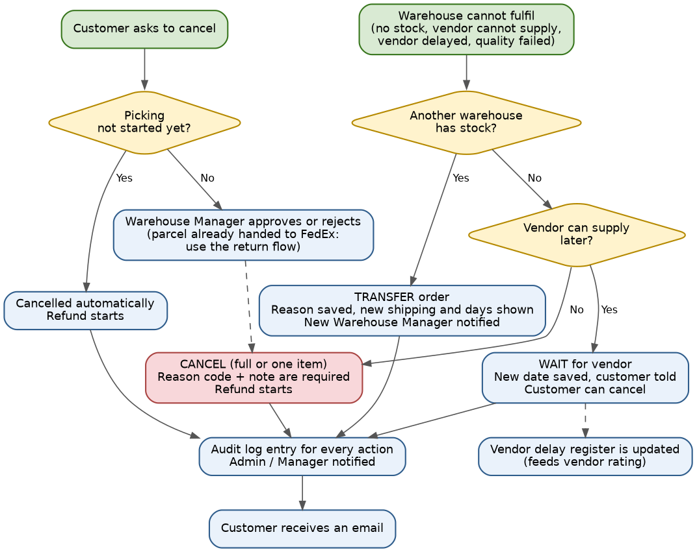
7.6 Split orders (items from two warehouses)
MISSING IN CURRENT FLOW
Missing | The flow does not say what happens when items must ship from two warehouses.
What real stores do | They avoid splitting whenever possible. If a split is needed, the customer is told 'Ships in 2 packages', each package has its own tracking and email. Large marketplaces show one checkout total; many store owners charge shipping per package; some absorb part of it.
Solution for our system | - Choose in this order: (1) one warehouse that holds all items, starting with the default warehouse, (2) another single warehouse that holds all items, even if a little farther, (3) split with the fewest packages.  - Shipping price: calculate per package from its own source warehouse and show each package with its price and days, then one total.  - After the order: each package is its own fulfilment with its own warehouse manager, label, tracking number and customer email.  - Cancel or return can be done per package.
Where to add | Checkout (step 13), order routing (step 15), Orders page.

7.7 Batch choice and expiry limits
MISSING IN CURRENT FLOW
Missing | Batches are saved, but the flow does not say which batch is sent first or when a batch stops being sold.
What real stores do | Food and other expiring goods use earliest expiry first (also called FEFO). Stores also require a minimum remaining shelf life, so the customer does not receive a product that is almost expired.
Solution for our system | - Earliest expiry first is the default. The specific batch is reserved when the order is placed.  - Minimum shelf life for the customer is set at product level (a default per category, changeable on the product), for example 60 days.  - Sellable check per batch: expiry date minus warehouse handling days, minus FedEx transit days of the option selected, must still be at least the product's minimum shelf life. Cross-border orders have longer transit days, so the limit moves automatically.  - If no batch in a warehouse passes, that warehouse counts as having no stock and the next warehouse is checked.  - Near expiry: batches that fail the check are marked Near expiry / Not for sale and the Admin is alerted. Options: discount sale, donate or write off, each with a reason.  - Show 'Best before' date on the product page.
Where to add | Product form (minimum shelf life), stock update (step 7), checkout, Orders page.

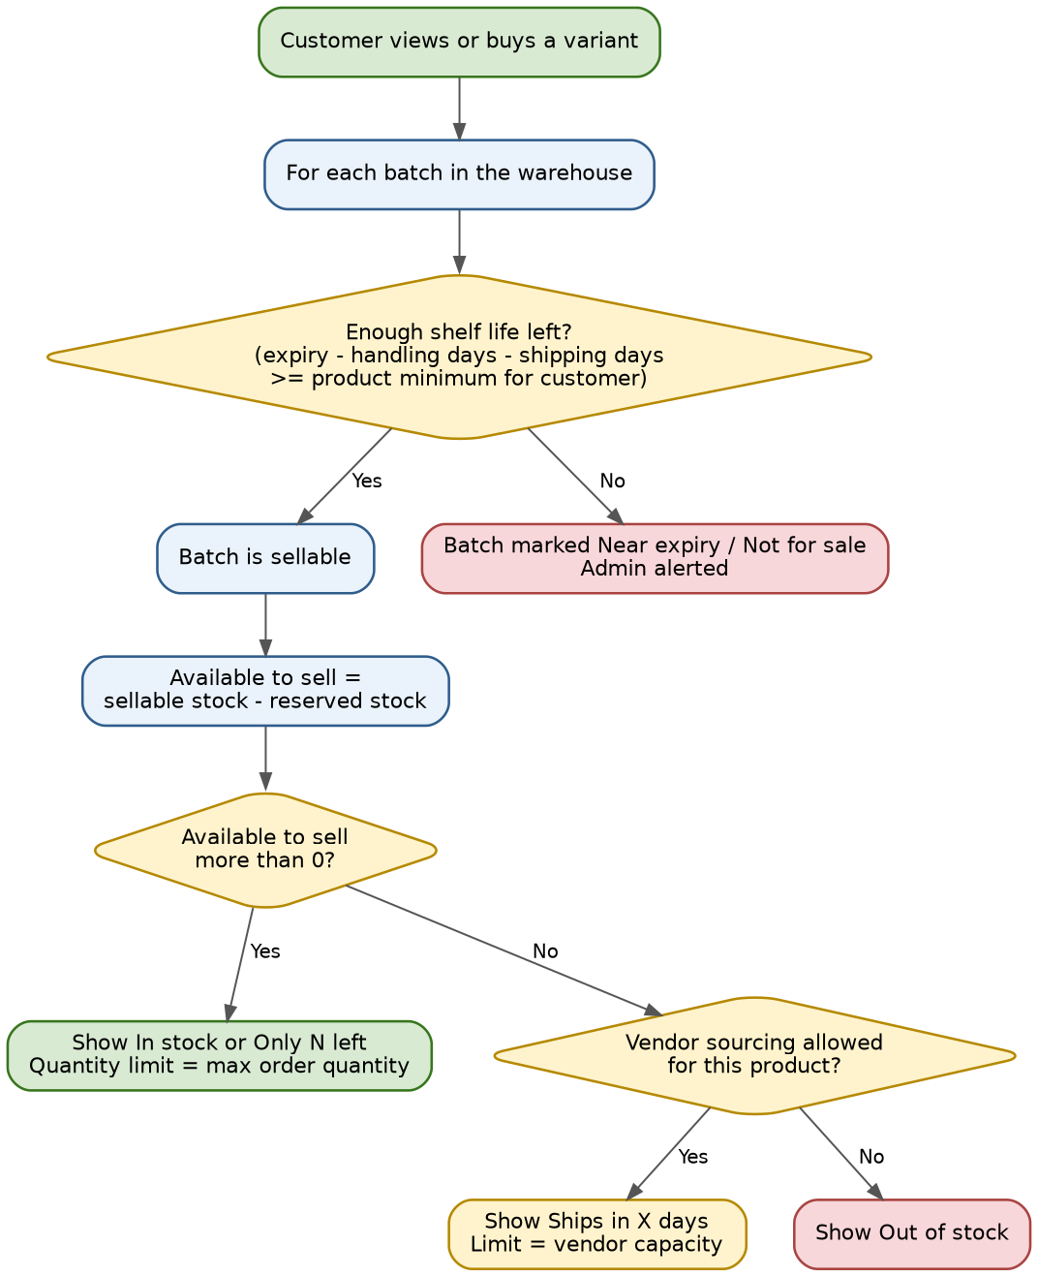
7.8 Stock shown to customers and vendor-sourced products (the big question)
MISSING IN CURRENT FLOW
Missing | If the store shows only the real stock in our warehouses, vendor sourcing is never needed. If it shows unlimited stock, we may sell what nobody can supply.
What real stores do | Stores do not show the exact stock number. They show Available to sell = sellable stock minus reserved stock. The page shows 'In stock', or 'Only N left' when it is low (for example 10 or fewer). The quantity box is limited by a maximum order quantity. A limit like 100 or 96 on some grocery stores is usually such a maximum, often a multiple of a case size. For items that are made or bought on order, stores use a different message such as 'Ships in 5 to 7 days' (backorder or made-to-order).
Solution for our system | - Keep two kinds of stock on each variant: Own stock (in our warehouses) and Vendor capacity (the quantity a vendor can supply, for example 100).  - Product settings: Sell when out of stock (yes or no), Vendor lead time in days, Maximum order quantity, Low stock message at (number).  - Customer sees: In stock / Only N left when own stock is available; Ships in X days when own stock is 0 and vendor sourcing is allowed (X = handling + vendor lead time + FedEx days); Out of stock otherwise.  - Quantity limit: own available stock first; for vendor items, the vendor capacity; never more than the maximum order quantity.  - Source address for the FedEx price when no warehouse has stock: map each vendor to the warehouse that receives its goods (on the vendor page). Use that warehouse; if several are mapped, use the one nearest the customer; if none, use the default warehouse.  - Delivery days for vendor items are shown longer, and the customer sees this before paying.
Where to add | Product form, Vendor page (receiving warehouse), storefront product page and cart, checkout (step 13).

7.9 Other real-world items to plan
Area | What to add
Parcel weight check | FedEx can change the price if the real weight or size is different from the setting. Weigh and measure at packing and compare.
High-value parcels | Optional insurance and signature on delivery for high-value orders.
Address problems | Address validation at checkout, and a clear message for addresses FedEx cannot serve.
Payment methods | For India customers, UPI, wallets and cash on delivery are common. Decide which to support.
Risk review | Hold orders that look risky (high value, first order, mismatched addresses) for a manager check before packing.
Documents | Invoice for every order (US sales tax, India GST) and the customs invoice for cross-border parcels.
Stock counting | Regular counting of a few items per week to keep stock correct.
Customer help | An order help form, so cancel, address change and delay questions reach the right warehouse.

8. Supporting flows missing from the 23 steps
A real enterprise store also needs the flows below. They are not in your 23 steps but every order depends on them. Each item lists what to build.
8.1 Customer account, login and addresses
MISSING IN CURRENT FLOW
Flow | Customer registers or buys as a guest, verifies email, logs in, saves addresses, sees My Orders, tracks parcels, starts returns, resets password.
Required to implement | - Sign up, login, email verification, forgot password, optional login with Google.  - Protection: limit login attempts, captcha on sign up, strong password rule.  - Saved addresses (many, one default), phone number, communication choices.  - Guest checkout with an email link to track the order.  - Cart merge after login.  - Admin Customers page: orders, notes, block or unblock.  - Customer data request: export or delete on request (see 8.10).

8.2 Pricing, currency and tax in several countries
MISSING IN CURRENT FLOW
Flow | The same product can sell in US dollars and Indian rupees, with different tax rules, and the invoice must show the correct tax.
Required to implement | - Prices: a price per currency or price list per country; rounding rules; compare-at price; tax shown included or excluded depending on country.  - Discounts: coupon types (percent, fixed amount, free shipping), start and end dates, usage limits, minimum cart value.  - US tax: sales tax by delivery state and city, tax class per product, tax on shipping where the state requires it. Use a tax rate table or a tax service, and check where your company must collect.  - India tax (GST): CGST and SGST inside a state, IGST between states, GSTIN on invoices.  - Invoices: number series per country or legal entity, PDF, credit notes for refunds.  - Currency: order currency is saved; refunds are paid in the same currency.

8.3 Payment, refund and reconciliation
MISSING IN CURRENT FLOW
Flow | Customer pays through a gateway. The order is confirmed only after the gateway confirms. Refunds go back through the same gateway.
Required to implement | - Gateway integration with hosted card fields, so card numbers never touch your server. Add 3-D Secure where required. For India, UPI, wallets or cash on delivery if you decide to support them.  - Flow: create payment, customer pays, gateway webhook confirms, order is confirmed. Verify webhook signatures and handle the same webhook twice.  - Decision: charge at once, or authorise first and charge when the parcel ships. Authorise-then-charge is common for items that may be cancelled.  - Statuses: Pending, Authorised, Paid, Failed, Partially refunded, Refunded, Disputed.  - Daily reconciliation report: gateway payments against orders; handle chargebacks and disputes.  - Refunds: full or partial, with failure retry and a customer email.

8.4 Buying from vendors, goods receipt and shelf places
MISSING IN CURRENT FLOW
Flow | Stock reaches a warehouse in three ways: (a) a planned purchase with a purchase order, (b) a vendor pickup agreed by phone or email for a customer order, (c) a transfer from another warehouse. All three end in a goods receipt.
Required to implement | - Vendor pickup record (no purchase order needed): vendor, items, quantity, agreed price, how agreed, contact, promised date, Picker, status (Planned, Agreed, Picked up, Received, Closed, Delayed, Cancelled).  - Purchase (when a vendor works with purchase orders): order, approval, expected date, partial receipts, invoice match.  - Goods receipt: quantity received and rejected, batch and expiry, quality result, photos, shelf place.  - Shelf places (bin locations): aisle, rack and shelf per warehouse so pickers find items; suggested place when receiving.  - Vendor payments: amount, paid or unpaid, date; shown in Expenses.  - Return to vendor for faulty stock, with credit tracking.  - Reorder suggestions from low stock and sales speed (optional).

8.5 Moving stock between warehouses (for example India to US)
MISSING IN CURRENT FLOW
Flow | A transfer request is approved, the sending warehouse packs and ships, stock shows as incoming at the receiving warehouse, the receiving warehouse checks it in with the same batch and expiry dates.
Required to implement | - Transfer record: from, to, items, quantities, batches, status (Requested, Approved, Packed, In transit, Received, Closed), carrier and tracking.  - Stock effect: stock leaves the sender when shipped, shows as Incoming at the receiver, and joins available stock only after the receiver confirms.  - Differences: short or damaged quantities are recorded with a reason and approved by a Manager.  - Cross-border transfers are commercial imports: customs papers and, for food, FDA registration and Prior Notice (see 7.1). Use freight or normal FedEx service.  - Roles: Warehouse Manager or Vendor Sourcing Manager requests, Manager or Admin approves.

8.6 Inventory control
MISSING IN CURRENT FLOW
Flow | Stock is always split into buckets so the system knows what can be sold.
Required to implement | - Buckets: on-hand, reserved, available, incoming, quarantine, damaged, expired.  - Reservation: the cart does not hold stock. Stock is held when payment starts (for example 15 to 30 minutes) and becomes reserved when the order is placed.  - Two customers, last item: reserve with an atomic update so only one succeeds.  - Adjustments need a reason and a Manager approval above a set amount.  - Cycle count: count a few items every week and record differences.  - Nightly job: marks near-expiry and expired batches and sends alerts.  - Ledger of every stock movement that cannot be edited.

8.7 Shipping engine (FedEx) in detail
MISSING IN CURRENT FLOW
Required to implement | - FedEx services to use: Address Validation, Rates and Transit Times, Ship (labels and return shipments), Pickup Request, Track with the Shipment Visibility Webhook, Trade Documents Upload and Global Trade (for cross-border), Locations Search (for the Dropper). Confirm with FedEx which are enabled on your account in each country.  - Setup: one FedEx account number per warehouse; test (sandbox) and live keys stored encrypted per company.  - Rate rules: allowed services per product, mark-up table, free-shipping limit, backup flat rates when FedEx is down.  - Packing: box types, size and weight rules, maximum items per box, size-based weight, ship-alone items.  - Labels: PDF and label-printer formats, cancel a label before pickup, save the label file.  - Extras: insurance, signature on delivery, hold at a FedEx location (optional).  - Safety: retry with waiting time, alert on repeated failures, save request and answer logs without private data.  - Design: keep a carrier layer so another carrier can be added later.

8.8 Notifications and escalation
Event | Who is told | Channel | Rule
Order placed | Customer; Warehouse Manager; Admin and Manager | Email; in-app | Customer at once; staff summary (see 7.4)
Payment failed | Customer | Email | Link to retry
Task assigned | Picker, Packer or Dropper | In-app, push or SMS | At once
Task not accepted in time | Warehouse Manager and Admin | In-app, email | After the time set in settings
Order not accepted in time | Admin and Manager | In-app, email | After the time set in settings
Vendor delay | Warehouse Manager, Vendor Sourcing Manager, Admin | In-app, email | When the promised date passes
Low stock or near expiry | Vendor Sourcing Manager, Warehouse Manager | In-app, email | Daily summary
Cancel or transfer by warehouse | Admin and Manager; customer when it affects delivery | In-app, email | At once, with reason
Shipped, Out for delivery, Delivered | Customer | Email (SMS or WhatsApp if used) | From FedEx updates
Delivery problem | Customer; Warehouse Manager | Email, in-app | From FedEx exceptions
Return requested | Warehouse Manager and Manager | In-app, email | At once
Return label, received, refund done | Customer | Email | At each step
Compliance checklist pending | Warehouse Manager | In-app | Before packing
Also needed: editable email templates, a notification list page for each user, failed-send retry and a send log.

8.9 Reports and dashboards
MISSING IN CURRENT FLOW
Admin and Manager | - Sales by day, country, warehouse, product and variant; orders by status.  - Time from placed to shipped; late orders; cancellations by reason; transfers.  - Return rate and reasons; refunds; shipping cost against shipping charged (mark-up margin).  - Stock value, stock ageing, near-expiry and low stock.  - Vendor on-time percent and delays; cross-border checklists pending.  - Customer numbers and repeat buyers.
Warehouse Manager | - Today's orders, open tasks, late tasks, staff workload, stock alerts, returns waiting.
Vendor Sourcing Manager | - Low stock, vendor pickups by status, vendor delays, purchases.
All reports | Date and warehouse filters, export to CSV, time zone of the viewer.

8.10 Security, activity log and privacy
MISSING IN CURRENT FLOW
Required to implement | - Access: permissions checked in every API; company separation tests; two-step login for Admin and Manager; password rules and lockout; session timeout.  - Activity log that cannot be edited: login, role change, price change, stock adjustment, cancel, transfer, refund, settings change and data export, with who, when, old and new value.  - Secrets: FedEx and payment keys stored encrypted, never shown again after saving.  - Payments: use the gateway's hosted fields so you do not store card data.  - Privacy: consent, customer data export and delete, how long data is kept. Check which privacy laws apply to your customers in the US and India.  - Safety: limit request rates, validate inputs, scan uploaded files, verify webhook signatures.  - Backups: daily, with a restore test.

8.11 Technical foundations
MISSING IN CURRENT FLOW
Required to implement | - Background jobs (queue) for emails, FedEx calls, tracking sync, expiry check and report building, with retry and a failed-job list.  - Order and stock changes in one database transaction. MongoDB needs a replica set for this.  - Idempotency for order creation, payment webhooks and FedEx webhooks.  - Indexes on company, warehouse, status and date for orders, stock and tasks; order number sequence per company.  - Search for the storefront (text and filters); cache for homepage sections.  - Time and money: store times in UTC and show in the warehouse or customer time zone; store money with currency and fixed decimals.  - File storage for images, labels, documents and photos.  - Environments: test and live, with sandbox keys; monitoring and alerts for errors and slow pages.

9. Status lifecycles and data to store
Each object moves through clear statuses. Every change is saved in the activity log with user and time.
Object | Statuses in order | Notes
Order | Payment pending, Placed, Accepted, Waiting for vendor (optional), Picking or Packing, Packed, Shipped, Out for delivery, Delivered, Completed | Side statuses: On hold, Cancelled, Partly cancelled. Completed after the return window.
Package (shipment) | Planned, Label created, Handed to FedEx, In transit, Out for delivery, Delivered | Exceptions: Delivery problem, Returned to sender, Lost.
Task | Unassigned, Assigned, Accepted, In progress, Done | Failed (with reason), Cancelled, Escalated.
Vendor pickup | Planned, Agreed, Picked up, Received, Closed | Delayed, Cancelled, Rejected on quality.
Stock transfer | Requested, Approved, Packed, In transit, Received, Closed | Short or damaged difference.
Return (RMA) | Requested, Approved, Label created, In transit, Received, Inspected, Refunded or Replaced, Closed | Rejected, Expired (customer never sent).
Payment | Pending, Authorised, Paid, Partly refunded, Refunded | Failed, Disputed.
Stock batch | Active, Near expiry, Not for sale, Expired, Written off | Quarantine.

Main data to store
Data | Key fields
Company, Settings | Profile, tax, mark-up, return limits, notification rules, shipping rules, FedEx and payment keys
User, Role, Permission | Name, email, role, warehouses, status; permission per page and action
Warehouse | Code, type, address and map position, country, time zone, cut-off, handling days, FedEx account, default flag
Vendor, Vendor product | Contact, terms, lead time, rating, receiving warehouse; vendor SKU, cost, minimum quantity
Category, Attribute | Tree, attribute type, used for variants, used as filter
Product, Variant | Details, return settings, compliance, shelf-life and order limits; SKU, barcode, price, package size and weight
Stock batch, Stock ledger | Warehouse, variant, batch, manufacturing and expiry dates, quantity buckets; every movement with before and after
Customer, Address, Cart | Account, saved addresses, cart lines with price seen
Order, Order line, Allocation | Totals, currency, addresses, status; variant, quantity, price, tax; warehouse and batch chosen
Package, Task, Vendor pickup, Transfer | Tracking number, label, status; assignee, deadline, proof; vendor, promised date; from and to warehouse
Return, Refund, Payment | RMA, items, reason, photos, decision; amounts and method; gateway reference and status
Notification, Activity log | Event, recipient, channel, status; who, when, what, old and new value

10. Test scenarios before launch
No. | Scenario | What must happen
1 | US customer buys an item that the default warehouse holds | Default warehouse is the FedEx source, rate and days shown, order reaches that Warehouse Manager, Packer ships it, customer is updated.
2 | US customer buys a non-food item held only in India | Allowed by the shipping rules, duties and longer days added, compliance checklist created, label only after checklist.
3 | US customer buys food held only in India | Blocked or routed by the shipping rules; never sold without the compliance data.
4 | One order with items in two warehouses | Two packages, two prices, two tracking numbers, one total.
5 | No own stock, vendor sourcing allowed | 'Ships in X days' shown; Picker task; goods receipt; packing.
6 | Vendor misses the promised date | Alerts, delay register updated, transfer, wait or cancel with a reason, customer informed.
7 | Payment fails | No confirmed order; reservation released; customer can retry.
8 | Two customers buy the last unit together | Only one order is accepted.
9 | A batch is close to expiry | It is not sold; the next batch is used; Admin is alerted.
10 | FedEx misses the pickup | Dropper task with proof; status changes only after proof or first scan.
11 | Customer cancels before picking, and after packing | Automatic cancel and refund before picking; after packing it is rejected or handled as a return.
12 | Low-value damaged item returned within days | Refund without return by rule, with photos and the rule name saved.
13 | High-value return | Return label, pickup, inspection, restock or damaged log, refund by policy.
14 | No staff free for a task | Task alerts Warehouse Manager and Admin; Warehouse Manager completes it.
15 | A Picker calls the Orders API directly | Blocked by the server.
16 | India Warehouse Manager opens a US order | Blocked by warehouse scope.
17 | FedEx does not answer at checkout | Backup flat rates shown and flagged.

11. Suggested order of building
Build in three phases so the store can go live early and grow safely.
Phase | What to build | Why in this phase
Phase 1: Launch | Users, roles and API permission checks; catalog with variants, shipping, package, return and shelf-life fields; warehouses and mappings; stock with batches and ledger; storefront, cart, checkout with address check, FedEx rates, tax and payment; order creation with reservation; Orders and Returns pages; To-do pages; goods receipt; packing with FedEx label and pickup; tracking updates and emails; return label, receiving and refund; cancel and transfer with reasons; activity log; setup checklist. | Without these an order cannot be sold, shipped and returned safely.
Phase 2: Control | Vendor delay register and vendor score; order queue with batches, cut-off and digest alerts; refund-without-return rules; cross-border rules and customs papers; stock transfers between warehouses; reports; coupons; reviews; cycle counts. | Improves speed, cost and control once orders flow.
Phase 3: Scale | Price lists and many currencies; UPI and cash on delivery; risk review; more carriers; barcode scanning and shelf places; customer API and webhooks; extra languages. | Needed when volume and countries grow.

12. A day in the life of each role
Role | Daily activities | Example day
Admin | Create users, warehouses and configuration. Check dashboard, orders, returns and reports. | Alex adds a new hub in India and maps Ravi to it.
Manager | Same pages as Admin. Handles orders and returns. | Nina checks open orders and a new return request.
Vendor Sourcing Manager | Add vendors and products, update stock and batches, work on purchases. | David adds a batch with expiry date for EcoFoods Corp.
Warehouse Manager | Accept new orders, check stock, assign tasks, receive goods, receive and inspect returns. | Sarah accepts an order, assigns Maria to pack and checks a returned parcel.
Picker | Open the To-do list, travel to vendors, collect items and hand them over at the warehouse. | John collects 20 cartons from EcoFoods and hands them to Sarah.
Packer | Open the To-do list, pick products in the warehouse, pack, print label, hand over to FedEx. | Maria packs Emily's order and hands it to the FedEx driver.
Dropper | Open the To-do list and take missed parcels to FedEx. | Tom takes 4 parcels to the FedEx location.
Customer | Browse, add to cart, pay, track the order, request a return, receive the refund. | Emily buys 2 cartons, tracks them and returns one damaged carton.

Glossary
Term | Meaning
SKU | Unique code for one variant of a product.
Variant | A version of a product, such as size or colour.
Batch | A group of items received together, with one manufacturing and expiry date.
Default warehouse | The main warehouse and company store address, checked first for stock.
Source warehouse | The warehouse the order is shipped from, and the address FedEx uses for the price.
Mark-up | Extra percent added by the company on the FedEx price, set in the company profile.
Purchase Order (PO) | Written order from the company to a vendor. Some vendors supply without one.
To-do task list | Separate page for Picker, Packer and Dropper showing only their own tasks.

