EVERGREEN POS & LANDSCAPING MANAGEMENT SYSTEM
CLIENT-SIDE END-TO-END USER MANUAL
This document provides complete, end-to-end client-side user guidelines for all
9 core Landscaping modules:
1. SERVICES
2. PRODUCTS
3. ASSETS / EQUIPMENT
4. LABOR
5. ENQUIRIES
6. REQUESTS
7. QUOTES
8. INVOICES
9. JOBS

TABLE OF CONTENTS
1. GLOBAL NAVIGATION & UI CONTROLS EXPLAINED
2. MODULE 1: SERVICES MANAGEMENT
3. MODULE 2: PRODUCTS & INVENTORY
4. MODULE 3: ASSETS & EQUIPMENT MANAGEMENT
5. MODULE 4: LABOR & WORKFORCE MANAGEMENT
6. MODULE 5: ENQUIRIES (LEAD MANAGEMENT)
7. MODULE 6: REQUESTS & SITE VISITS
8. MODULE 7: QUOTATIONS (ESTIMATION & PRICING ENGINE)
9. MODULE 8: INVOICES & PAYMENTS
10. MODULE 9: JOBS (DISPATCH, ROUTING & FIELD EXECUTION)
11. COMPLETE END-TO-END WORKFLOW (FROM FIRST CONTACT TO PAYMENT)

1. GLOBAL NAVIGATION & UI CONTROLS EXPLAINED
Every page in the Evergreen Landscaping platform shares a standard set of

intuitive header buttons, icons, filters, and tables:

• [Search Bar] (Magnifying Glass Icon):

Allows live text search across names, phone numbers, emails, addresses,
item codes, and transaction numbers.
• [Date Range Picker] (Calendar Icon):
Filters records by predefined date ranges (Today, This Week, This Month,

Quarter, Year) or custom Start & End dates.
• [Reset Filters Button] (Filter with 'X' or Circular Arrow):
Resets all search bars, date pickers, and dropdowns back to default.

• [Toggle Deleted / Trash Bin Icon]:
Switches the view between Active records and the Deleted/Trash list.
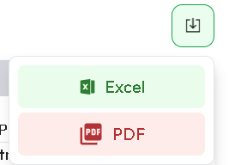

• [Format List / Active List Icon]:
Switches back from Deleted view to the Active records list.
• [Download / Export Button] (Download Arrow):

Exports currently filtered data into Excel (CSV/XLSX) or PDF formats.
• [Comment Icon] (Speech Bubble):

Opens the Comments Popover to view internal notes or post a new comment.
• [Action History Icon] (Clock / History Icon):
Hovering or clicking reveals the complete audit log (Who created, updated,
status changed, or deleted the item with exact timestamps).
• [Pagination Controls] (Bottom of tables):
Controls items per page (5, 10, 15, 20, 50, 100, and 150) and navigates between pages.
2. MODULE 1: SERVICES MANAGEMENT
Purpose:
Configure the service catalog (e.g., Sod Installation, Lawn Mowing, Mulching,
Paver Patios, Tree Trimming) with dynamic mathematical pricing formulas,
required product materials, labor calculations, and equipment assignments.

2.1 Service Categories
Navigation: Services -> Categories
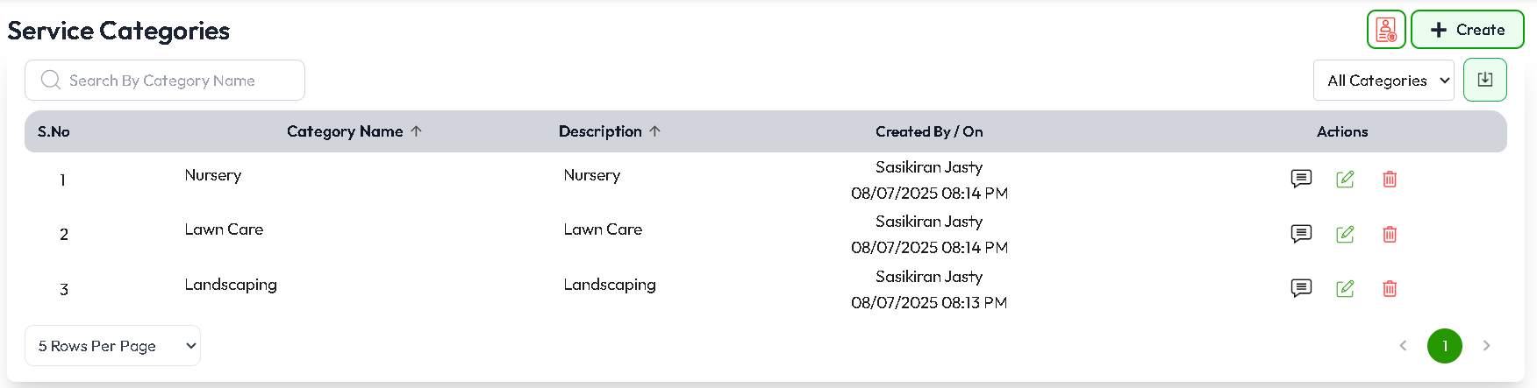
BUTTONS & ACTIONS:
• Search by Category Name using search bar filter.

• Filter based on categories using dropdown.
• Button: Opens a modal to enter Category Name, Description.
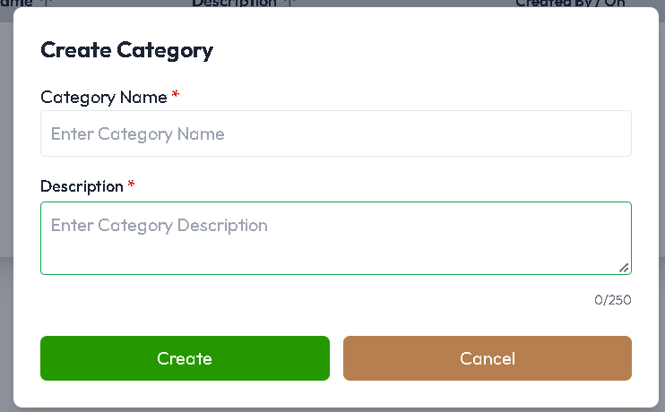

• [Edit Icon] : Opens the edit modal to update the category name or description.
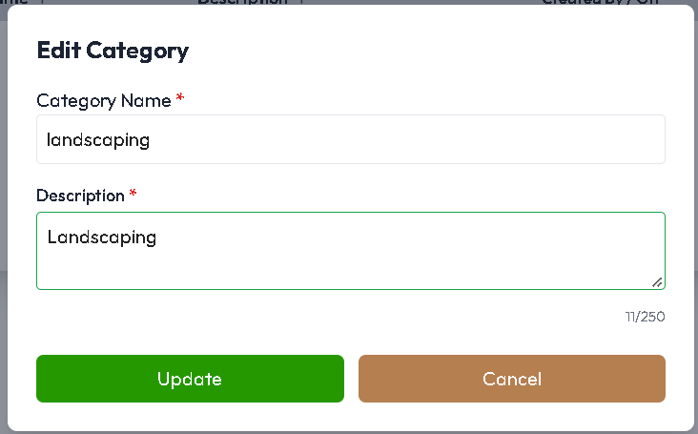

• [Delete Icon]: Prompts for a required deletion comment and moves category to trash.

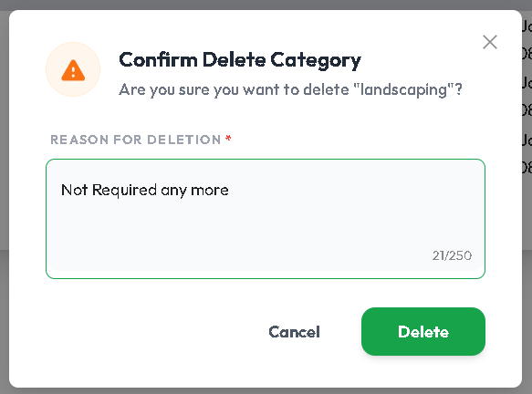
• [Action History Icon]: Hovering or clicking reveals the complete audit log (Who created, updated, status changed, or deleted the item with exact timestamps).

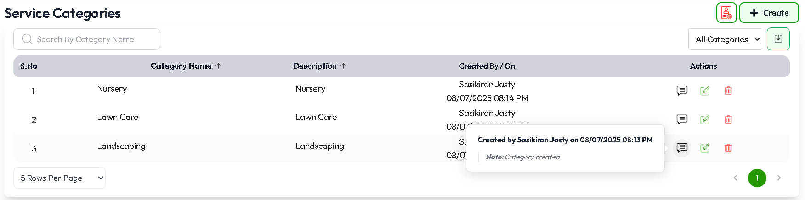
• [Download Icon]: Exports currently filtered data into Excel or PDF formats.
• [Trash Icon]: Toggles between Active and Deleted services.
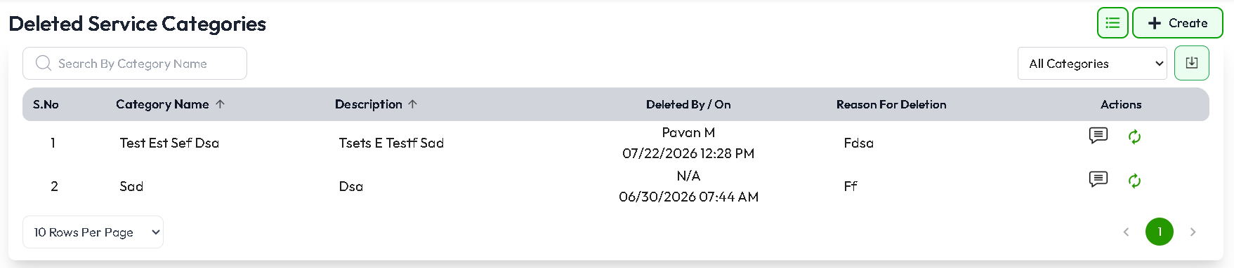
• [Restore Icon]: Restore Deleted services from deleted list actions column.

2.2 Services List Screen
Navigation: Services -> Services
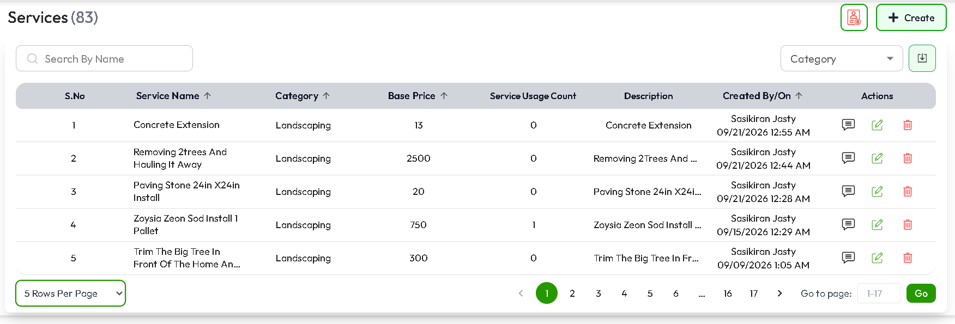

TOP CONTROLS & BUTTONS:
• [+ Create Service] Button: Navigates to the Service Creation Form.
• [Search Input]: Live searches by Service Name, Category, or Description.
• [Category Filter Dropdown]: Filters services by specific category.
• [Export Button]: Downloads the full service catalog.
• [Trash Icon]: Toggles between Active and Deleted services.
• Clicking on a specific service row opens the Service Details View page.
• Action Icons:
- [Edit Icon] (Pencil): Opens the Service Form to modify rules & formulas.
- [Delete Icon] (Trash): Prompts for comment before soft deletion.
- [History Tooltip]: Shows who created and edited the service.
• [Restore Icon]: Restore Deleted services from deleted list actions column.
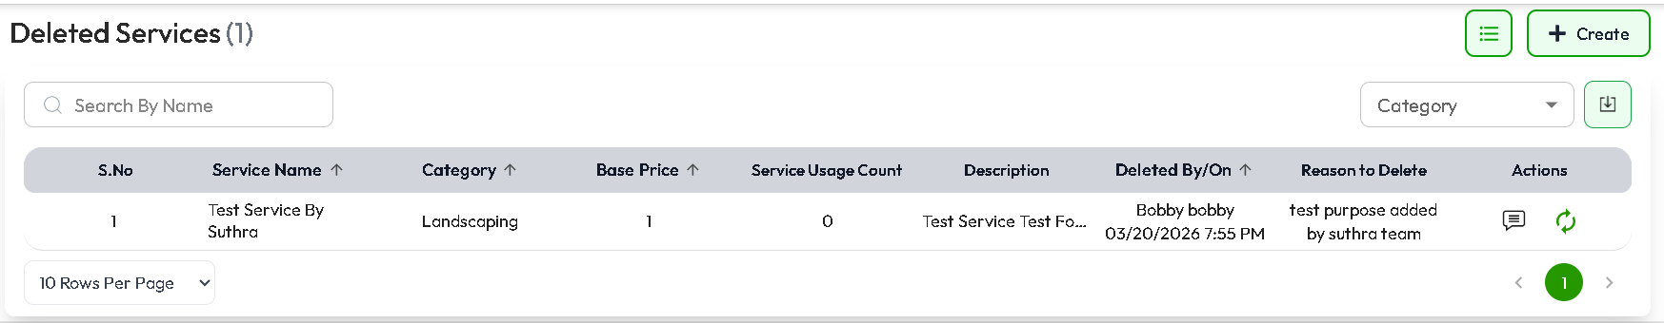

2.3 Service Create / Edit Form Walkthrough
Navigation: Services -> + Create Service
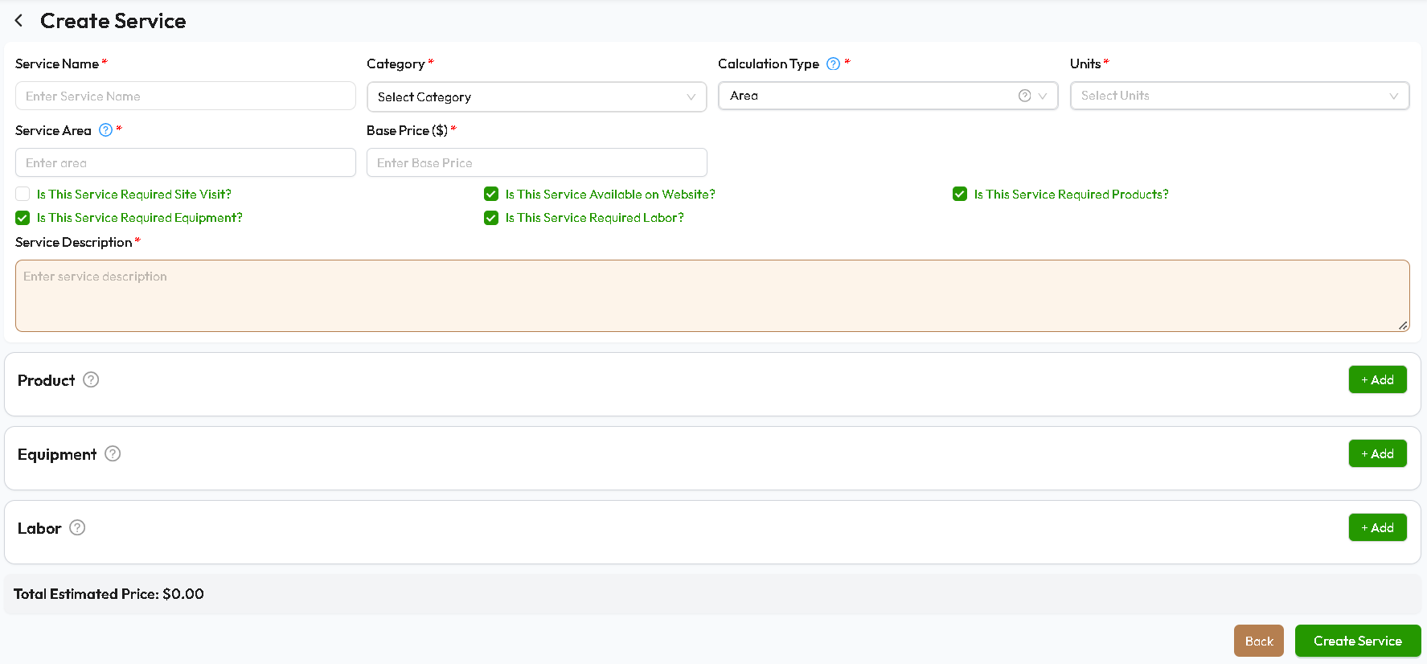
FORM SECTIONS & INPUT FIELDS:
1. Basic Details:
• Category Dropdown: Select parent category (e.g., Landscaping, Nursery).
• Service Name Input: e.g., "Sod Installation".
• Calculation Type: Select how this service should be calculated
• Units: Select Calculation Units Square Feet, Acre (ac), Cubic Yard(yd3)
• Service Area: Pricing Configuration for Selected Unit.
• Base Price ($): Minimum starting price.
• Service Description: Notes on what the service includes.
• Is this Service Required Site Visit: Indicates whether a site visit is required before the service can be booked.
• Is this Service Available on Website: Indicates whether customers can view and book this service online.
• Is this Service Required Products: Indicates whether products are required to perform the service.
• Is this Service Required Equipment: Indicates whether specific equipment is required to perform the service.
• Is this Service Required Labor: Indicates whether additional labor or technicians are required to perform the service.
2. Measurement & Unit Configuration:
• Unit Type Selector:
- Area (Length x Width = Square Feet / Square Yards / Acres)
- Quantity (Number of units, trees, bags, plants)
- Time (Hours / Days)
- None (Fixed Price Service)
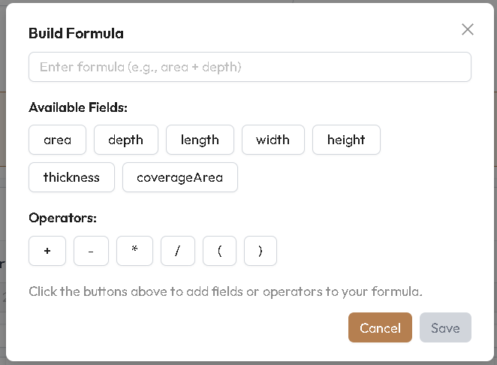
4. Dynamic Products / Materials Calculation:
• [Products Needed Toggle]: Turn ON to link raw materials.
• [+ Add Product Option] Button:
- Product Dropdown: Select product (e.g., Black Cedar Mulch).
- Rate Source: 'Fixed Product Rate' or 'Dynamic Formula'.
- Calculation Formula Input: Uses math expressions (e.g., `(length + width ) `).
- Required Field Tags: Auto-detects variables like `length`, `width`, `depth`.
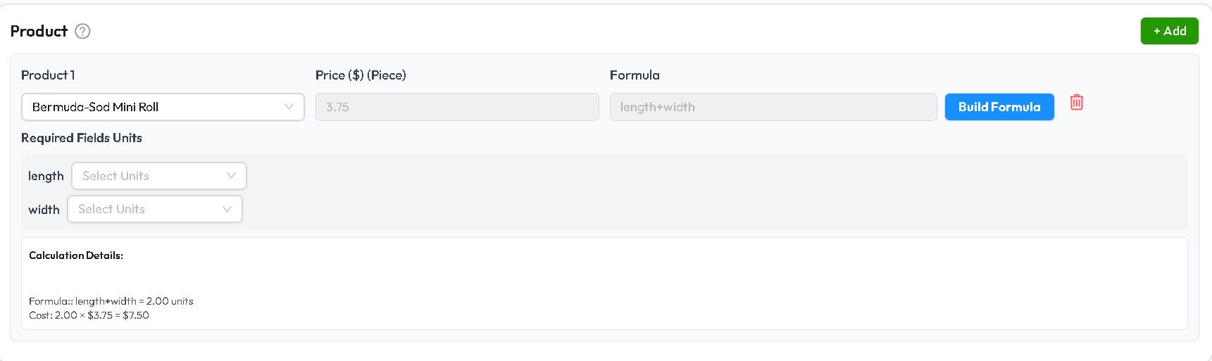

5. Equipment / Assets Assignment:
• [Equipment Needed Toggle]: Turn ON to link machinery.
• [+ Add Equipment] Button:
- Select Equipment (e.g., Skid Steer, Lawn Mower, Plate Compactor).
- [Default Equipment Checkbox]: Automatically assigns to this service.
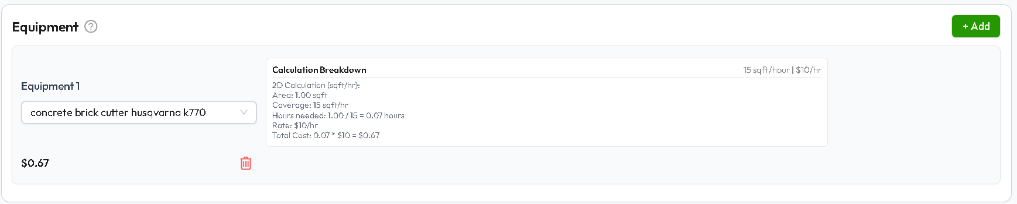
6. Labor Rates:
• [Labor Needed Toggle]: Turn ON to link required workforce.
• [+ Add Labor] Button:
- Select Labor Type (e.g., General Laborer, Stone Mason).
- Rate & Coverage formula linked to service duration.
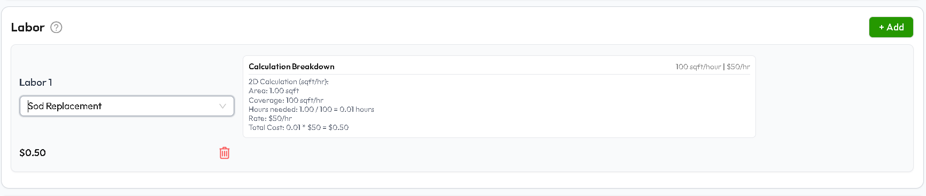

FORM SUBMISSION BUTTONS:
• [Save / Submit Service Button]: Validates formulas, creates service.
• [Cancel / Back Button]: Returns to Service list without saving.

3. MODULE 2: PRODUCTS & INVENTORY
Purpose: Manage raw materials, plants, trees, bagged goods, pavers, fertilizer, and tools
sold directly or used during service jobs.

3.1 Product List & Inventory Overview
Navigation: Products -> Products
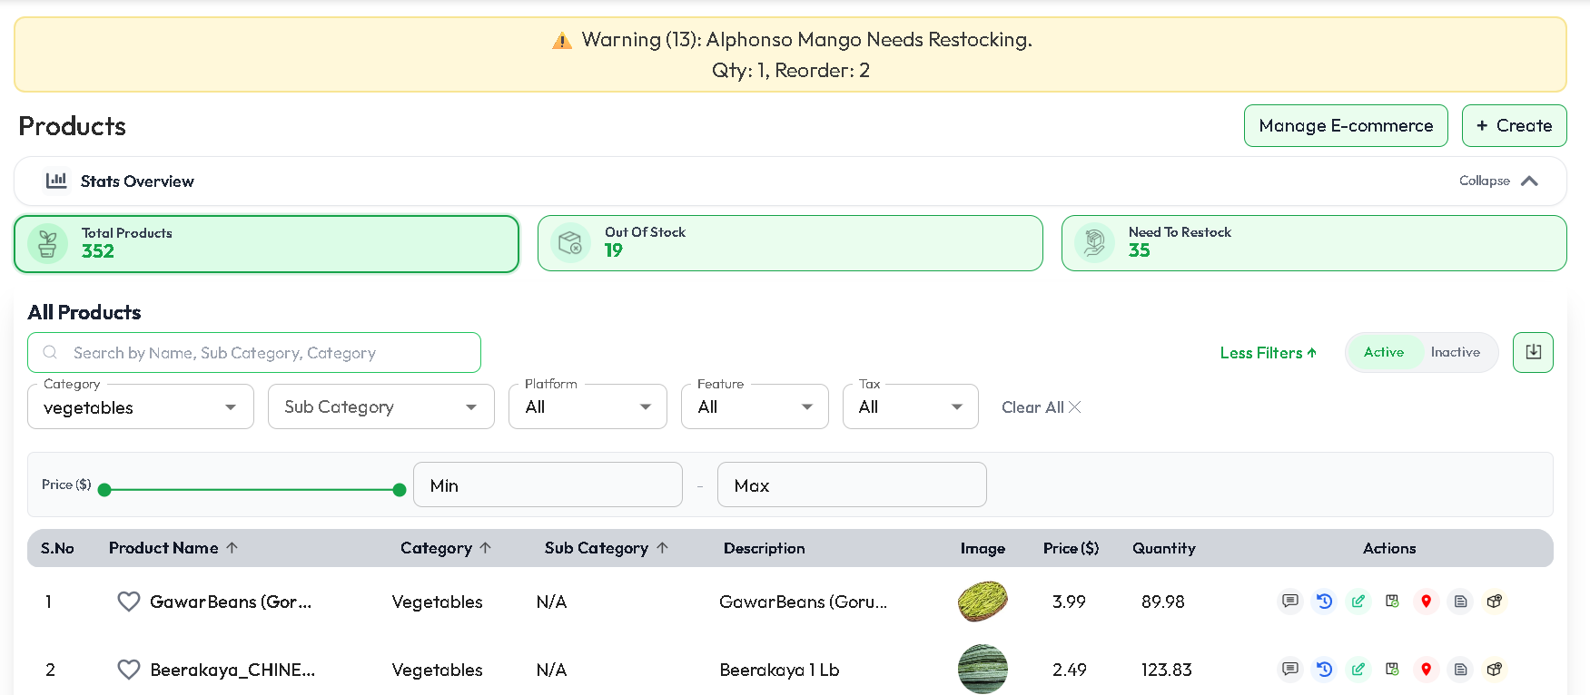
TOP CONTROLS & BUTTONS:
• [+ Create Product] Button: Opens the Product Creation Form.
• [Manage E-commerce] Button: Using this we can update products availability for E-Commerce or Delivery.
• [Stats Cards]: It Represents Total Number of products, out of stock and Need to Restock.
• [Search Input]: Search by Product Name, Category or Sub Category.
• [Category & Subcategory Dropdown Filters]: Filter catalog by group.
• [Platform Dropdown Filters]: Filter products by Orders or Pre-Orders
• [Feature Dropdown Filters]: Filter products by featured (show in display) or Non-Featured.
• [Tax Dropdown Filters]: Filter products by taxable or Non-Taxable.
• [Price Range Filters]: Filter products by Minimum and Maximum Prices.
• [Download Button]: Exports inventory ledger to Excel/PDF.
• [Status Chip]: To Check which Products in Active & Inactive.


• Action Icons:
- [Edit Product]: Update Product Details like pricing, stock levels, or images etc..,
- [Action History Icon]: Hovering or clicking reveals the complete audit log (Who created, updated, status changed, or deleted the item with exact timestamps).

- [Sale Summary]: To Check Total Sales Count of Respective Product based on date.
- [Status Update]: To Update/Toggle Status of a product Active/Inactive.

- [Notes]: Select Vendor and Update Notes.
- [Warehouse Location]: To Check in which warehouse the product is stored.
3.2 Product Create / Edit Form
Navigation: Products -> + Create Product
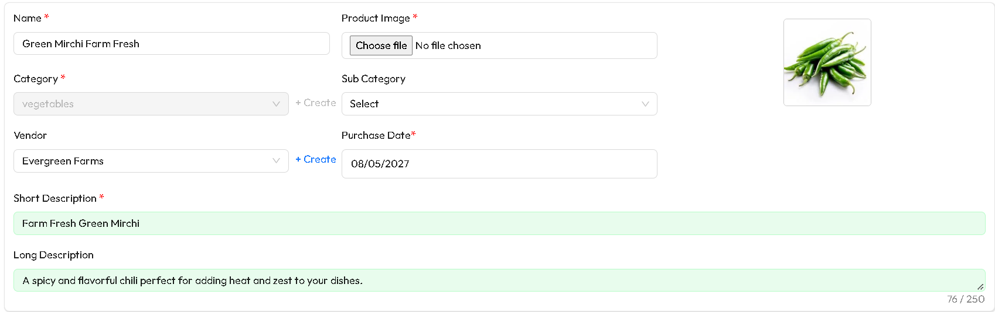

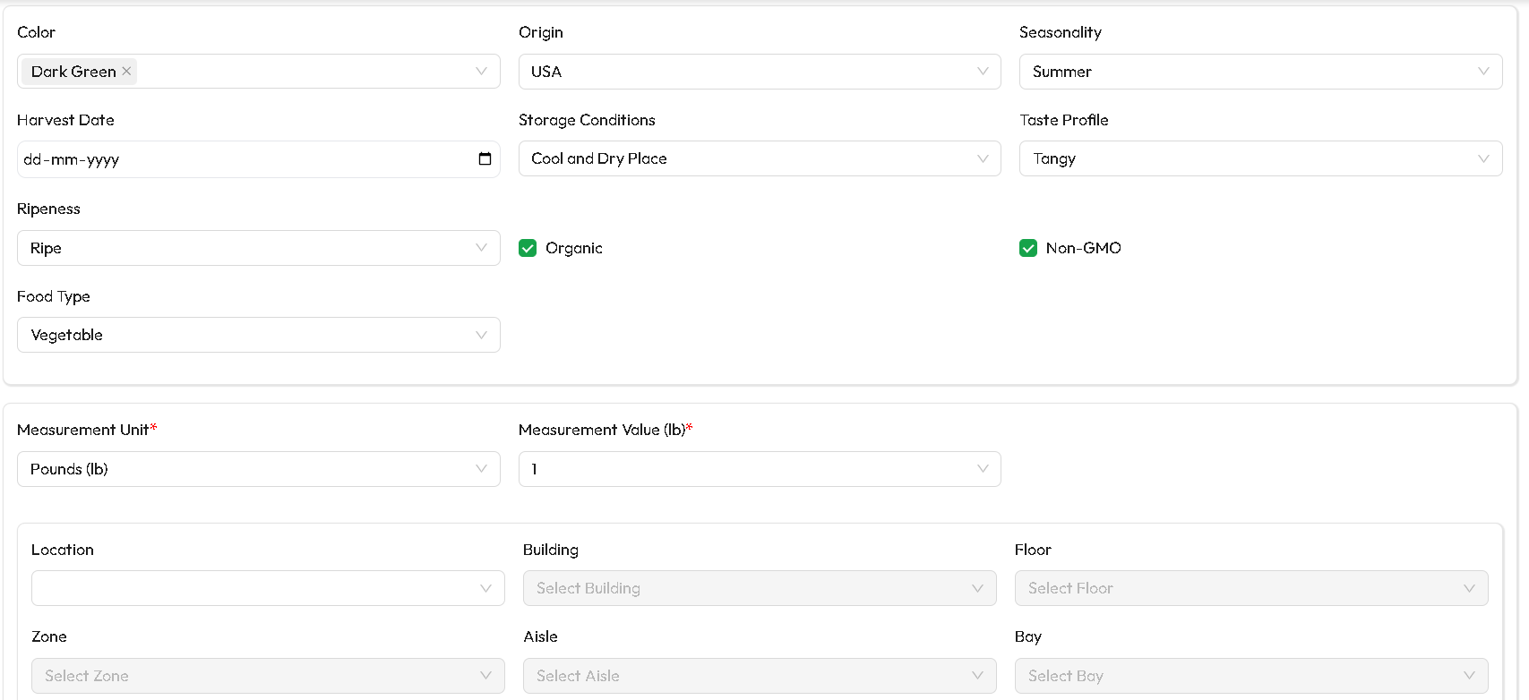

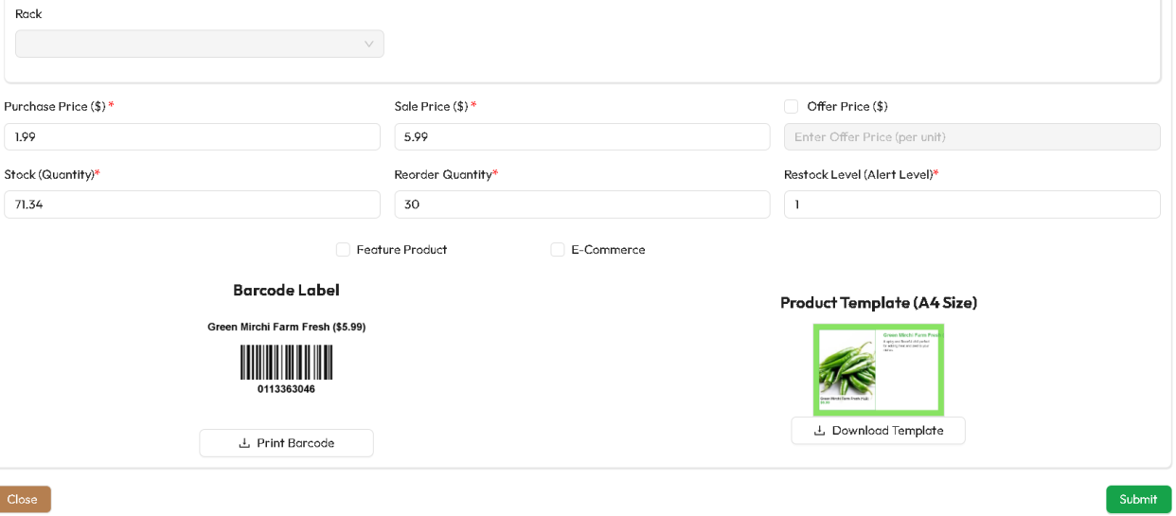

FORM FIELDS:
• Product Name & Product Image.
• Category & Subcategory & Vendor selection & Purchase Date of Product.
• Description: Short Description & Long Description.
• Based on selected category, fields will be rendered/changed.
• Choose Measurement Unit & Value of that product.
• Pricing:
- Purchase / Cost Price ($)
- Selling Price ($)
- [Offer Checkbox]: Check it to enter offer price for a respective product.
• Stock & Warehouse:
- Stock: Initial Quantity on Hand.
- Reorder Threshold (triggers Low Stock alert).
- Restock Threshold (triggers Low Stock alert).
- Warehouse / Yard Location (e.g., Aisle 3, Yard Bay B).
• Coverage & Dimensions (for Landscaping Calculations):
- Coverage per unit (e.g., 1 Bag covers 12 sqft at 2-inch depth).
- Unit of Measurement (Sqft, Cu Yd, Ton, Lb, Gallon, Piece).
- [Feature Checkbox]: Check and ensure that the product is displayed in the project store.
- [E-commerce Checkbox]: Check and ensure that the product is available for e-commerce and then check whether is it deliverable or not.
• Printable Bar code Label and downloadable Product Template.
• [Submit Product Button] & [Close Button].

4. MODULE 3: ASSETS & EQUIPMENT MANAGEMENT
Purpose:
Track machinery, vehicles, trailers, commercial mowers, excavators, and handheld
tools. Manages maintenance logs, warranties, document expiries, and job allocations.
4.1 Assets List & Tabs
Navigation: Assets -> Assets
TABS:
- [Categories Tab]: Asset category creation (Heavy Machinery, Vehicles, Hand Tools).
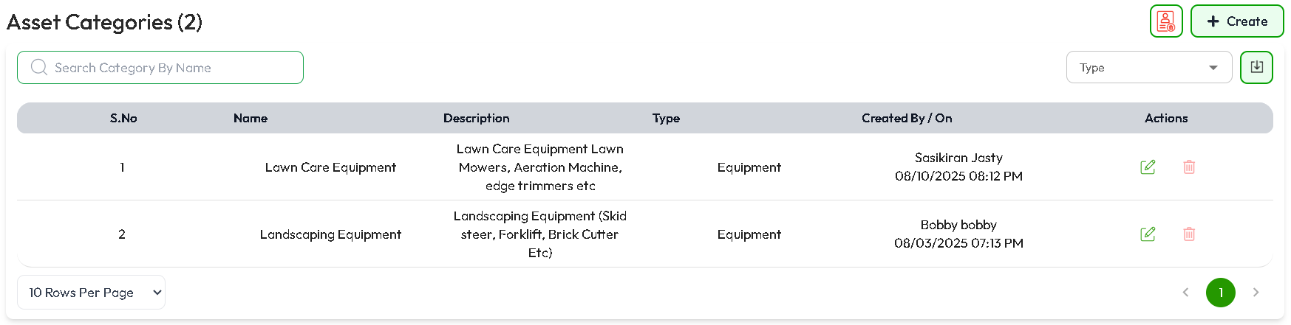
TOP CONTROLS & BUTTONS:
• [+ Create] Button: Opens the Asset Category Creation Form.
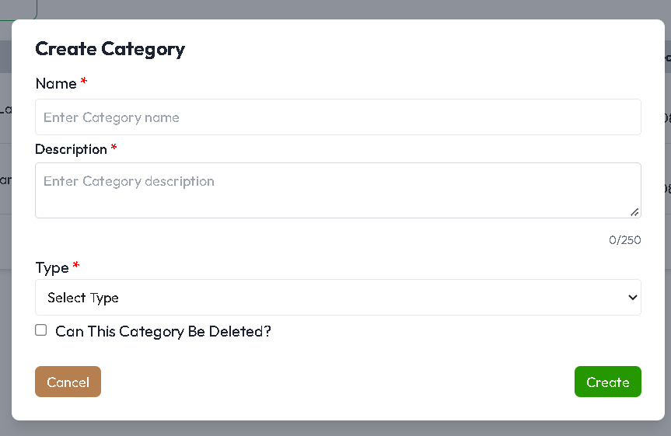
• [Search Bar]: Search by Asset Name, Serial Number, or Asset Tag.
• [Category Filter]: Filter by Types (e.g., Furniture, Tools, Equipment, etc..,).
• [Download Button]: Exports asset inventory and maintenance reports.
• [Toggle Trash / Active]: View active vs decommissioned assets.
• [Check Box in Create Asset]: Can this category be deleted?
If this option is enabled, users will not be allowed to delete the category.
- [Assets Tab]: Master list of physical equipment and machinery.
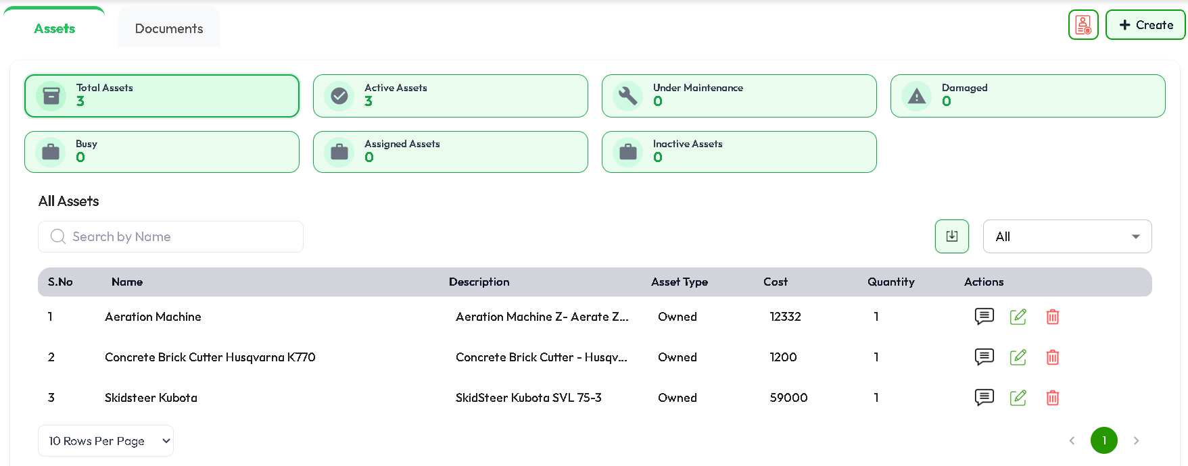

TOP CONTROLS & BUTTONS:
• [+ Create] Button: Opens the Asset Onboarding Form.
• [Search Bar]: Search by Asset Name.
• [Status Filter]: Filter by Asset Status.
• [Download Button]: Exports asset inventory and maintenance reports.
• [Toggle Trash / Active]: View active vs decommissioned assets.
• Action Icons:
- [Edit Asset] (Pencil): Update specifications, rates, or status.
- [History Tooltip]: Shows who created and edited the Assets.
- [Delete Icon]: Soft delete with mandatory comment.

  - Asset Create / Edit Form
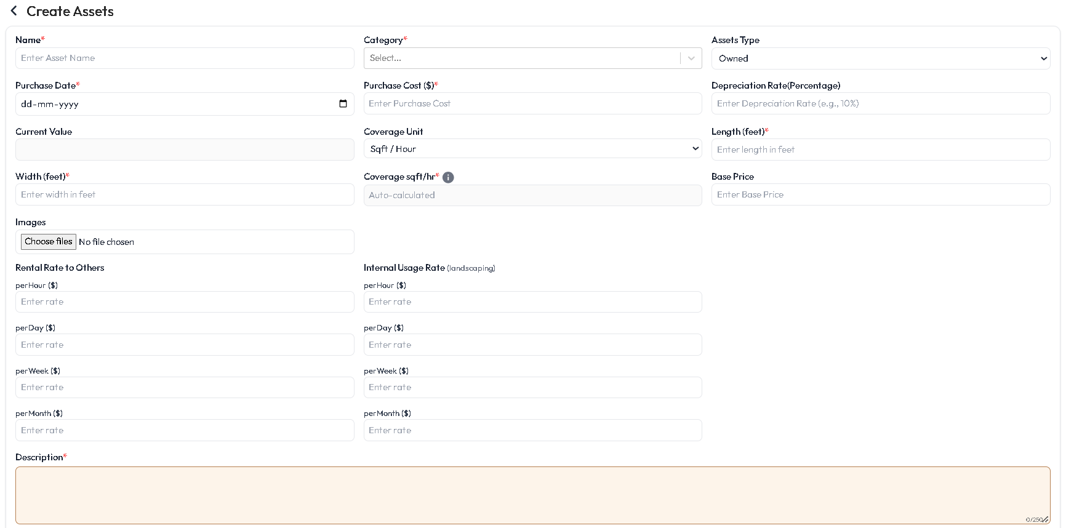
FORM FIELDS:
• Asset Name & Manufacturer / Model.
• Category Selection.
• Select Asset Type Owned / Rental.
• Purchase Date, Purchase Price ($), and Current Depreciated Value (%).
• Coverage Unit: Hourly Rate ($/hr) or Daily Rate ($/day) for job costing.
• Base Price: Enter Base Price for that Asset.
• Enter Hour, Day, Week, Month rates for Internal Usage and Rental Rate to others
• Enter a brief and clear description of the assets, including relevant details such as their purpose, type, usage, or any other information that helps users understand what the assets are and how they are intended to be used.
• Choose the Number of Quantity available with us.
• [Submit Button] – to Save Asset & [Back Button] – To go back to Assets page.

- [Documents Tab]: Equipment registrations, insurance policies, certifications,
and renewal tracking.
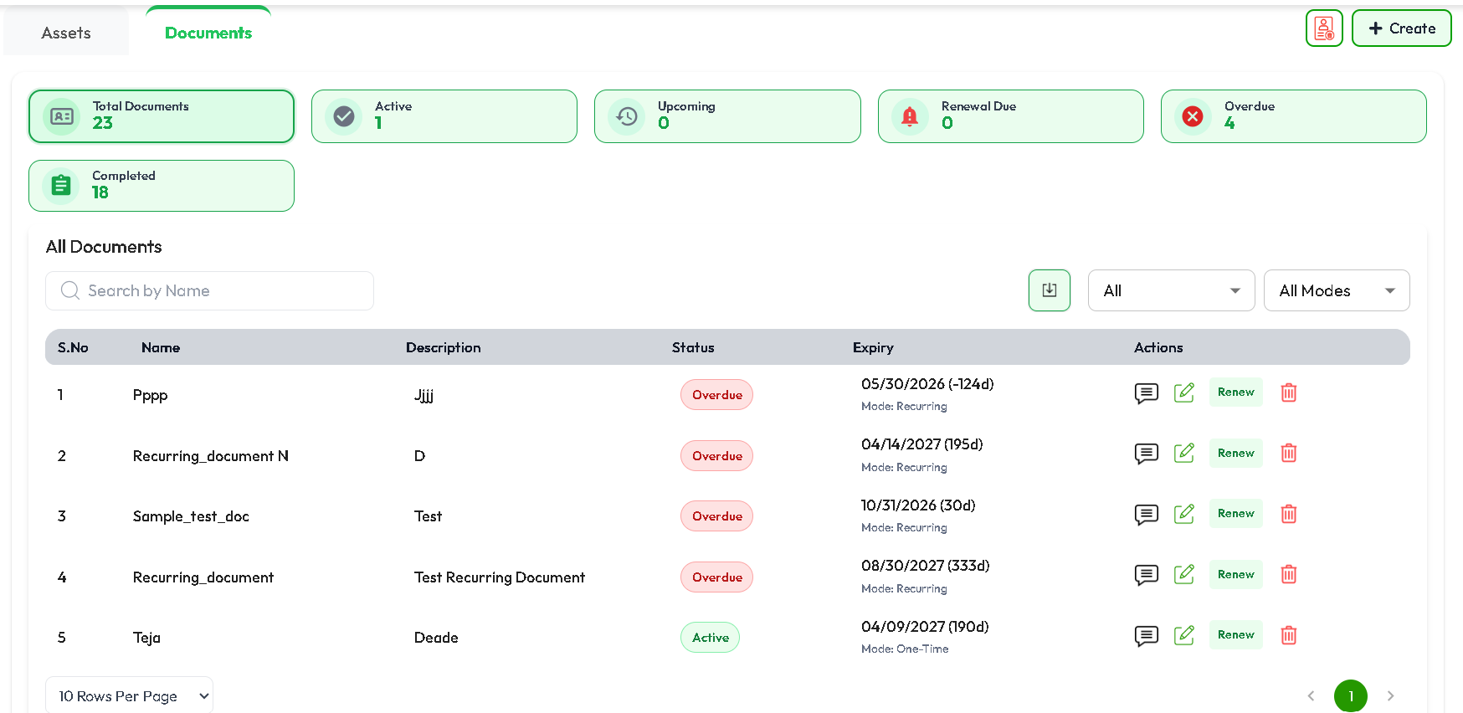

- [Asset Usage Tab]: Real-time allocation of assets across active customer jobs.
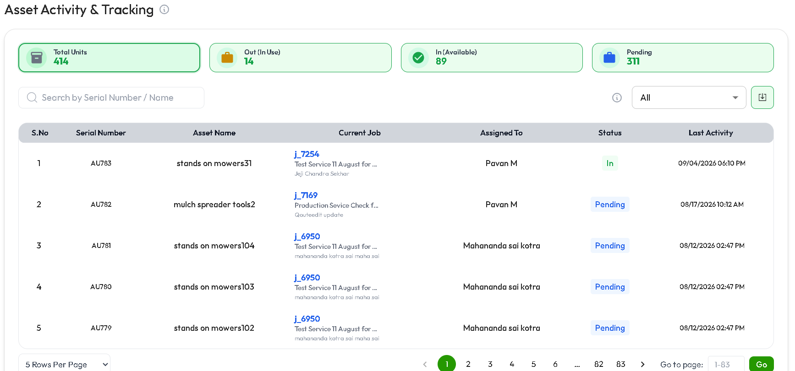

Asset Activity & Tracking – Key Points
- Asset Summary: Displays the total number of assets along with their current availability and usage status.
- Total Units: Shows the overall number of assets available in the system.
- Out (In Use): Displays the number of assets currently assigned or being used.
- In (Available): Shows the number of assets currently available for assignment.
- Pending: Displays assets that are awaiting assignment, approval, or further action.
- Search Assets: Users can search for assets using the Serial Number or Asset Name.
- Status Filter: Allows users to filter assets based on their current status.
- Current Job: Displays the job associated with the asset, along with relevant job details.
- Assigned To: Identifies the person currently responsible for or assigned to the asset.
- Asset Status: Indicates whether the asset is In, Pending, or in another defined status.
- Last Activity: Shows the most recent activity date and time for each asset.
- Export/Download: Provides an option to export or download the displayed asset activity data.

5. MODULE 4: LABOR & WORKFORCE MANAGEMENT
Purpose:
Define labor roles, wage cost structures, client billing rates, production
coverage speeds (sqft/hr), overtime rules, and field technician rosters.
5.1 Labor Types Screen
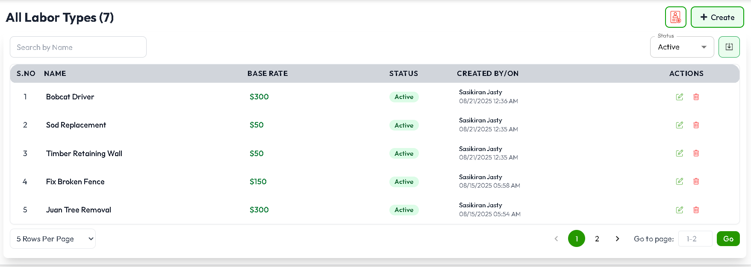
TOP CONTROLS & BUTTONS:
• [+ Create Labor Type] Button: Opens the Labor Configuration screen.
• [Search Input]: Search by Labor Role Name (e.g., Senior Mason, General Crew).
• [Status Filter]: Active / Inactive.
• [Download Button]: Export labor cost matrices.
• [Trash Icon]: Toggles between Active and Deleted Labors.
• Action Icons:
- [Edit] (Pencil): Update rates, coverage capacity, or overtime policies.
- [Delete] (Trash): Remove role with comment.
- [Audit History Tooltip]: Track wage and rate changes over time.

5.2 Labor Create / Edit Form
Navigation: Labor -> + Create Labor Type
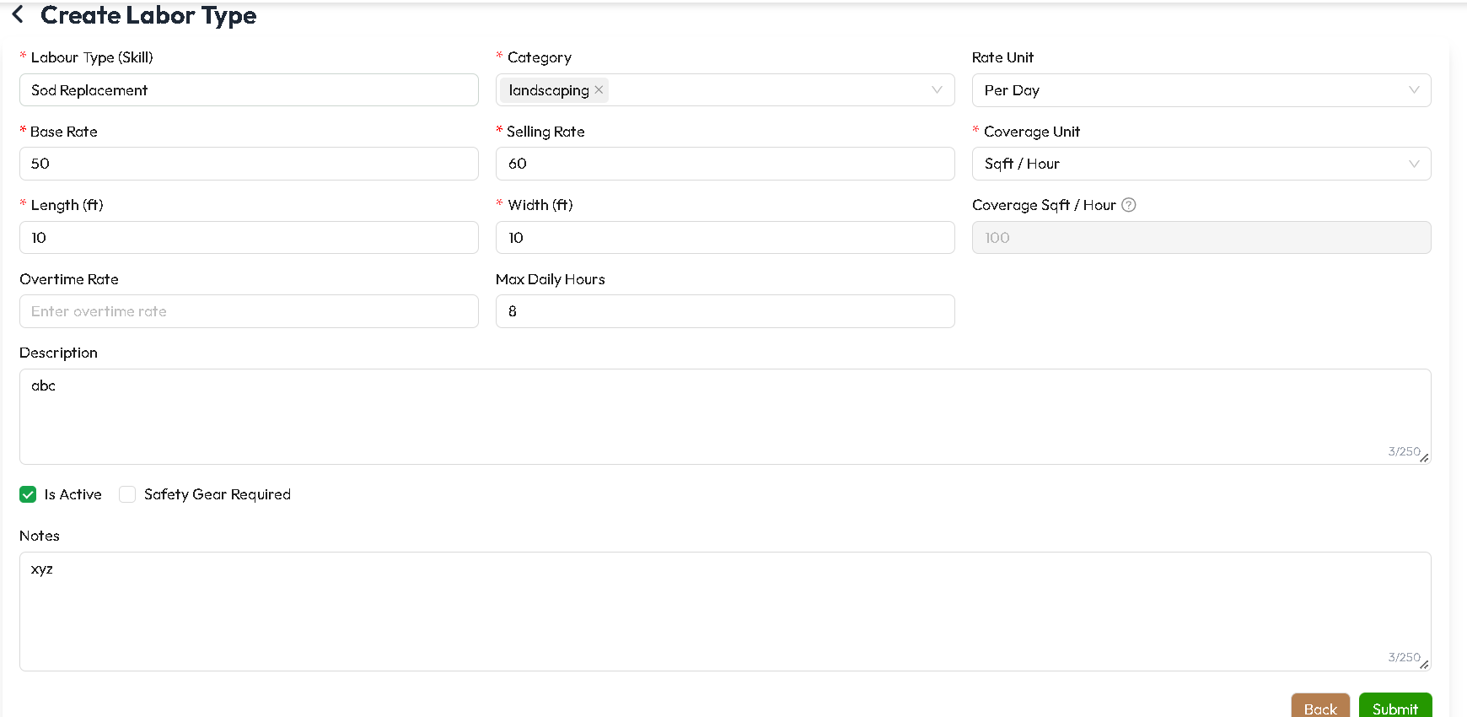
FORM FIELDS:
• Labor Type Name (e.g., "Landscape Crew Lead", "Sod Installation Worker").
• Role Description & Responsibilities.
• Linked Service Categories and Asset Categories (Multi-select from Drop-Down).
• Rate Units: 'Per Hour', 'Per Day', or 'Per Task'.
• Base Cost Rate ($): What the company pays the worker.
• Selling / Billing Rate ($): What the customer is charged.
• Coverage Unit & Productivity Capacity:
- Unit: Sqft/Hr, Sqft/Day, Cu Yd/Hr, Cu Yd/Day.
- Coverage Value: Amount of work completed per hour.
• Max Daily Hours & Overtime Rate ($/hr).
• [Safety Gear Required Checkbox]: Requires PPE equipment check.
• Notes for a brief description or identification of the labor required for the service.
• [Save Labor Button] & [Cancel Button].

5.3 Field Staff List
Navigation: Field Staff -> Field Staff
• View active field technicians
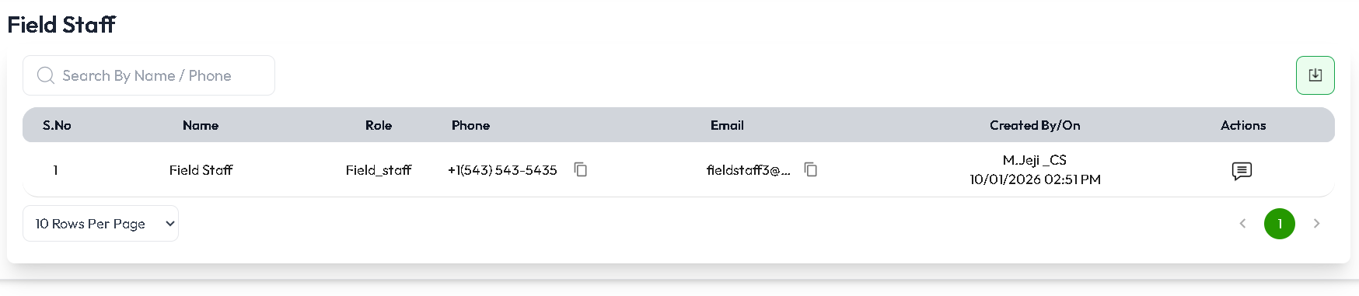

6. MODULE 5: ENQUIRIES (LEAD MANAGEMENT)
Purpose:
Capture prospective customer interest across phone calls, web forms, walk-ins,
and partner referrals. Qualifies leads before converting them into Requests or Quotes.
6.1 Enquiries List Screen
Navigation: Sidebar -> Enquiries
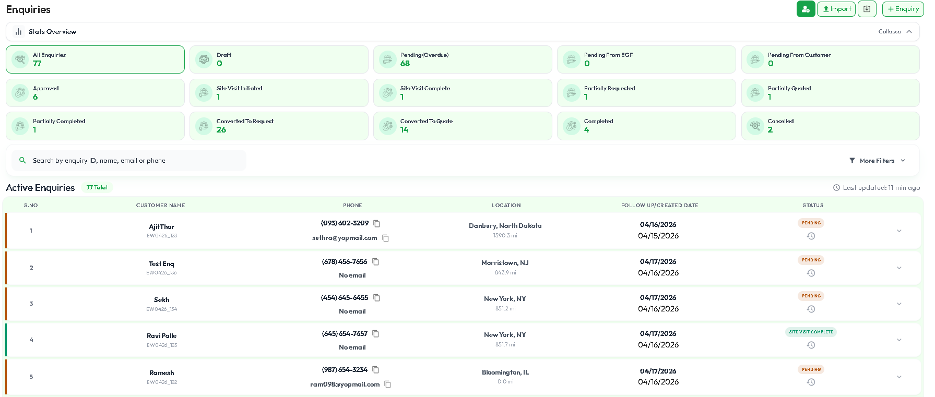
COLLAPSIBLE STATUS METRIC CARDS:
• Total Enquiries
• Draft / Pending Review / Approved
• Pending from Customer (Waiting on client details)
• Pending from Company (Waiting on estimator)
• Site Visit Initiated / Complete
• Converted to Request / Partially Converted
• Converted to Quote/ Partially Converted
• Completed / Cancelled
• [Export Button]: Downloads enquiries to Excel/PDF.
• [Trash / List Toggle]: View active leads vs deleted/disqualified leads.

TOP CONTROLS & BUTTONS:
• [Excel Import Button] (Upload Icon): Batch import leads from spreadsheet.
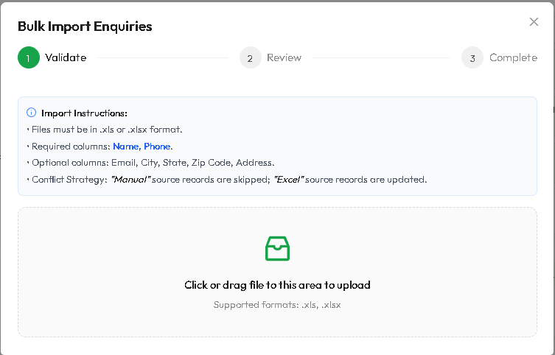
• In first step validate that uploaded excel is correctly structured or not.
•Then we can review list of leads details in review phase.
•Now we are supposed to create multiple leads at a time.
• [+ Create Enquiry] Button: Opens the New Enquiry Form.
• [Search Input]: Search by Client Name, Phone, Email, Property Address, or ID.
• [Date Range Filter]: Filter by Enquiry Created Date and Follow-Up Date.
• [Status Filter Dropdown]: Filter by lifecycle state.
• [Priority Filter Dropdown]: Low, Medium, High, Urgent.
• [Assigned Sales Rep Dropdown]: Filter leads by estimator/salesperson.
• [Reset Filters Button]: Clears all search criteria.

TABLE COLUMNS & ACTIONS:
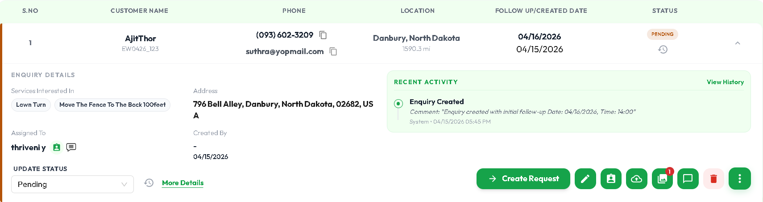
• Client Information (Name, Formatted Phone, Email, Service Address & Distance)
• Requested Services & Notes
• Priority Badge (Urgent [Red], High [Orange], Medium [Blue], Low [Gray])
• Assigned Representative (with Avatar hover)
• Follow-Up Date & Time
• Row Actions:
- On Row Click enquiry opens an accordion with necessary details, click on More Details for more Enquiry Details in that accordion.
- [Edit] (Pencil): Opens Lead editing form.
- [Convert to Request] (Arrow Icon): Automatically creates a formal Request.
- [Convert to Quote] (Quote Icon): Transfers client and scope directly into Quote builder.
- [Schedule Site Visit] (Calendar Icon): Opens technician dispatch modal.
- [Comments Popover] (Speech Bubble): View/add internal sales notes.
- [Upload Icon]: Admin can upload images when site visit did or reference images.
- [Album Icon]: Admin can View images uploaded for the respective enquiry.
- [Delete Icon]: Soft deletes with required comment reason.

6.2 Create / Edit Enquiry Form
FORM SECTIONS: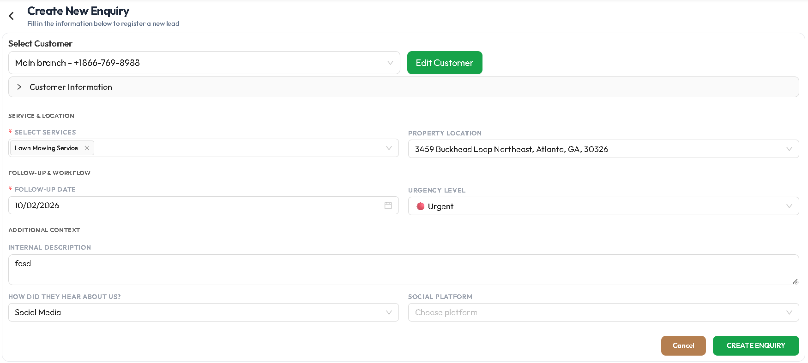
• Customer: Create 'New Customer' or Select 'Existing Customer'.
• First Name, Last Name, Phone Number, Email.
• Property Address (Street, City, State, ZIP).
• Referral Source: Social Media, Events, Friends, Internal Employees, Walkins.
• Interested Services: Multi-select from Service available or else choose other service and type and fill custom service name which client requires.
• Project Description / Scope Details.
• Priority Level & Assigned Staff.
• Follow-Up Date & Reminder Time.
• [Submit Enquiry Button] & [Cancel Button].

7. MODULE 6: REQUESTS & SITE VISITS
Purpose:
Formal customer project requests requiring site measurement, field inspection,
design evaluation, and estimator assessment prior to quoting.
7.1 Requests List Screen
Navigation: Sidebar -> Requests
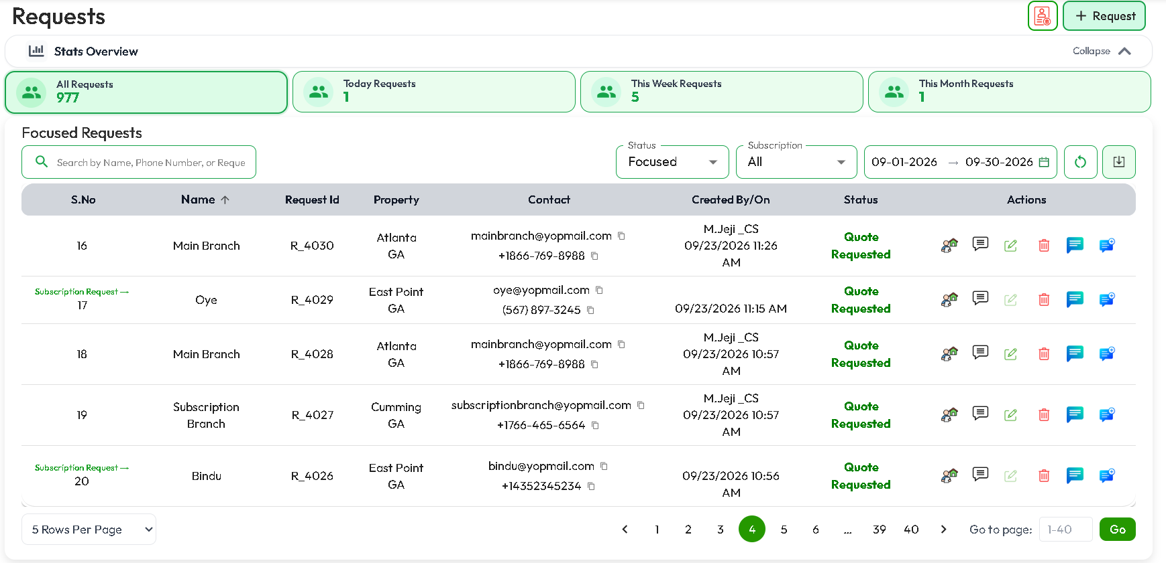
METRIC SUMMARY CARDS:
• Total Requests
• Today Requests
• This Week Requests
• This Month Requests
HEADER CONTROLS & BUTTONS:
• [+ Create Request] Button: Opens the Customer Request Builder.
• [Search Bar]: Live search across client name, request ID, Phone Number.
• [Date Range Picker]: Filter by request creation date.
• [Status Filter]: Filter by request lifecycle.
• [Subscription Filter]: Filter requests by subscription or Non-subscriptions.
• [Reset Button] & [Download Button].
• [Trash Bin Toggle]: Switch between Active and Deleted requests.
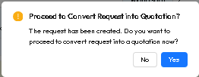
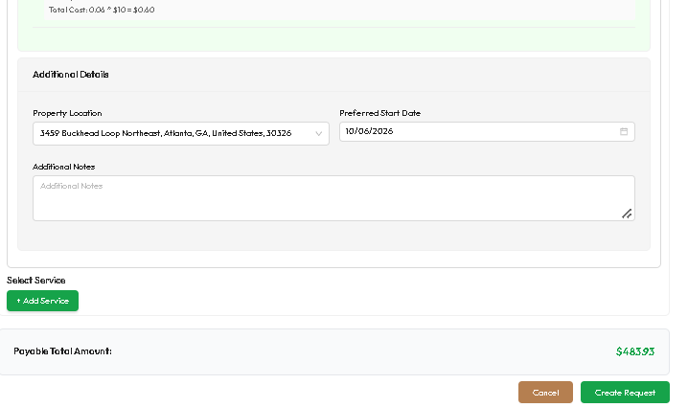
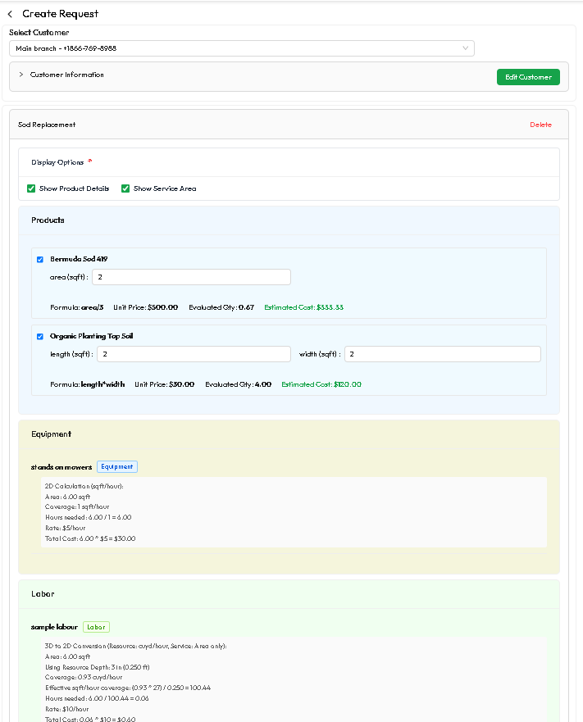
TABLE COLUMNS:
• Request ID (e.g., #REQ-0089)
• Client Name & Contact Info
• Service Address
• Site Visit Status (Unscheduled / Scheduled / Completed)
• Created Date
• Action Icons:
- [Edit Request] (Pencil): Modifies request parameters.
- [Site Visit Modal Button] (Inspection Icon): Schedules technician inspection.
- [Comments Popover] & [Action History Tooltip].
- [Delete Button]: Soft delete with comment reason.
Create a Request:
- Search and Select client from dropdown.
- If client has address then we can add Services or else a address entry dialogue will appear, in that dialogue update client address and then select the services client required
- Then enter Measurement like area / length / width etc.,
- Then based on measurements required labor and equipment are calculated.
- And then choose service address and start date and add additional notes from customer if they want.
- Then click on Create Request and a request is created, then it asks for do you want to proceed to create quotation, if you want to create quotation click on Yes, No means it navigates to Requests page

7.2 Site Visit Scheduling Modal
TRIGGER: Click [Site Visit Icon] on any Request row.
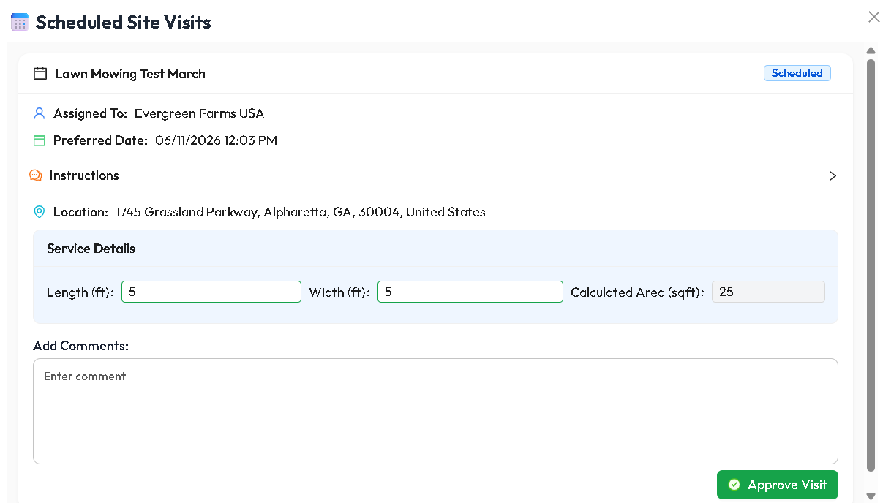

MODAL FIELDS & CONTROLS:
• Select Field Technician / Estimator (from active field staff list).
• Visit Date & Start/End Time Slot.
• Site Inspection Instructions (e.g., "Check gate width for excavator access, measure slope").
• [Send SMS / Email Alert to Customer Checkbox]: Notifies client of visit window.
• [Confirm & Schedule Button]: Dispatches site visit to technician's mobile schedule.
• [Close / Cancel Button].

8. MODULE 7: QUOTATIONS (ESTIMATION & PRICING ENGINE)
Purpose:
Generates comprehensive landscaping estimates. Auto-calculates product quantities,
labor hours, equipment charges, transport, and profit margins.
8.1 Quotes List Screen
Navigation: Sidebar -> Quotes
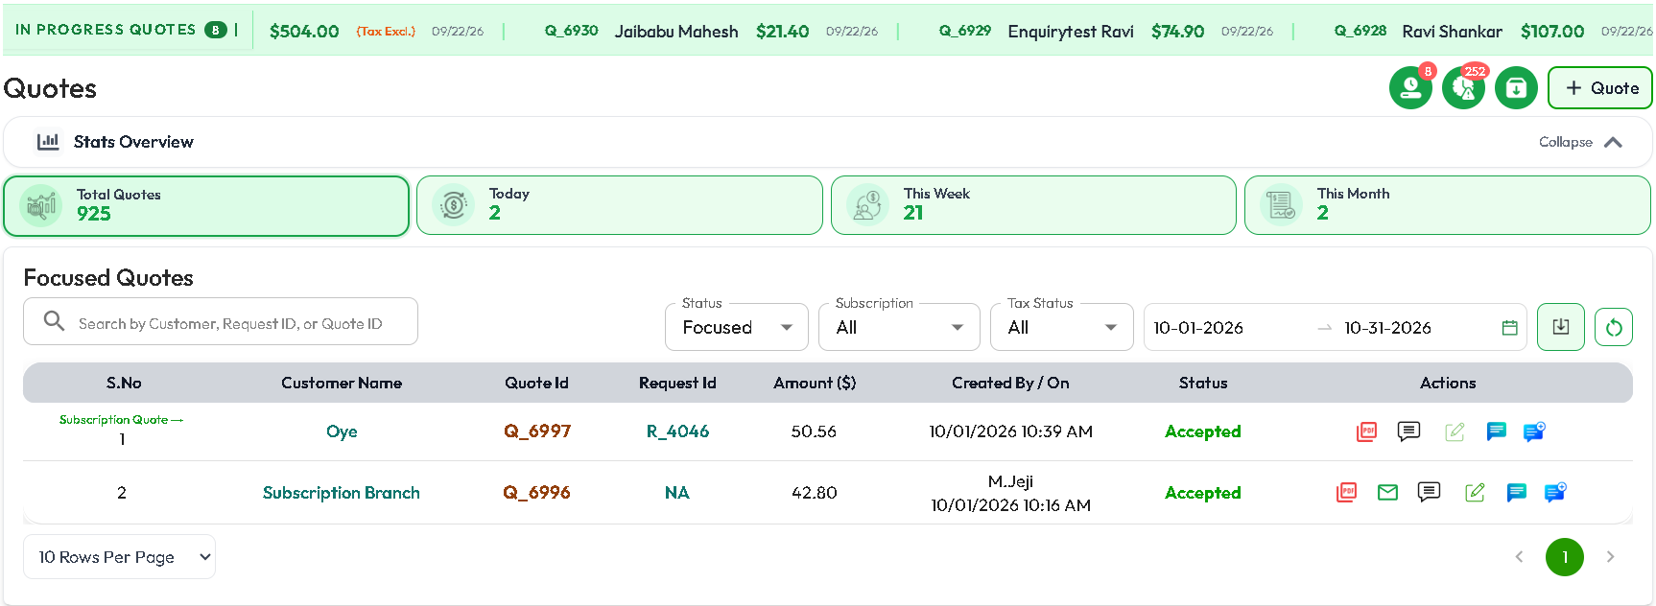
KPI CARDS:
• Total Quotes
• Today Quotes
• This Week Quotes
• This Month Quotes

TOP CONTROLS & BUTTONS:
• [+ Create Quote] Button: Navigates to the Advanced Quotation Builder.
• [In-Progress Quotes Ticker]: Bar displaying In-Progress Quotes means customer having queries.
• [Search Input]: Search by Quote #, Client, Phone, or Request ID.
• [Date Range Filter]: Filter by quotation issue date.
• [Status Filter Dropdown]: Draft, Sent, Accepted, Converted, Rejected, Etc.,
• [Subscription Filter Dropdown]: Filter Quotes based on Subscription and Non-Subscription.
• [Download / Export Button]: Export quotes ledger.

TABLE COLUMNS:
• Quotation Number (e.g., #EST-2026-045)
• Client Name, Email, & Property Address
• Total Estimated Amount ($)
• Quote Status Badge (Draft [Gray], Sent [Blue], Approved [Green], Converted [Purple])
• Action Icons:
- [Edit Quote] (Pencil): Opens quote builder to adjust quantities or pricing.
- [Re-Send Quote] (Mail/SMS Icon): Opens delivery modal with live Public Link.
- [View PDF] (PDF Icon): View customer quote document.
- [Comments Popover] & [Action History Tooltip].
- [Delete Icon]: Moves quote to trash with mandatory comment.
- We can Accept/ Achieve / Expire a quote, when is it created or Waiting for Approval Status.
- We can directly Complete a quote when respective quote invoice is Fully Paid.

8.2 Quotation Builder Form Walkthrough
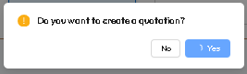
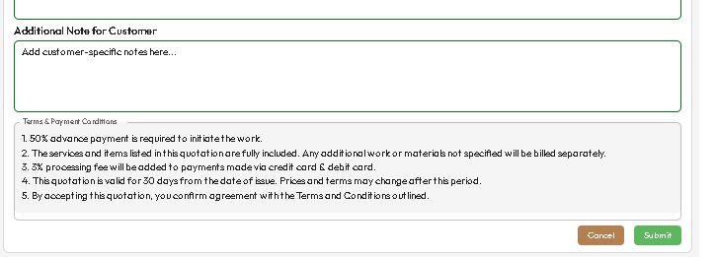
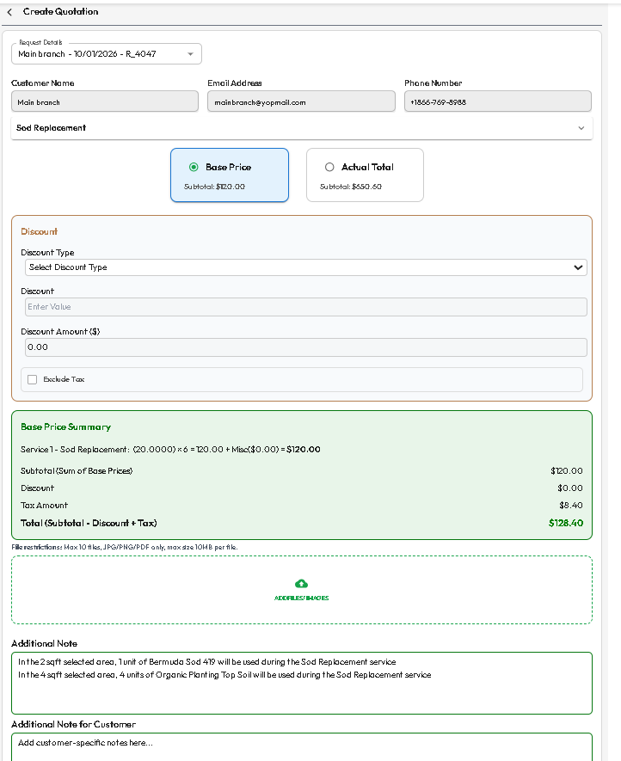
Navigation: Quotes -> + Create Quote (/dashboard/mvp2createQuote)

STEP-BY-STEP BUILDER:
1. Customer & Property Information:
• Customer Dropdown / Search: Select existing client or click [+ New Client].
• Property Address Selector: Choose service location or add new job site.
• Quotation Expiration Date (e.g., Valid for 30 days).

2. Adding Services:
• [+ Add Service] Button:
- Select Service from catalog (e.g., "Sod & Turf Installation").
- System automatically executes formula:
`Calculates Total Area (Sqft) -> Material Rolls Needed -> Labor Hours -> Equipment Allocation`.
• Real-Time Cost Breakdown Accordion:
- Products Cost ($): Itemized material pricing.
- Labor Cost ($): Calculated crew hours x labor rate.
- Equipment Cost ($): Machinery allocation rates.
- Transport Surcharge ($).
- Services Subtotal ($).

3. Overall Financial Summary & Deposit Terms:
• Subtotal ($) across all services.
• Discount Selector: 'Percentage (%)' or 'Fixed Amount ($)'.
• Tax Calculation: Auto-calculated based on local state/county tax rates.
• Final Grand Total ($).

4. Actions & Finalization:
• [Create Quotation]: Click on create quote button and click on yes to create a Quotation. 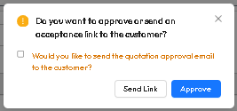
• [Dialouge]: After Successful quote creation it pop-ups a dialogue either to send quotation to customer or else admin can accept quotation directly.
• [Accept Quotation]: If you want to send accepted mail when quotation approves check the check box first and then click on Approve button.
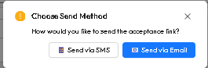
• [Send Via SMS / E-Mail]: After click on send link need to choose send via SMS or email. 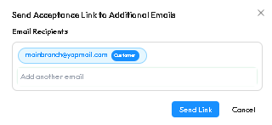
• [Send Link]: After click on send link need to choose send via SMS or email and click on send link.
• [Cancel Button]: Go back to Quotes Page.

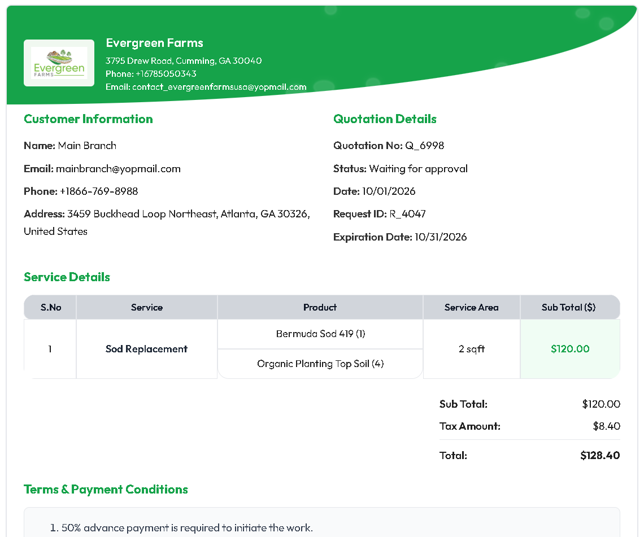
8.3 Customer Public Quote URL & E-Sign Portal
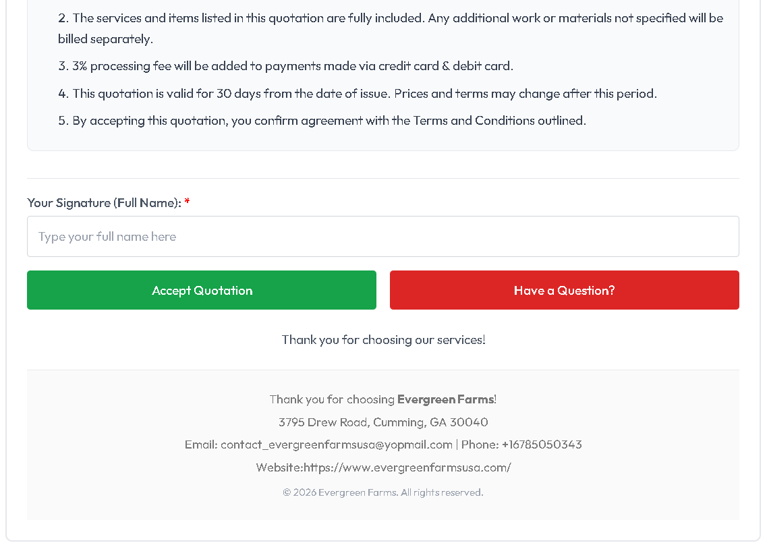

When a quote is sent, the client receives a secure online link:
• View branded proposal with itemized service descriptions and Amounts.
• [Approve Quote Button]: Client types their name and draws digital signature.
• [Have A Question Button]: Client can clarify doubts in that particular quotation.
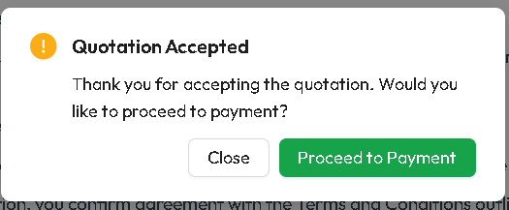
• [Quotation Approved]: After Client Accepts Quotation, a pop-up appears whether they would like to proceed to payment or not.
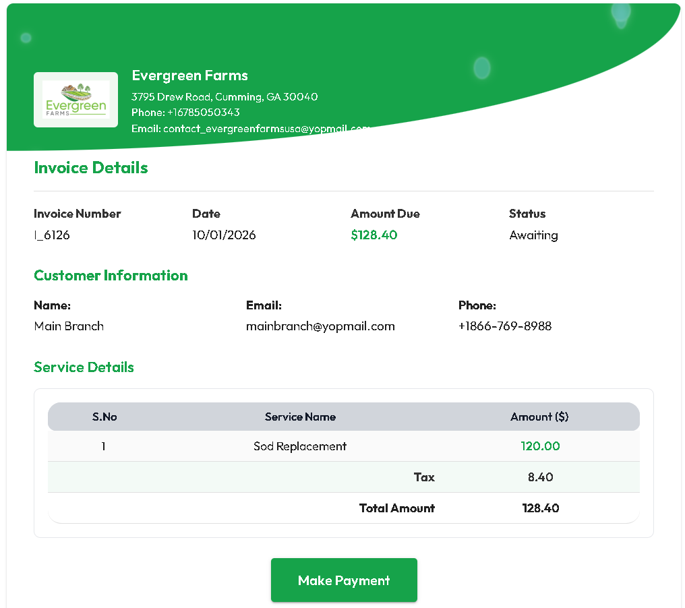

9. MODULE 8: INVOICES & PAYMENTS

Purpose:
Manage billing, deposits, progress payments, final balances, tax calculations,
payment gateways (Credit Card, Cash, Cheque, Bank Transfer), and receipts.

9.1 Invoices List Screen
Navigation: Sidebar -> Invoices
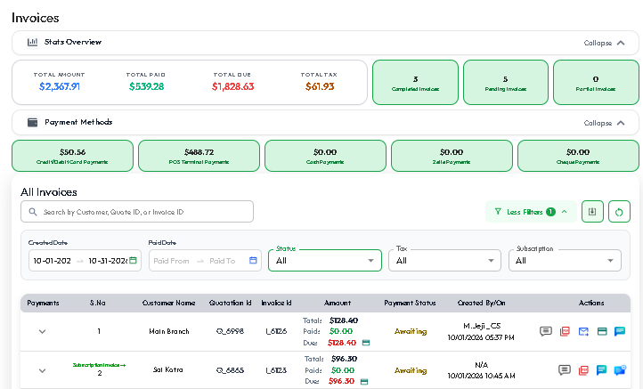
FINANCIAL KPI CARDS:
• Total Invoiced Revenue ($)
• Paid Invoices ($)
• Unpaid / Outstanding Balance ($)
• Overdue Invoices ($)
• Total Tax Amount ($)
• Also Showed the Amounts Received via different payment methods

TOP CONTROLS & BUTTONS:
• [+ Create Invoice] Button: Opens the Manual Invoice Creator.
• [Search Input]: Search by Invoice #, Client Name, Email, or Quotation Number.
• [Date Range Filter]: Filter by Created Date or Paid Date.
• [Status Filter Dropdown]: All, Focused, Awaiting, Partially Paid, Paid, And Cancelled.
• [Tax Filter]: Tax Excluded / Tax Included.
• [Subscription Filter]: Filter Subscription and Non Subscription Invoices.
• [Reset Filters Button] & [Download Button] (PDF/CSV Export).

TABLE COLUMNS:
• Invoice Number (e.g., #INV-8832)
• Client Name, Phone, and Email
• Quotation Number
• Total Amount ($)
• Amount Paid ($)
• Remaining Balance Due ($)
• Status Badge (Paid [Green], Awaiting [Red], Partial [Orange])
• Action Icons:
- [Collect Payment / Pay Now] (Credit Card Icon): Opens Payment Processing Modal.
- [Send Invoice] (Mail Icon): Resends payment link via SMS / Email.
- [Download PDF] (PDF Icon): Downloads official tax invoice.
- [Invoice Action History] (Clock Icon): Shows payment ledger and attempt history.
- [Comments Popover] & [Action History Tooltip].

9.2 Collect Payment Dialog Walkthrough
TRIGGER: Click [Credit Card / Collect Payment Icon] on any unpaid invoice.
PAYMENT MODAL CONTROLS:
• Payment Amount Input: Defaults to remaining balance; allows custom partial amounts.
• Payment Type: 'Deposit Payment' or 'Full / Final Settlement'.
• Payment Method Tabs:
1. [Credit Card Tab]:
- Cardholder Name, Card Number, Expiry Date, CVC.
- Process live transaction via integrated Stripe terminal/gateway.
2. [Cash Tab]:
- Amount Received ($), Change Given ($), Cashier Reference Note.
3. [Cheque Tab]:
- Cheque Number, Bank Name, Issue Date.
4. [Online Payment Link Tab]:
- Generates copyable payment link or sends direct SMS invoice to customer.
• [Process Payment Button]: Submits payment, updates ledger, and issues receipt.
• [Cancel / Close Button].
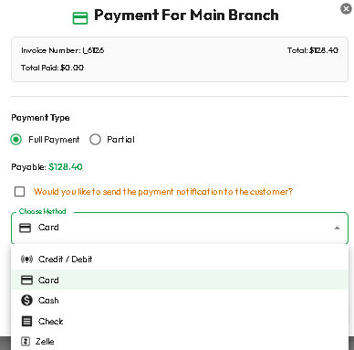

10. MODULE 9: JOBS (DISPATCH, ROUTING & FIELD EXECUTION)

Purpose:
Operational core for scheduling landscaping crews, allocating machinery, routing
vehicles on Google Maps, tracking live job progress, recording expenses, and
closing out completed projects.

10.1 Jobs Master List Screen
Navigation: Sidebar -> Jobs
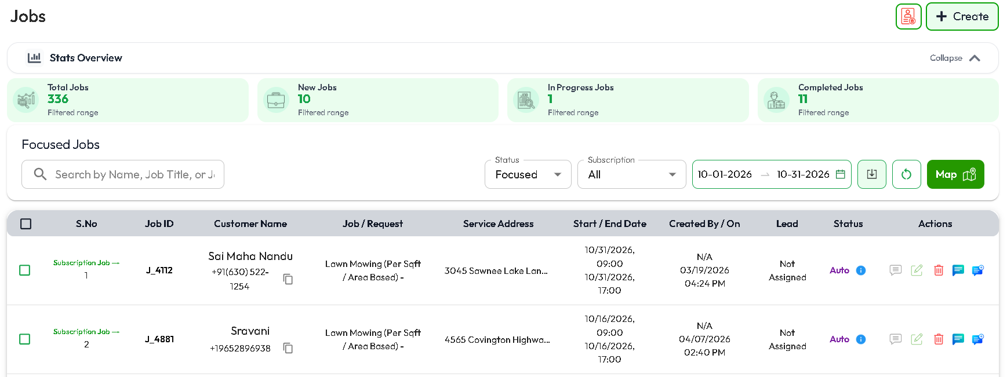
COLLAPSIBLE JOB METRIC CARDS:
• Total Scheduled Jobs
• New Jobs
• Jobs In Progress
• Completed Jobs

TOP HEADER CONTROLS & BUTTONS:
• [+ Create Job] Button: Opens the Manual Job Creation Wizard.
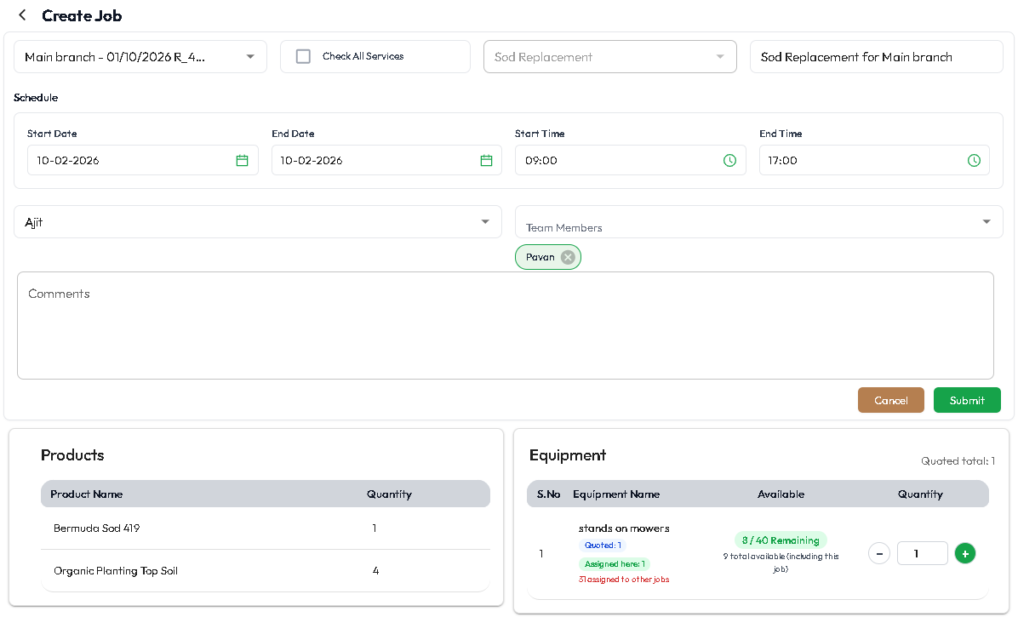
• [Optimized Route Map Button] (Map Pin Icon):
Opens map modal plotting all scheduled jobs for the day with optimized driving routes.
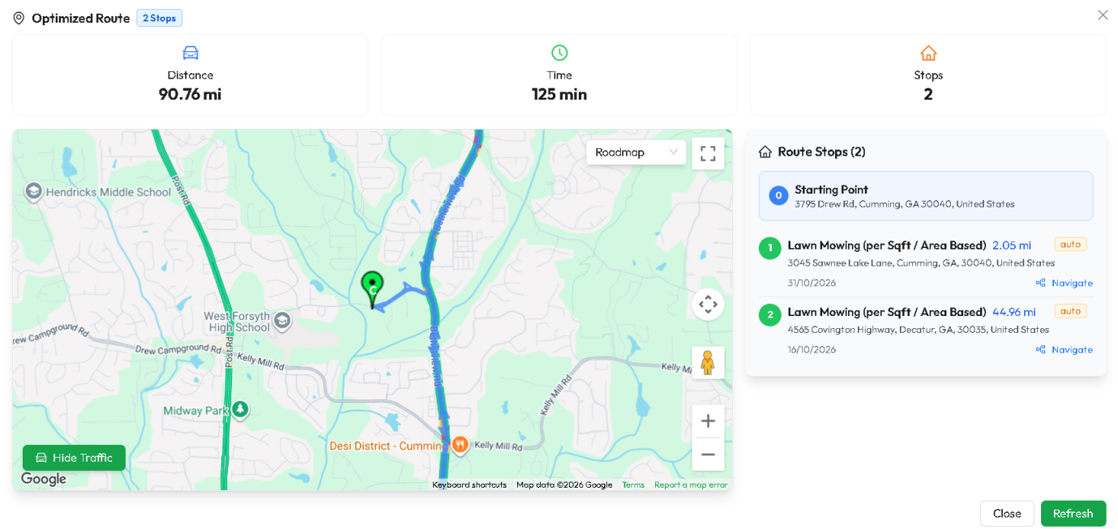

• [Bulk Job Update Button]:
Allows selecting multiple job checkboxes to bulk-reassign crews or update status.
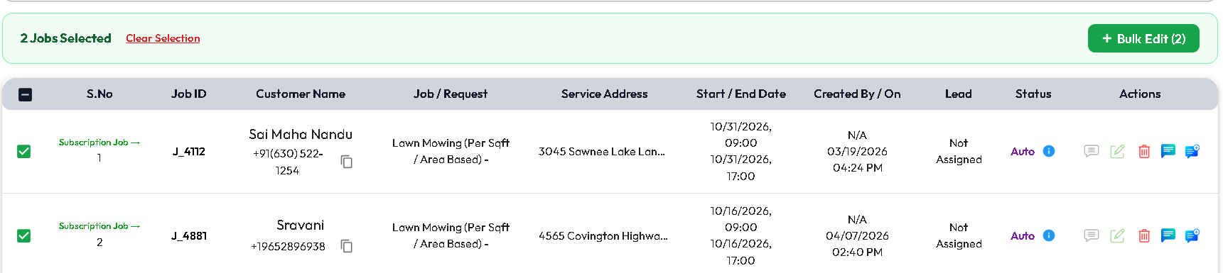
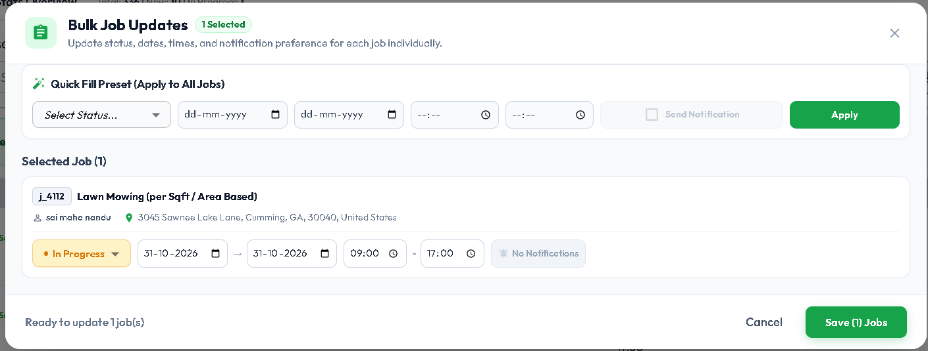
• [Search Input]: Search by Job #, Job Title, Client Name, or Site Address.
• [Date Range Filter]: Filter by scheduled start/end dates.
• [Status Filter Dropdown]: Scheduled, In Progress, Completed, Cancelled, Action Required.
• [Subscription Filter]: Filter Subscription and Non Subscription Jobs.
• [Download Button]: Export job logs and time-sheets.
• [Trash / List Toggle]: View active vs cancelled jobs.

TABLE COLUMNS:
• [Selection Checkbox]: For bulk operations.
• Job Number & Title (e.g., #JOB-5012: Front Yard Hardscaping).
• Client Name, Phone, and Site Address.
• Job Schedule (Start Date, End Date, Time Window).
• Status Badge:
- Scheduled [Blue], In Progress [Orange / Spinning], Cancelled [Red], Completed [Green],
• Action Icons:
- [Edit Job] (Pencil): Reschedule dates, change crew, or add tasks.
- [Comments Popover] & [Action History Tooltip].
- [Delete Job] (Trash): Soft delete with comment.

10.2 Job Details Screen
Navigation: Click [View Details] on any Job row
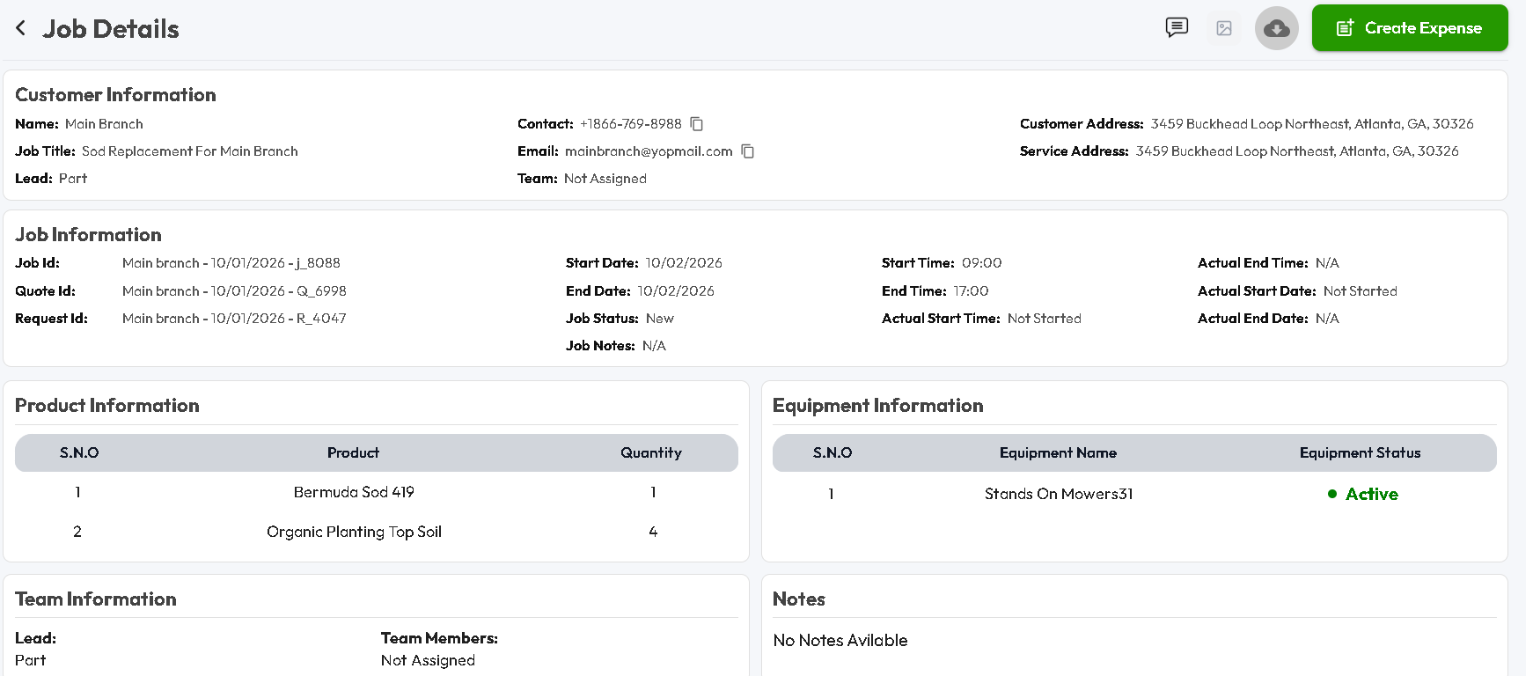
SECTIONS & TABS:
• Scope & Services Accordion: List of tasks, quantities, and material checklists.
• Assigned Staff & Asset Allocation:
- Assigned Technicians and Crew Lead.
- Allocated Equipment (e.g., Excavator #3, Mower Unit B).
• Time-sheet & Work Log Tab:
- Technician Clock-In / Clock-Out timestamps and total labor hours worked.
• Job Expenses Tab:
- [+ Add Expense Button]: Logs unexpected on-site material purchases or dumpsite fees.
• Photos & Attachments Tab:
- Before & After job site photos uploaded by field technicians via mobile.
• [Complete Job Button]: Prompts technician signature, verifies checklist, marks complete.
• [Generate Final Invoice Button]: Transfers billable labor & materials to Invoicing.
11. COMPLETE END-TO-END BUSINESS LIFECYCLE WORKFLOW

Below is the seamless, step-by-step path of how a landscaping project moves
through the entire Evergreen platform:

STEP 1: LEAD CAPTURE (MODULE 5 - ENQUIRIES)
1. Customer contacts the company via phone, web lead, or office visit.
2. Staff clicks [+ Create Enquiry] in Enquiries.
3. Enters customer name, phone, address, and requested services (e.g., Sod + Mulch).
4. Sets priority and assigns an estimator.
5. If on-site inspection is required:
-> Click [Schedule Site Visit] to dispatch technician.
6. When ready to quote:
-> Click [Convert to Quote] button on the Enquiry row.

STEP 2: ESTIMATION & FORMULAS (MODULE 7 - QUOTES)
1. The Quote Builder auto-populates client and property details.
2. Estimator adds services from the catalog (Module 1).
3. Enters yard dimensions (Length: 50ft, Width: 30ft, Depth: 3in).
4. System auto-calculates:
- Required Sod rolls and Mulch cubic yards (Module 2).
- Estimated Labor hours and crew cost (Module 4).
- Equipment usage rates (Module 3).
5. Tax exclusions and discounts are available..
6. Clicks [Save & Send] -> Client receives SMS/Email with Public Quote URL.

STEP 3: CUSTOMER APPROVAL & DEPOSIT (MODULE 7 & 8)
1. Customer opens the link on their mobile device or computer.
2. Reviews line items, signs digitally, and clicks [Approve Quote].
3. Customer pays the full amount / partial amount online using Credit Card.
4. The system automatically:
- Marks the Quote status as 'Accepted'.
- Generates a Deposit Invoice in Module 8 and marks it 'Paid'.

STEP 4: DISPATCH & EXECUTION (MODULE 9 - JOBS)
1. Create a job for this approved quote.
2. Selects scheduled start and end dates.
3. Assigns field technicians (Module 4) and allocates required machinery (Module 3).
4. Clicks [Optimized Route Map] to verify travel efficiency across all daily crews.
5. Field Technicians open their mobile dashboard:
- View site address, gate codes, and material checklists.
- Click [Start Job] -> Job status changes to 'In Progress'.
- Technicians complete work, snap 'After' photos, and click [Complete Job].

STEP 5: FINAL BILLING & SETTLEMENT (MODULE 8 - INVOICES)
1. Manager reviews completed job time-sheets and expenses.
2. Check Respective Invoice:
- If it is fully paid then quotation will be marked as completed automatically.
- If there is any outstanding amount, the Manager can resend the invoice to the customer to collect the remaining payment by clicking [Send Invoice] or [Collect Payment] and selecting the payment method: Card, Cash, or Cheque.
4. Customer settles the remaining balance.
5. Invoice status changes to 'Paid' and the quotation marks as ‘Completed’.

