The STRUCTURAL CHECK stage should determine whether the wall needs engineering, permits, reinforcement, a footing/foundation, or tie-backs—and then convert those requirements into quantities and costs.
A good structure is:
STRUCTURAL CHECK → Engineering → Permit → Foundation/Footing → Geogrid/Reinforcement → Tie-Back/Anchoring → Drainage → Structural Safety Checks → Cost Adders
Engineering Cost = Base Engineering Fee + Height Adjustment + Complexity Adjustment + Geotechnical Cost + Stamping/Permit Support
Don't simply trigger engineering based on one universal height number. U.S. requirements vary by jurisdiction and wall conditions.
Permit Cost = Application Fee + Plan Review Fee + Inspection Fee + Other Applicable Fees
For a professional estimating system, "Verify" is important because permit requirements shouldn't be hard-coded as one nationwide rule.
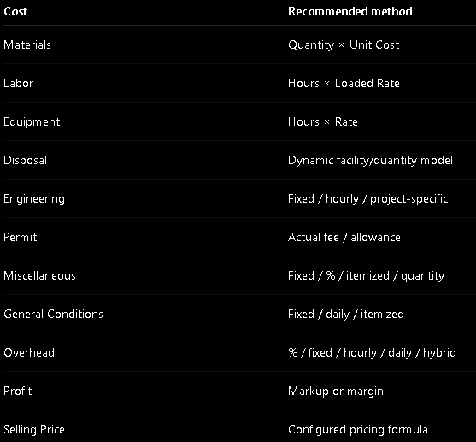
1. Basic disposal-cost formula
The most general formula is:
- Total Disposal Cost = Loading + Transportation + Disposal/Tipping Fee + Taxes/Surcharges + Miscellaneous
- Disposal Cost = Quantity (CY) × Disposal Rate ($/CY)
- Disposal Cost = Weight (tons) × Tipping Fee ($/ton)
- Weight (tons) = Volume (CY) × Material Density (tons/CY)
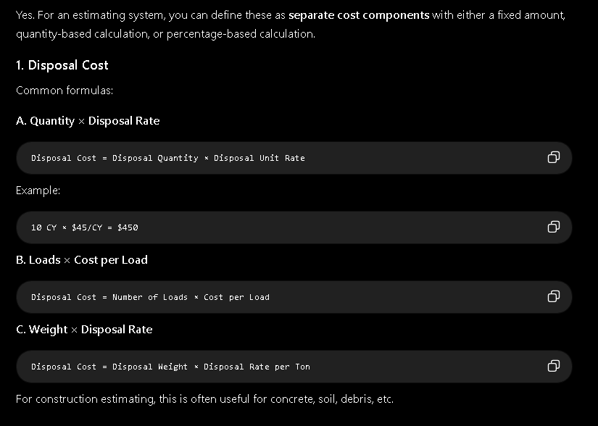
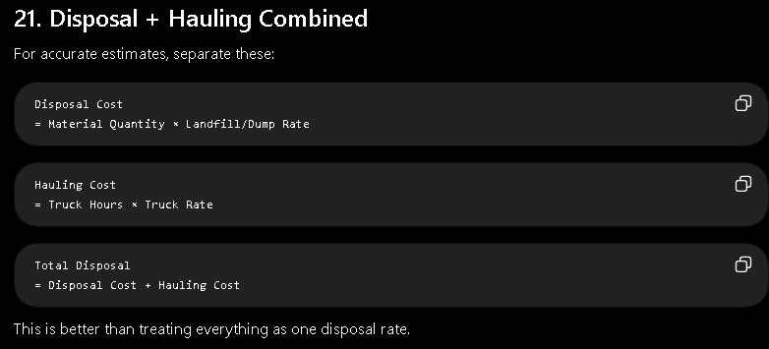
- Miscellaneous Cost = Direct Cost × Miscellaneous %
- Miscellaneous Cost = Fixed Allowance
- Miscellaneous Cost = Item 1 + Item 2 + Item 3 + ...
- Cost = Wall Length × Misc. Rate/LF
- Cost = Wall Area × Rate/SF
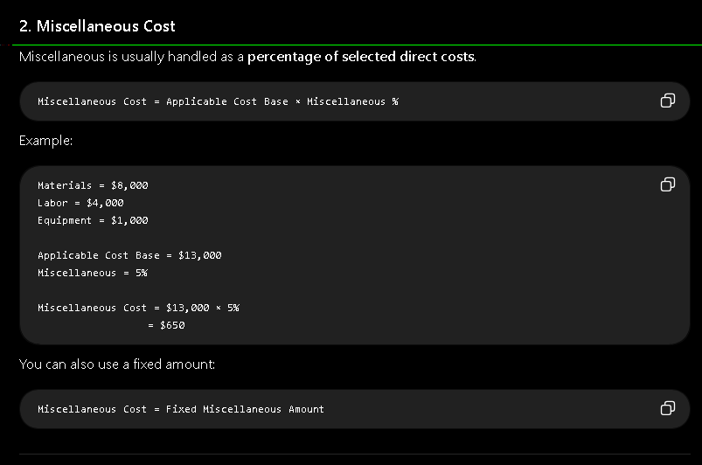
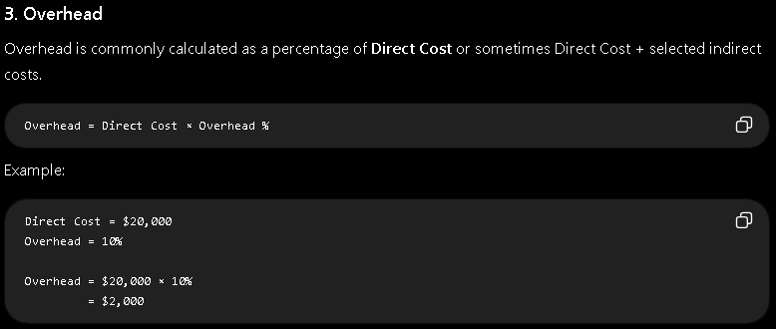
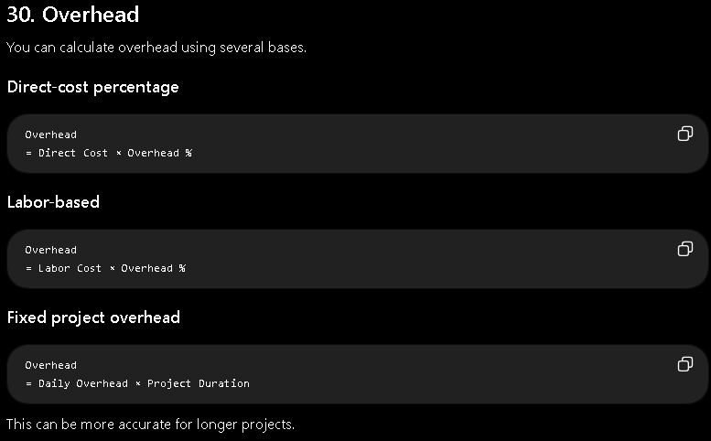
MATERIAL + LABOR + EQUIPMENT + DISPOSAL + ENGINEERING + PERMIT + MISCELLANEOUS = DIRECT / PROJECT COST
DIRECT / PROJECT COST + OVERHEAD = COST BEFORE PROFIT
COST BEFORE PROFIT + PROFIT = SELLING PRICE
